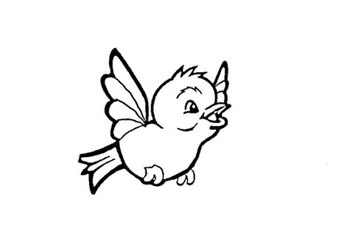
Our Lady of Pity
Pre-School CIC
Rigby Drive, Greasby, CH49 1RE Tel: 0151 677 6813
management@ourladyofpitypreschool.co.uk
accounts@ourladyofpitypreschool.co.uk

Lockdown policy
Our Lady of Pity Pre-School recognises the potentially serious risk to children, staff and visitors in emergency or harmful situations.
“provider’s must take reasonable steps to ensure the safety of children, staff and others on the premises in case of fire or any other emergency and must have an emergency evacuation procedure” (Early years foundation stage statutory framework, April 2017)
A lock down may take place where there is a perceived risk of threat to the pre-school, its staff, children and visitors or property.
Where possible the pre-school will act to ensure the safety of all personnel in the setting in the following situations;
- In the event that unauthorised person(s) considered dangerous are on the pre-school grounds or if we have intelligence that they were in the vicinity and pose a threat.
- In instances including domestic break downs where estranged parties are attempting to abduct children
- In instances where staff, students or volunteers from within the setting become a threat to the well-being of others.
- In emergency situations within the area of the pre-school where there is potential risk from spillages or poisonous fumes.
A lock down will be initiated by;
- The person shouting “ATTENTION, ATTENTION, ATTENTION, LOCKDOWN, LOCKDOWN, LOCKDOWN”. They would then continue to phone the main school and repeat the same on the person answering the phone.
- Lock down procedures will be practiced form time to time so that staff are familiar with them.
Practices and procedure.
To follow the CLOSE procedure;
Close all windows and doors
Lock up
Out of sight and minimise movement
Stay silent and avoid drawing any attention
Endure, be-aware that you may be in lock down for some time.
The following steps provide guidelines for staff, visitors and students in an emergency situation;
- On hearing the lockdown signal a member of the management team / person raising the alarm will call 999.
- Once lockdown has been announced, members of staff will alert staff and children outside to get indoors. And take registers.
- Staff will close all windows and close blinds, lock doors and shutters where possible, turn off lights.
- Staff and children will go by the desk/quiet area and toilets and barricade the doors.
- Any staff member that is not within their area at the time of Lockdown must go to the nearest lockdown zone if safe to do so. Roll call will commence.
Go In stay in tune in
Local industrial accidents e.g a factory fire with hazardous fumes, may also require the need for sheltering in the pre-school. All windows and doors should be kept shut and appliances such as extractor fans and air conditioning units. The emergency units and local authority will give the all clear. Further advice may be given over the radio.
Internal threat response / evacuation.
- On hearing the fire alarm during LOCKDOWN. Make no attempts to leave your lockdown zone unless authorised to do so by management or the police etc.
- Do not use the pre-school phones; intercom or outside lines unless you are giving the Lockdown message or calling the emergency services.
- Remain in lockdown until the all clear message is given.
- Do not contact parents until the all clear message is given.

