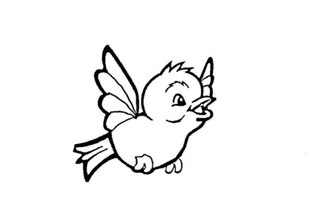
Our Lady of Pity
Pre-School CIC
Rigby Drive, Greasby, CH49 1RE Tel: 0151 677 6813
management@ourladyofpitypreschool.co.uk
accounts@ourladyofpitypreschool.co.uk

Transition to school
Policy statement
We recognise that children sometimes move to another early years setting before they go on to school, although many will leave our setting to enter a nursery or reception class.
We prepare children for these transitions and involve parents and the receiving setting or school in this process. We prepare records about a child’s development and learning in the Early Years Foundation Stage in our setting; in order to enable smooth transitions, we share appropriate information with the receiving setting or school at transfer.
Confidential records are shared where there have been child protection concerns according to the process required by our Local Safeguarding Children Board.
The procedure guides this process and determines what information we can and cannot share with a receiving school or setting. Prior to transferring information, we will establish the lawful basis for doing so.
Procedures
Transfer of development records for a child moving to another early years setting or school
- Using the Early Years Outcomes (DfE 2013) guidance and our assessment of children's development and learning, the key person will prepare a summary of achievements in the seven areas of learning and development through their tracking sheets.
- The manager will have a meeting with the school teacher to discuss the children’s strengths and areas for development.

Transfer of confidential information
- The receiving school or setting will need to have a record of any safeguarding or child protection concerns that were raised in our setting and what was done about them.
- We will make a summary of the concerns to send to the receiving setting or school, along with the date of the last professional meeting or case conference. Some Local Safeguarding Children Boards will stipulate the forms to be used and provide these for us to use.
- Where a CAF has been raised in respect of any welfare concerns, we will pass the name and contact details of the lead professional on to the receiving setting or school.
- We post or take the information to the school or setting, ensuring it is addressed to the setting or school’s designated person for child protection and marked as 'confidential’.
- We do not pass any other documentation from the child's personal file to the receiving setting or school.

