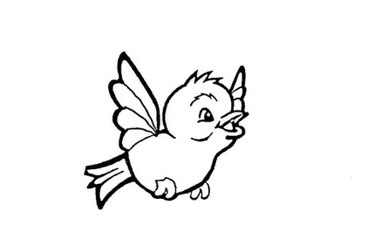
Our Lady of Pity
Pre-School CIC
Rigby Drive, Greasby, CH49 1RE Tel: 0151 677 6813
management@ourladyofpitypreschool.co.uk
accounts@ourladyofpitypreschool.co.uk

Two year funding policy

Who is eligible for funding?
Your two year old will be eligible for funding if you receive:

- Income Support
- Income-based Jobseeker’s Allowance (JSA)
- Income-related Employment and Support Allowance (ESA)
- Support through part 6 of the Immigration and Asylum Act
- The guaranteed element of State Pension Credit
- Child Tax Credit (but not Working Tax Credit) and have an annual income not over £16,190
- The Working Tax Credit 4-week run on (the payment you get when you stop qualifying for Working Tax Credit)
- Working Tax Credits and earn £16,190 a year or less
Children are also eligible if:

- They’re looked after by a local council
- They have a current statement of special education needs or an education health and care plan
- They get Disability Living Allowance
- They’ve left care under a special guardianship order, child arrangements order or residence order

When you can claim
- Children become eligible from the term after their second birthday.
- Children born between 1st January and 31st March become eligible in April (Summer Term)
- Children born between 1st April and 31st August become eligible in September (Autumn Term)
- Children born between 1st September and 31st December become eligible in January (Spring Term).
You will need to tell HMRC when you get free childcare. Call the Tax Credit Helpline.

What will we do:
- We will make 15 hours per week the standard offer to parents, however, parents may choose not to take-up their full entitlement.
- Ensure no session is longer than 10 hours;
- Ensure no session is shorter than 2.5 hours;
- Ensure no session begins before 7am and extends after 7pm.

