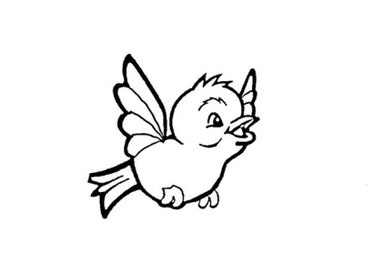
Our Lady of Pity
Pre-School CIC
Rigby Drive, Greasby, CH49 1RE Tel: 0151 677 6813
management@ourladyofpitypreschool.co.uk
accounts@ourladyofpitypreschool.co.uk

Breast Feeding Policy

Principles
Our pre-school believes that breastfeeding is the healthiest way for a woman to feed her baby and recognises the important health benefits now known to exist for both the mother and her child.
All mothers have the right to receive clear and impartial information to enable them to make a fully informed choice as to how they feed and care for their babies.
In support of this policy we have:
- No advertising of breast milk substitutes, feeding bottles, teats or dummies is permissible. The display of manufacturer’s logos on items such as calendars and stationery are also prohibited.
- No literature provided by infant formula manufacturers is permitted. Educational material for distribution to parents must be approved by the manager.

