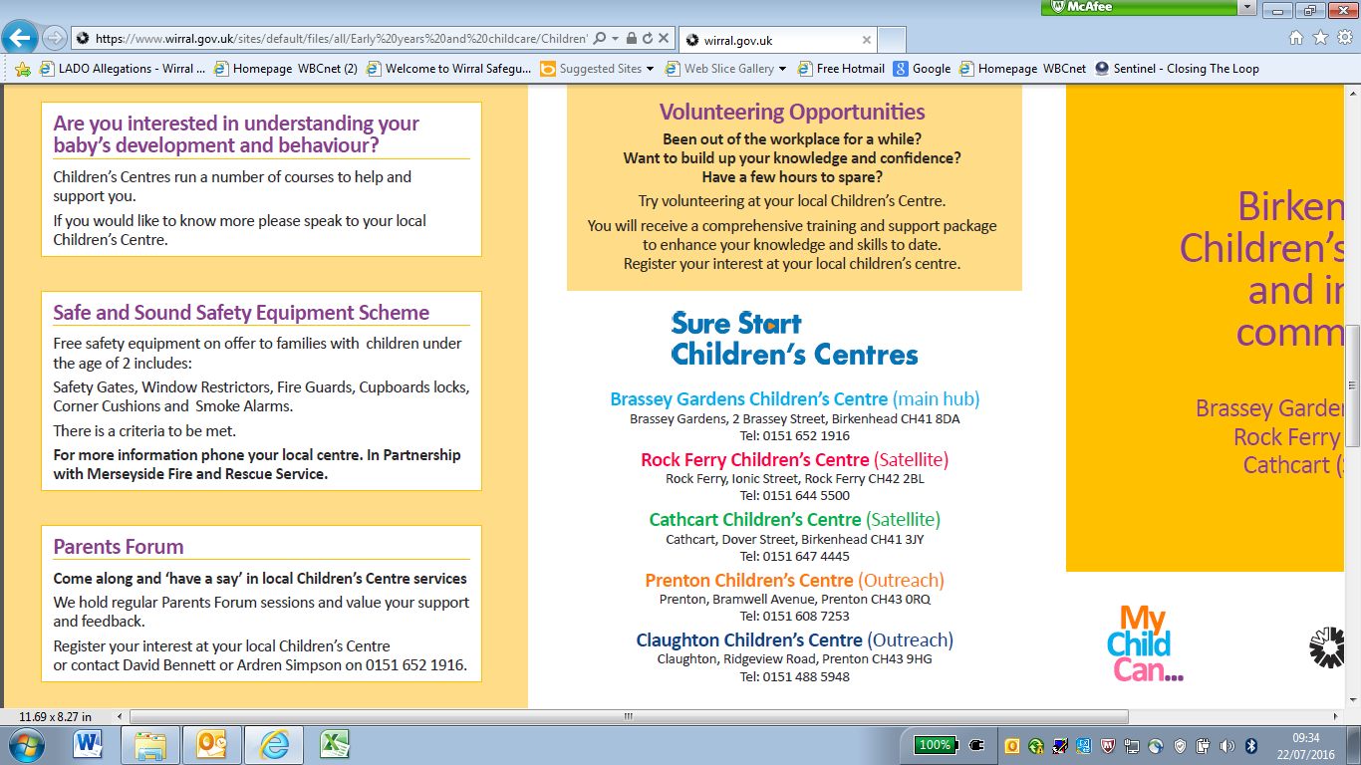

**Early Years Funding Entitlement for children under 5**

**EYFE2 - Parental Agreement for Early Years Funding Entitlements**



**SECTION 1: Child’s Details**

To be completed by all families claiming Early Years Funding Entitlement for children under 5

| **LEGAL SURNAME** |  | **ADDRESS 1** |  |
| --- | --- | --- | --- |
| **LEGAL FORENAME(s)** |  | **ADDRESS 2** |  |
| **KNOWN AS**  (if different from above) |  | **ADDRESS 3** |  |
| **Date of Birth** |  | **ADDRESS 4** |  |
| **GENDER** | FEMALE ☐ MALE ☐ | **POSTCODE** |  |
| **FUNDING** (please tick) | Under 2’s ☐  (Working Families offer) | 2-year-old funding ☐  (Additional Support) | 2-year-old funding ☐  (Working Families offer) |
|  | 3 & 4 year old funding ☐  (Universal 15 hours) | 3 & 4 year old funding ☐  (Extended 15 hours-working parents) |

| **WHITE** | **WBRI** | White British |  | **ASIAN or ASIAN BRITISH** | **AIND** | Indian |  |
| --- | --- | --- | --- | --- | --- | --- | --- |
| **WIRI** | White Irish |  | **APKN** | Pakistani |  |
| **WIRT** | White Traveller of Irish Heritage |  | **ABAN** | Bangladeshi |  |
| **WROM** | White Gypsy/Roma |  | **AOTH** | Any other Asian |  |
| **WOTH** | Any other white background |  | **MIXED** | **MWBC** | White and Black Caribbean |  |
| **BLACK** | **BCRB** | Caribbean |  | **MWBA** | White and black African |  |
| **BAFR** | African |  | **MWAS** | White and Asian |  |
| **BOTH** | Any other black background |  | **MOTH** | Any other mixed background |  |
| **OTHER** | **CHNE** | Chinese |  | **REFUSED** | **REFU** | Refused to share information |  |
| **OOTH** | Any other ethnic background |  | **NOT OBTAINED** | **IFNO** | Information not obtained |  |

| **Documentary evidence to be completed by Early Years Provider** | | | | |
| --- | --- | --- | --- | --- |
| **Documentary proof of DOB Type** (e.g. Birth certificate, Passport): |  | **Document recorded by**  (name of staff member): | |  |
| **Date document recorded** (DD/MM/YYYY) |  | **EARLY YEARS PROVIDER SIGNATURE** | |  |
| **First Language of Family** (Please specify from portal list): |  | | | |
| **Special Educational Needs and Disability (SEND) INFORMATION** | | | | |
| Is your child receiving support for SEND? | | | YES ☐ NO ☐ | |
| Does your child have an Education Health and Care Plan (EHCP)? | | | YES ☐ NO ☐ | |
| Is your child in receipt of Disability Living Allowance (DLA)? | | | YES ☐ NO ☐ | |

**SECTION 2: Parental Information**

To be completed by parent(s) or carer(s) with legal responsibility for child in section 1

| **TITLE** (Mr/Mrs/Miss/Dr etc) |  | **NI NUMBER** |  |
| --- | --- | --- | --- |
| **LEGAL SURNAME** |  | **NASS NUMBER** (if applicable) |  |
| **LEGAL FORENAME(S)** |  | **PARENT/CARER DATE OF BIRTH** |  |
| **WORKING PARENT CODE** (if applicable) |  | **2 YEAR FUNDING REF** (if applicable) |  |
| **RELATIONSHIP TO CHILD** |  | **DATE** |  |
| **SIGNATURE** |  | | |
| **TITLE** (Mr/Mrs/Miss/Dr etc) |  | **NI NUMBER** |  |
| **LEGAL SURNAME** |  | **NASS NUMBER** (if applicable) |  |
| **LEGAL FORENAME(S)** |  | **PARENT/ CARER DATE OF BIRTH** |  |
| **WORKING PARENT CODE** (if applicable) |  | **2 YEAR FUNDING REF** (if applicable) |  |
| **RELATIONSHIP TO CHILD** |  | **DATE** |  |
| **SIGNATURE** |  | | |

**Section 3: Guidance**

**Early Years Entitlement 2025-26**

Expanded Early Years Funding Entitlement for under 2’s, 2 year olds of working families, and Extended funding entitlement for 3 & 4 year olds needs to be reconfirmed every 3 months from the date of the original application through [www.childcarechoices.gov.uk](http://www.childcarechoices.gov.uk), or by telephone 0300 1234 097. Reconfirmation can be completed by parents/carers only.  
Funding is split into 3 terms, for each term there are a maximum number of funded hours available.

| **Claim period** | **Summer 2025** | **Autumn 2025** | **Spring 2026** |
| --- | --- | --- | --- |
| Max. hours for under 2’s claiming **Expanded** Funding Entitlement | 195 hours | 210 hours | 165 hours |
| Max. hours for 2-year-olds claiming funding (Additional support) | 195 hours | 210 hours | 165 hours |
| Max. hours for 2-year-olds claiming funding (Expanded) | 195 hours | 210 hours | 165 hours |
| Max. hours for 3 & 4 year olds **Universal** Early Years Funding Entitlement | 195 hours | 210 hours | 165 hours |
| Max. hours for 3 & 4 year olds **Extended** Early Years Funding Entitlement | 195 hours | 210 hours | 165 hours |

1. Hours may be claimed by a maximum of 2 sites per day (physical sites), including Local Authority Classes or Schools.
2. Funding can be claimed between 6am and 8pm, with a maximum of 10 hours in one day.
3. For under 2’s funding a maximum of 15 hours can be claimed in a single week (*Starting from Sept 2025 this entitlement will increase to 30 hours*)
4. For Additional support 2-Year-Old funding a maximum of 15 hours can be claimed in a single week.
5. For Working Families 2-Year-Old funding a maximum of 15 hours can be claimed in a single week. (*Starting from Sept 2025 this entitlement will increase to 30 hours*)
6. For 3 and 4 Year Old funding a maximum of 15 hours Universal funding and 15 hours Extended funding can be claimed in a single week (maximum of 30 hours in total).
7. This agreement covers your child’s under 2’s funding, 2 Year Old Funding, Universal Early Years Funding Entitlement for 3 & 4 year olds, Extended Early Years Funding Entitlement for 3 & 4 year olds and Early Years Pupil Premium.
8. Persistent absence will be reported by your Early Years Provider to Wirral Council.
9. Additional time and services provided by the Early Years Provider is a separate agreement with them.
10. Deposits may be requested but will be returned within a reasonable time scale by whichever method you and your provider agree.
11. Your entitlement is in hours only. Hours above your entitlement will be charged as per your agreement with the Early Years Provider.
12. Your Early Years Provider may offer your entitlement as a stretched offer.
13. **Funding can only be moved from one setting to another before the start of the funding term*.* Moving your child during term is only possible after receiving confirmation from the Early Years Business Support Team, (Tel: 0151 666 3980). Your Early Years Provider may require a period of notice prior to your child leaving. Failure to receive confirmation before moving your child may result in you being liable to pay your childcare provider for any loss of funding.**
14. It is your responsibility to complete this form with accurate information and proof of age, preferably a birth certificate, promptly to allow the provider to receive funding for your child.

**SECTION 4: Funded Hours**

This section is to be completed for all newly eligible children under 5 who wish to claim the Early Years Funding Entitlement, and any 3- & 4-year-old children currently claiming universal hours who wish to access the extended hours entitlement.

* Universal 15 hours for 3- & 4-year-olds will continue regardless of entitlement to extended hours.
* You need to complete this claim form for each provider your child attends to ensure that funding is paid between them for a maximum of 15 hours per week.
* Your child can attend a maximum of two sites in a single day. Funding can be split between multiple providers.
* In the case of 2-year-old funding (Additional Support) please complete the Two-year-old funding (Additional Support) box
* For Under 2’s, and 2-year-olds accessing the new working families offer please complete the expansion entitlement box

|  | **Hours being claimed for PER WEEK (Total)** | **If stretched, over how many weeks?** |
| --- | --- | --- |
| **Two-year-old funding (Additional Support)** |  |  |
| **Universal Funding (15 hours max)** |  |  |
| **Extended Funding (15 hours max)** |  |  |
| **Expanded Funding (15 hours max)** |  |  |

If your child attends any other Early Years provision, please state below

| **SETTING NAME** |  | | **PHONE NUMBER** | |  |
| --- | --- | --- | --- | --- | --- |
|  | | **Hours being claimed for PER WEEK (Total)** | | **If stretched, over how many weeks?** | |
| **Two-year-old funding (Additional Support)** | |  | |  | |
| **Universal Funding (15 hours max)** | |  | |  | |
| **Extended Funding (15 hours max)** | |  | |  | |
| **Expanded Funding (15 hours max)** | |  | |  | |

**SECTION 5: Individual child register** *(New for 2025/26)*

This section is to be completed for all children.

The individual child register no longer needs to be completed termly as previously required, this can now be completed within the EYEF form as and when a child increases/decreases their hours.

When a change is required, please complete the below fields and collect the parent/carer signature as part of the hours change agreement

| **START DATE** |  | **END DATE** |  |
| --- | --- | --- | --- |
| **TOTAL HOURS ATTENDED PER WEEK** |  | **UNDER 2’S WORKING FAMILIES HOURS ATTENDED PER WEEK** |  |
| **2-YEAR-OLD ADDITIONAL SUPPORT HOURS ATTENDED PER WEEK** |  | **2-YEAR-OLD WORKING FAMILIES HOURS ATTENDED PER WEEK** |  |
| **UNIVERSAL HOURS CLAIMED PER WEEK** |  | **EXTENDED HOURS CLAIMED PER WEEK** |  |
| **STRETCHED FUNDING: YES/NO** |  | **SHARED FUNDING: YES/NO** |  |
| **PARENT/CARER SIGNATURE** |  | | |
| **HOURS INCREASED/DECREASED AMENDMENTS** | | | |
| **START DATE** |  | **END DATE** |  |
| **TOTAL HOURS ATTENDED PER WEEK** |  | **UNDER 2’S WORKING FAMILIES HOURS ATTENDED PER WEEK** |  |
| **2-YEAR-OLD ADDITIONAL SUPPORT HOURS ATTENDED PER WEEK** |  | **2-YEAR-OLD WORKING FAMILIES HOURS ATTENDED PER WEEK** |  |
| **UNIVERSAL HOURS CLAIMED PER WEEK** |  | **EXTENDED HOURS CLAIMED PER WEEK** |  |
| **STRETCHED FUNDING: YES/NO** |  | **SHARED FUNDING: YES/NO** |  |
| **PARENT/CARER SIGNATURE** |  | | |
| **HOURS INCREASED/DECREASED AMENDMENTS** | | | |
| **START DATE** |  | **END DATE** |  |
| **TOTAL HOURS ATTENDED PER WEEK** |  | **UNDER 2’S WORKING FAMILIES HOURS ATTENDED PER WEEK** |  |
| **2-YEAR-OLD ADDITIONAL SUPPORT HOURS ATTENDED PER WEEK** |  | **2-YEAR-OLD WORKING FAMILIES HOURS ATTENDED PER WEEK** |  |
| **UNIVERSAL HOURS CLAIMED PER WEEK** |  | **EXTENDED HOURS CLAIMED PER WEEK** |  |
| **STRETCHED FUNDING: YES/NO** |  | **SHARED FUNDING: YES/NO** |  |
| **PARENT/CARER SIGNATURE** |  | | |

**SECTION 6: Declaration**

I confirm that:

* I am the parent/carer with legal responsibility for the child claiming the Early Years Funding Entitlement named within this claim form.
* All information provided in this document is accurate and true.

I understand:

* The criteria for my child to be eligible for the Early Years Funding Entitlement claimed for on this form
* And agree to the conditions set out in this document

I authorise:

* **Our Lady of Pity Preschool CIC** to claim the early years funding entitlement, as agreed above, on behalf of my child and to discuss funded hours with my child’s other provider.

In addition, I understand that

* The information I have provided will be shared with the local authority, Department for Education and other partner services e.g. health or council services, who will access information from other government departments to confirm my child’s eligibility and enable this provider to claim Early Years Pupil Premium (EYPP) on behalf of my child.
* If I have applied for my child to access the working families entitlement for 2-year-olds but my child is found to be eligible for the 2-year-old funding for families accessing additional support, my child will be moved to this funding entitlement.
* Any entitlement or change in entitlement status will be shared by the local authority with the providers that the child attends.
* The information provided will be used for rechecking, monitoring and evaluation purposes, and will be stored and processed in accordance with the Data Protection Act 2018 and Wirral Council’s Privacy Notice, a copy of which can be found at <https://www.wirral.gov.uk/about-council/freedom-information-and-data-protection/privacy-notice>.
* This information may be used as an application for free school meals and registration for pupil premium when my child starts in reception class.

| **Parent or Carer with legal responsibility** | | **Childcare Provider** | |
| --- | --- | --- | --- |
| **NAME** |  | **NAME** | **Our Lady of Pity Preschool CIC** |
| **ADDRESS** |  | **EY NUMBER** | **2630867** |