COPACET Standards and Guidelines
Summary of Public Comments and Changes

Public Comment Period
Public comments were accepted from October 1-30, 2025. The public comment period was advertised broadly through multiple channels including listservs, emails, professional organizations, social media sites, web sites, and national meetings. Efforts were made to obtain input from multiple communities of interest including clinical ethicists, students, educators, healthcare professionals, administrators, patients, and families.

Submissions Received
We received a total of 39 submissions from 44 people, including 7 submissions received during a pilot test of the public comment submission process that was conducted in late September. One submission received during the public comment period was from 4 clinical ethicists at one institution; another submission was from 3 clinical ethicists at another institution. Thirty-one submissions identified the commenter(s) and 13 submissions were anonymous.

Commenters
Commenters self-identified as follows:
Table 1: Commenters’ Characteristics
QUESTION: We are seeking input from representatives of multiple communities of interest. Which of the following statements describe you? (Check all that apply.) N=39
I have experience as a clinical ethics fellowship program director or associate/assistant director (or equivalent). | 23%
I have experience as an instructor in a clinical ethics fellowship program. | 41%
I have experience as a university-based clinical ethicist compensated at least 50% time for clinical ethics work. | 41%
I have experience as a community-based clinical ethicist compensated at least 50% time for clinical ethics work. | 28%
I have experience performing clinical ethics activities as a part of another job. | 26%
I have experience as a fellow in a clinical ethics fellowship program. | 72%
I have experience as a hiring manager who has hired clinical ethicists. | 31%
I am a healthcare professional who has experience working with clinical ethicists. | 21%
I am an administrator of a hospital or other health care institution. | 5%
I am an administrator of an institution that supports a clinical ethics training program. | 5%
I am a patient or family member who has experience with a clinical ethicist. | 8%
I do not have direct experience with clinical ethics but I have an interest. | 10%
None of the above | 3%
I live in Canada | 3%
Other:  “I have completed a clinical ethics graduate certificate and served on boards to write CAAHEP Standards and Core Curriculums; Site Visitors, CAAHEP Commissioner”  “I have experience with accreditation standards for other professions” | 3%  3%

Comments on Part 1

Summary
Twenty-eight (28) commenters chose to provide comments regarding Part 1. The public comment survey asked open-ended questions on the following topics: (1) impediments, (2) missing requirements; (3) necessity of changes to boilerplate language and (4) general comments. Commenters were also asked to comment separately on each of the 6 sections within Part 1: (1) Introduction, (2) Sponsorship, (3) Program Goals, (4) Resources, (5) Evaluation and (6) Fair Practices. Tables 2 through 4 summarize the responses received.

Table 2: Questions
 | Responses (N = 28)
No impediments identified | 71%
No missing requirements identified | 50%
Agree that changes to boilerplate language are necessary | 61%
General comments | 39%

Table 3: Sections
 | Critical comments or suggestions (N = 28)
Introduction | 36%
Sponsorship | 21%
Program Goals | 50%
Resources | 64%
Evaluation | 64%
Fair Practices | 39%

Table 4: Summary of Common Types of Comments Received on Part 1
Type of Comment | Examples | COPACET Response and Rationale
Comments expressing concerns that the standards lack requirements found in ABPD’s Fellowship Program Standards (i.e., minimum degree requirements for admission, minimum program duration, minimum number of consultations performed) | A few commenters advocated for including minimum requirements for admission, program duration, and/or minimum number of consultations performed by trainees. For example, one commenter stated “It is concerning that there are no minimum academic qualifications for being admitted to a fellowship program. Given the ethics expertise required to do well, it would be important for fellows to have a terminal degree in bioethics/ethics (or a masters in bioethics/ethics at a minimum).” Another commenter wrote, “The proposed standards nowhere require a MINIMUM DURATION OF PROGRAM to qualify as an accredited fellowship program.” A third commenter expressed a concern that “…the document does not set out a required minimum number of clinical ethics consults in order for a fellow to graduate.” Yet we also received the following contradictory comment: “It is critical that Part 1 does not contain prescriptive language on requiring a two year program duration or terminal degree attainment for prospective fellows. Taking a definitive position on these areas of dispute within fellowship training would be an absolute death knell to this initiative.” | No changes. The suggestions made by commenters are inconsistent with CAAHEP’s aim of fostering innovation in education programming while still setting forth what is minimally necessary for programs to deliver trainees the skills and knowledge needed to “function successfully within that profession.” (CAAHEP’s website). CAAHEP discourages this level of specificity in the standards without sufficient data to support that it is necessary. For example, under the FAQs for students on CAAHEP’s website, they state that “(a)dmissions (requirements) are the prerogative of the individual institution.” Regardless of a program’s admission requirements, program duration, or number of consultations, programs must demonstrate that they are providing trainees with the minimum necessary knowledge and skills outlined in Appendix B.  In addition, there is currently a lack of consensus or data in the field as to the minimum admission requirements, program length, or number of consults performed that would justify constraining institutional discretion in the ways that some commenters suggested. To the contrary, data show that these parameters vary widely across clinical ethics fellowship programs. Moreover, the public commenters differed in the specific requirements they suggested that COPACET include.
Comments seeking clarification regarding the requirement that program outcome assessments include “national credentialing examination(s) performance in relation to the Healthcare Ethics Consultant-Certified Program (HEC-C) | Some comments received expressed questions or concerns related to the inclusion of “national credentialing examination(s)” as a program outcome assessment. For example, “… the draft in its current form states that “national credentialing examination(s)” are required, with no further specification. As written, it is unclear to me whether COPACET envisions this to be a newly created clinical ethics exam for advanced fellowship-trained individuals (something I would support) or the current HEC-C exam. I would not be in support of the latter if that is what COPACET has in mind. For one, the HEC-C exam only assesses cognitive skills, but is unable to test the psychomotor and affective domains that are clearly required to achieve competence in clinical ethics (see the draft’s Appendix). Second, the minimum requirements to sit for the HEC-C exam (namely, a bachelor’s degree and 400 hours of consultation activity) are egregiously inadequate from the perspective of professionalization to ensure competence in clinical ethics. Imagine, one can become a “certified” ethicist having only 10 weeks of full-time practice. If COPACET insists on retaining the HEC-C as the national credentialing examination, then participation in the exam should be entirely optional.” | Made edits to clarify the relationship of HEC-C to the boilerplate language regarding national credentialing examination(s) performance.” While the HEC-C program is accredited by the National Commission for Certifying Agencies (NCCA), it certifies “healthcare ethics consultant” and not clinical ethicists. While clinical ethics consultation is a function accounted for in these standards, Appendix B is broader in scope. With this in mind, we deleted the language “national credentialing examination performance” as a required program outcome assessment and in IV.B.1 we added the following language within the standard “Currently there is no national credentialing examination for clinical ethicists, but if in the future a national credentialing examination for clinical ethicists becomes available, programs will be required to track exam performance as an outcome” and “The HEC-C examination is not a national credentialing examination for clinical ethicists and therefore tracking HEC-C performance is optional.”
Comments expressing concerns that the requirements for Program Advisory Committee membership are too onerous and could be a barrier to seeking accreditation | For example, one comment stated, “The requirements of the Program Advisory Committee are too onerous for a training program with ONE fellow every year. Suggest softening the language to say "The program advisory committee must include at least four the following representatives..." and then list them. But to expect all is too much.” Another commenter wrote, “The program goals includes the public as part of the advisory committee. This is not common in evaluation of clinical fellowship programs and might be difficult to achieve.”  However, other commenters supported the Program Advisory Committee and membership requirements. One stated simply, “I like the advisory committee requirement” and another stated “I just wanted to say that I love the incorporation of section B. Program Advisory Committee.” | Edited membership requirements to provide programs more discretion and flexibility regarding Program Advisory Committee membership. We strove to mitigate concerns that the requirements were potentially overly burdensome and raised conflicts of interest given the small faculty and trainee size of many programs. More specifically, instead of requiring representation from 8 communities of interest, the standards now require “at least one representative of each of the four communities of interest outlined in this section. These are “(1) trainees or recent graduates of clinical ethicist training programs, (2) faculty members of a clinical ethicist training program or practicing clinical ethicists, (3) sponsor administrators or employers, and (4) the public.” The standards also require including “a multidisciplinary sample of representatives from those healthcare professions with an interest in the functions of a clinical ethicist.”
Comments expressing concerns about the requirement that the Program Advisory Committee include a trainee member | For example, one commenter noted, “Also, if you only have one trainee, then they are on the Advisory Committee? This seems like a conflict of interest for them, let alone being awkward!” Another stated, “Trainees should not be included in the program advisory committee.” | Edited to allow programs more flexibility. To mitigate concerns underlying these comments, the standards were edited to enable a program to include either a trainee or a recent graduate on the Program Advisory Committee. The following language was also inserted related to trainees/recent graduates “…programs should consider trainees or graduates from other clinical ethicist training program(s) regardless of that program’s accreditation status. A recent graduate should be an individual that has graduated from a clinical ethics training program within the previous 3 years…” Note that similar edits were made regarding how a program may meet the requirement to include a faculty member or practicing clinical ethicist.  We note that the boilerplate text includes “student,” which we have replaced with the term “trainee” given the context of clinical ethicist training programs as supported by data.
Comments seeking more specific guidance regarding what is meant by “healthcare professionals” as a Program Advisory Committee member and encouraging more specifics to ensure a multidisciplinary sample | One commenter stated, “I think ‘B Program Advisory Committee’ (p. 3) … This needs to be more explicit about ‘Healthcare professionals.’ Nursing, for example, would be just as critical as physicians. Clinical ethicists work with physicians and nurses perhaps more than any other staff role, and the reasons for consulting those two groups can vary quite widely; I do think they are differing "communities of interest" even though they work side-by-side. I recommend adding language along the lines of "multidisciplinary healthcare professionals" or "a sample of representative healthcare professionals." And another comment stated, “The advisory committee should include representatives across the care continuum in healthcare, not just those who use the service often." | Edited to clarify what is meant by healthcare professionals. Also added the following language stating “When identifying healthcare professionals to include on the program advisory committee to meet the requirement for a multidisciplinary sample, programs should consider which disciplines across the care continuum have an interest in the functions performed by a clinical ethicist, which may include, but is not limited to, considering which disciplines most commonly utilize clinical ethics service. Examples of healthcare professionals that a program may consider are case managers, chaplains, nurses, occupational therapists, physical therapists, physicians, respiratory therapists, social workers, speech therapists, etc. Programs are not expected to have representation from every discipline with an interest in the functions of a clinical ethicist.”
Comments expressing concerns that the Program Director qualifications are insufficient to ensure that Programs Directors have the ethics expertise and clinical ethics experience necessary to lead a clinical ethics training program | Eight comments concerned the minimum education qualifications of a program director with one comment summarizing the underlying tension as follows: “If defined too narrowly, it excludes many individuals currently leading these programs who would be considered leaders in the field of bioethics. If defined too broadly, it includes many people with less formal training in bioethics than others who do not have a Master’s degree.” Seven commenters generally agreed that “the qualifications for being a program director ought to be higher,” but commenters differed on suggested minimum. Some comments advocated for a “terminal degree in an ethics-related field” while others advocated for a “terminal degree in ethics” or a “master’s degree in ethics” instead of an “ethics-related field.”  Similarly, some commenters suggested strengthening the clinical ethics experience requirement. For example, one recommended “requiring that program director have extensive experience as a clinical ethicist” and another recommended including “Have documented experience working as a clinical ethicist.” Some commenters recommended requiring a minimum number of years of experience (e.g., “…at least 2 years experience as a full-time clinical ethicist working in the single consultant model”) or requiring a “minimum hours of clinical ethics experience”). Another commenter recommended requiring as a qualification “leadership training and continuing leadership education.” | No changes to the minimum education qualification but strengthened the language regarding clinical ethics experience to mitigate the concerns underlying these comments. We appreciate the intent underlying the advocacy to strengthen the minimum education qualification. However, CAAHEP advises against setting a standard that is not widely accepted as a minimum necessary education requirement within the profession and that will be challenging for programs to meet. Currently, there is not a consensus within the field that a terminal degree is minimally necessary to perform the functions of a clinical ethicist. This is exemplified by the range of suggestions provided in the public comments. Additionally, while graduate programs in bioethics, ethics, and healthcare ethics are increasing in number, it is not clear that these programs are delivering foundational competencies necessary to practice as a clinical ethicist. Underscoring this uncertainty is the lack of program accreditation standards for either master’s or terminal degree programs in ethics. This is distinct from other professions that may require a terminal degree for licensing or post-graduate training programs within healthcare (i.e., medicine, psychology, social work, etc.). Moreover, many current program directors with a terminal degree in a healthcare ethics-related field (e.g., M.D., J.D.) do not necessarily have a master’s in ethics, bioethics, healthcare ethics or equivalent, potentially creating a barrier for current (and well respected) programs.  The concerns underlying these comments have been further mitigated by strengthening the requirements related to the clinical ethics experiences of the program director. The standard now reads. “Have documented experience as a practicing clinical ethicist, including but not limited to delivery of ethics consultation as an independent or lead ethics consultant and provision of other types of clinical ethics support services” instead of “Have experience as a clinical ethicist, including but not limited to delivery of ethics consultation.” We did not require a minimum number of years or hours of practice because there is insufficient data or consensus within the field as to how many years or hours are minimally necessary.
Comments seeking clarification as to what would meet the Program Director minimum requirement of a master’s degree in an ethics-related field | For example, one comment noted “Minimum qualifications of the Program Director are provided (master’s degree) but unclear. The draft does not state what “an ethics-related field or the equivalent” means. As written, it is subject to interpretation.” and another questioning “(would a JD or MD count? What about MPH?)” | Made edits to clarify the minimum education qualification. We edited the standard by changing “…a master’s degree in an ethics-related field or the equivalent” to “a master’s degree in ethics, clinical ethics, healthcare ethics, bioethics or an ethics-related field.” We also added the following language to clarify what is meant by “ethics-related”: “An “ethics-related” field includes those areas of study that include application of moral reasoning to life sciences, medicine. technology and healthcare. This may include, but is not limited to, philosophy, medicine, law, nursing, social work, theology, psychology, medical humanities, and public health.” We further clarified as follows: “and that a terminal degree in an ethics related field meets this minimum qualification.”
Comments questioning whether requiring a Program Coordinator is necessary or concerns as to whether it could be a barrier for some programs | Commenters provided were contradictory. Some questioned whether the addition of a program coordinator was necessary or may be overly burdensome, while others expressed appreciation for its inclusion. For example, one commenter stated “I don't think a program coordinator is necessary separate from a director if the program is well-organized. Giving that responsibility to another person or having to hire someone may be overly burdensome.” In contrast, another commentor said “The role of the program coordinator is also a crucial addition to the organization of programs.”  Several commenters noted that their concerns may be mitigated if the program director or other personnel may assume the responsibilities of the program coordinator (e.g., “These responsibilities may need to be divided up among existing personnel” and “The responsibilities of the program coordinator could be taken over by the director, especially for smaller services.”) | Retained the Program Coordinator role but added language to mitigate concerns about it being burdensome. While there was already language enabling a Program Director to serve as a Program Coordinator, we added additional language to explicitly enable “Faculty/Instructional Staff” to also fill that role and added the following: “The position of Program Coordinator may also be shared by more than one person, each meeting the above qualifications, and may only account for a portion of an individual’s jobs responsibilities.” Retaining a Program Coordinator requirement within the standards may also provide programs leverage within their institution to support a request for administrative support resources (or to account for it with protected time for individuals already fulfilling these responsibilities). This was also endorsed by some program directors in focus groups held prior to the public comment period.
Comments advocating for strengthening standards related to promoting trainee wellbeing in program infrastructure or design. | Multiple commenters suggested strengthening and adding standards related to the promotion of trainee well-being. For example, one stated, “Part 1 does not appear to sufficiently account for the well-being of clinical ethics fellows” and another noted, “…I think that further requirements are needed to support trainees’ social and emotional wellbeing and promote fair and healthy working conditions.” These commenters noted the importance of such requirements given that “research is increasingly suggesting that clinical ethicists experience significant emotional burden as a result of their work…”  Specific suggestions made within comments included “(r)esources and structures to support the psychosocial wellbeing of trainees and prevent and mitigate burnout, including sufficient mentoring programs that include regular one on one debriefs and peer to peer support,” “feedback and grievance structures for unfair treatment,” requiring fair salaries or stipends for services rendered, work hour limits, and enhance disclosure requirements to applicants and trainees about program and workplace expectations/ requirements. | Made multiple edits to the Resources and Fair Practices sections. In addition to the public comments relating to trainee wellbeing we also reviewed published commentaries on this topic in response to Fox and Wasserman’s article describing fellowship programs. We agree that standards should take into account the emotional burden of clinical ethics work and the importance of a healthy learning environment. As such, we made several changes. For example, in the Resource section, we added a minimum standard of “ancillary services” and provided examples that appeared within the comments including “peer support services” and “counseling services or other wellbeing services”; in the Fair Practices section, we added V.A.3.e requiring disclosure of workplace expectations; and in V.C. Safeguards we added “Trainee wellbeing must also be adequately safeguarded and considered when planning and developing program requirements and training activities.”  These changes are not as specific as some commenters suggested. The level of specificity suggested is inconsistent with CAAHEP’s deference to institutional discretion. The revised standards require programs to consider and address trainee wellbeing without specifying how programs need to do so.

Comments on Part 2
Summary
Thirty-four (34) commenters provided comments on Part 2 (Appendix B). The public comment survey included four Likert-scale questions on the following topics: (1) appropriateness, (2) comprehensiveness; (3) relevance, and (4) achievability. Commenters were also asked to comment separately on the Introduction to Appendix B and on each of 73 learning outcomes. Tables 5 through 10 summarize the responses received.

Table 5: Appropriateness
QUESTION: To what extent are the educational standards in Appendix B set at the appropriate level to prepare fellows for an entry-level job as a practicing clinical ethicist?
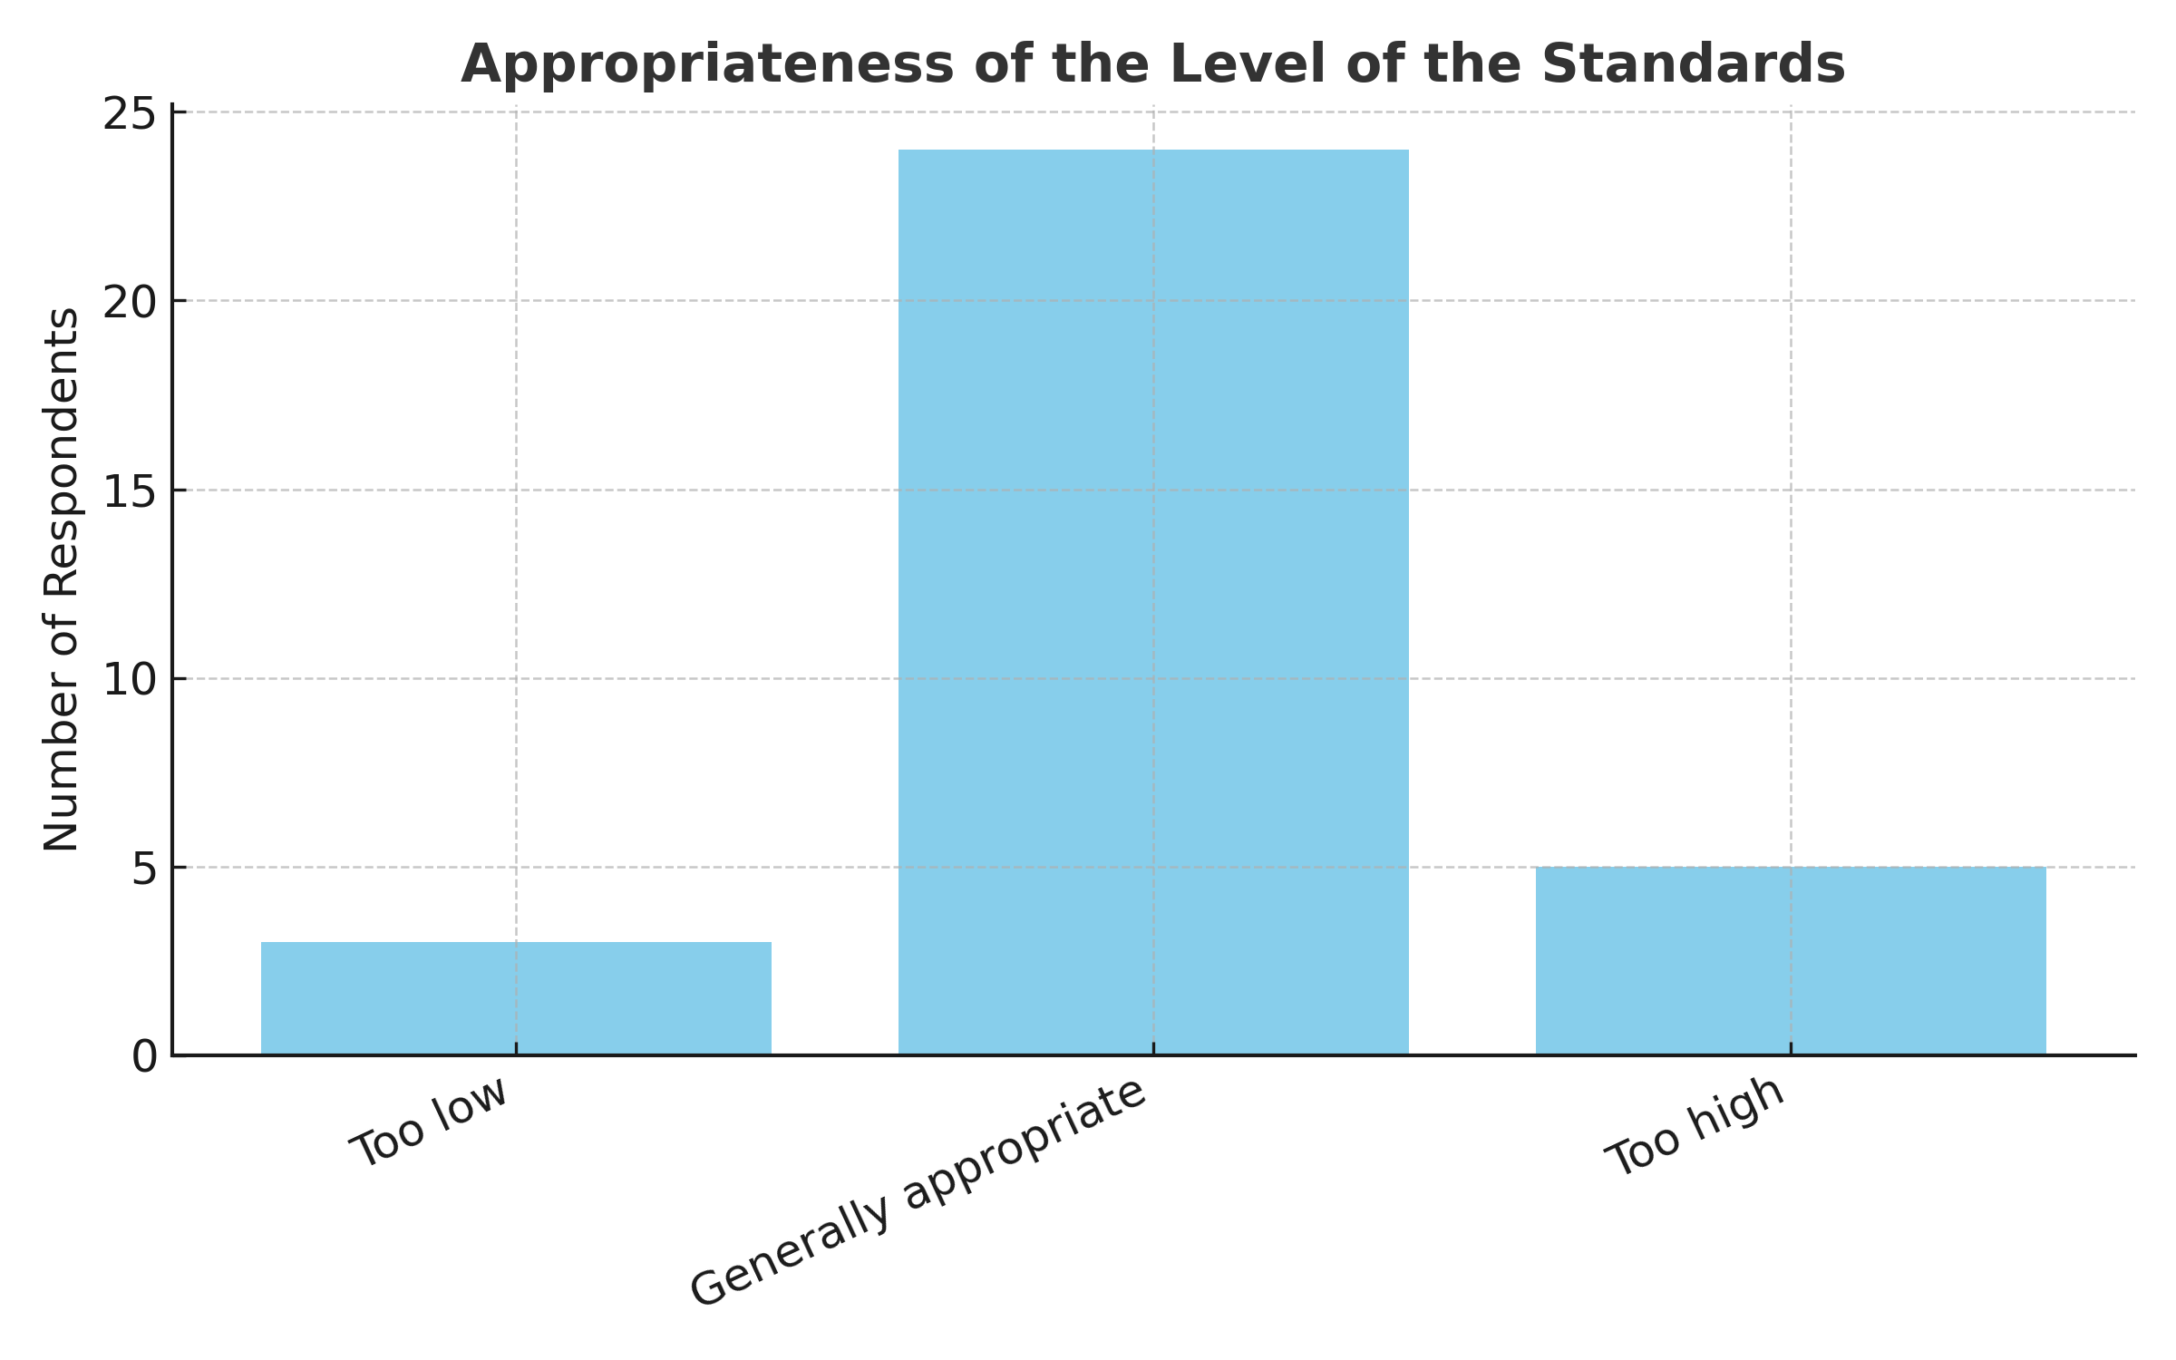

Table 6: Comprehensiveness
QUESTION: To what extent is Appendix B comprehensive (i.e., it covers all the educational content fellows need to be fully prepared for an entry-level job as a practicing clinical ethicist)?
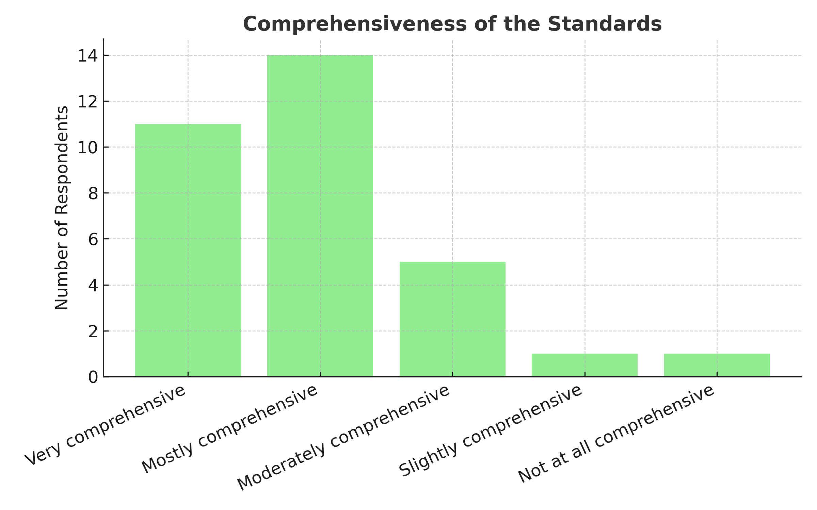

Table 7: Relevance
QUESTION: To what extent is the content of Appendix B relevant (i.e., it only includes content that fellows need to be fully prepared for an entry-level job as a practicing clinical ethicist)?
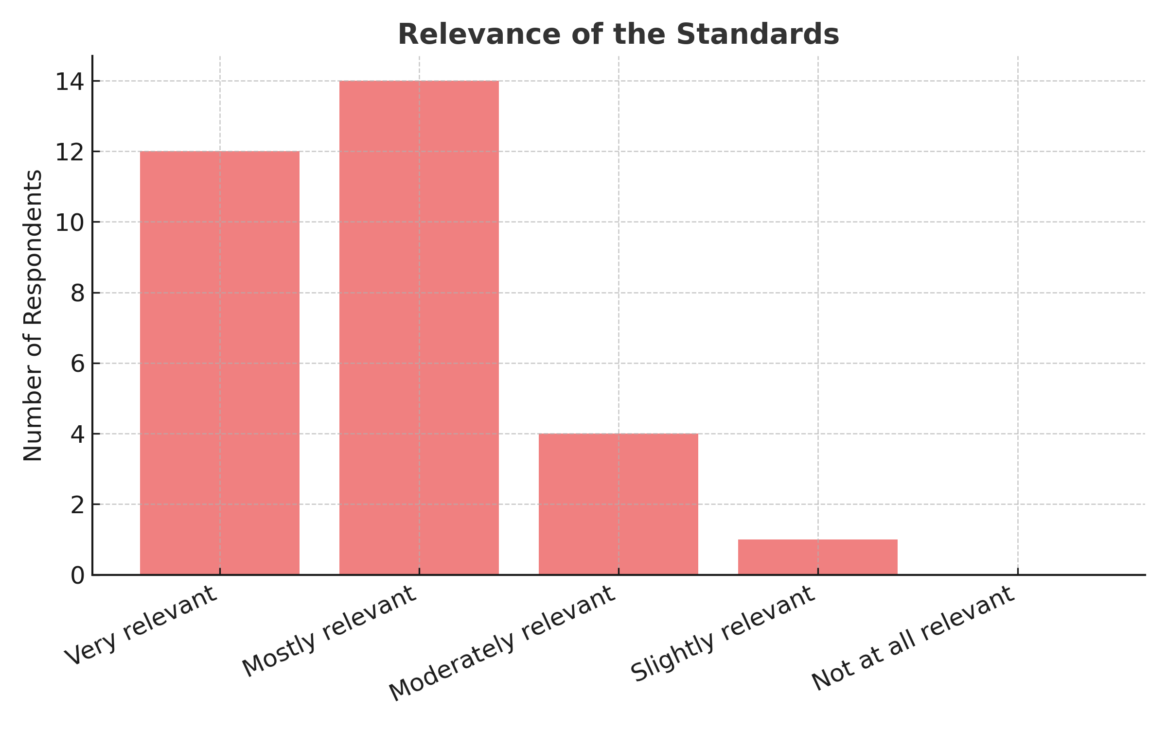

Table 8: Achievability
QUESTION: To what extent is the content of Appendix B achievable during a clinical ethics fellowship program (as described above in the introduction)?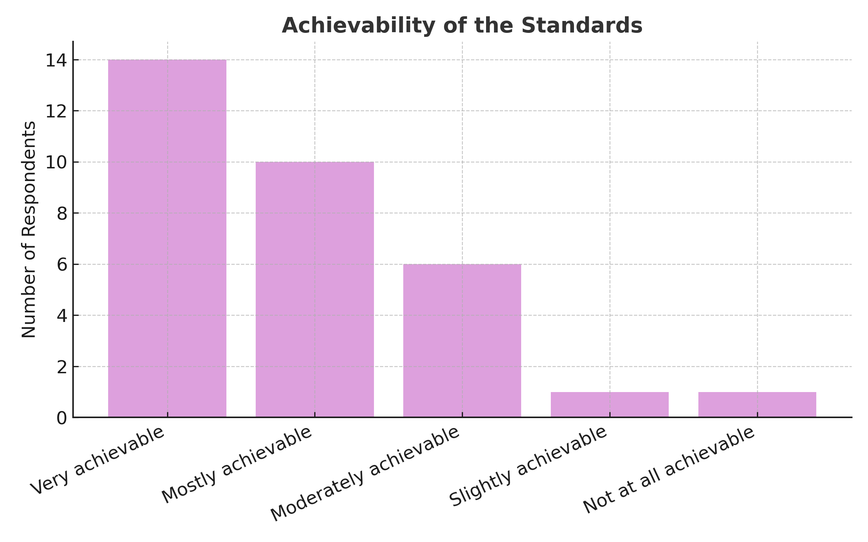

Table 9: Comments Received on Learning Outcomes
 | Number (%) of Learning Outcomes
0 critical comments or suggestions | 17 (23%)
1 or 2 critical comments or suggestions | 36 (50%)
3-5 critical comments or suggestions | 13 (18%)
5-9 critical comments or suggestions | 12 (17%)
10 or more critical comments or suggestions | 0 (0%)

Table 10: Summary of Common Types of Comments Received on Part 2
Type of Comment | Examples | COPACET Response and Rationale
Comments about the use of simulated learning experiences | Several commenters suggested strengthening the requirement for non-simulated learning experiences. For example, one commenter wrote, “the simulated learning requirement--EC.P.2., EC.P.3, IS.P.1-5, OS.P.1. A-E, E.L.P.1-4 all should also be non-simulated. If a program cannot support that, they may not be well-suited to take a fellow.” Another wrote, “totally disagree that you could become a competent clinical ethicist through simulated or scenario-based interactions only for domains of practice outside of case consultations.” However, several other commentators expressed concerns about the requirement to use non-simulated learning experiences because it may not be possible for programs to offer every learning experience to every fellow in actual practice. | Extensively revised and expanded the section on the use of simulated learning experiences. Specifically, we added to the list of learning outcomes requiring non-simulated learning experiences; we clarified that the listed learning outcomes require non-simulated practice experiences while performing ethics consultations; and we clarified that all psychomotor learning outcomes should be achieved through non-simulated supervised practice experiences where possible.
Comments suggesting that a learning outcome should be added | Several commenters pointed out gaps in the draft standards. For example, one commenter wrote, “There is no mention of equity or antiracism in the entire document…. Racism and racial injustice must be specifically recognized, combatted, and rejected as a matter of professionalism.” Another commenter wrote, “I was really surprised at the lack of attention given to developing skills and knowledge related to moral distress.” And one commenter wrote, “suggest you insist that a combination of virtual AND in-person exposure is required for trainees (not just all virtual consults).” | Added 3 learning outcomes and several sub-outcomes. These included additions relating to racism and other forms of discrimination, moral distress, managing stressors inherent to clinical ethics practice, and the need to perform in-person consults. Specifically, we added P.P.4., EC.P.3., SA.P.3., and sub-outcomes CK.C.1.D., F, and K., P.P.5.D., EC.P.1.G., and OS.P.1.F. We did not make changes in response to other suggestions (including the ability to perform community outreach, to perform legislative advocacy, to communicate with regulatory/ oversight personnel, and to participate in grand rounds) because, based on COPACET's research, these activities are not commonly included in the role of an entry-level clinical ethicist.
Comments suggesting that a learning outcome should be deleted | Several commenters suggested deleting specific learning outcomes, most often because they were not necessary for an entry-level clinical ethicist. For example, four commenters suggested that EL.P.4. was not an entry-level skill, while two commenters suggested that EL.P.5. was not an entry-level skill. Various concerns were raised about HS.P.1. (Spend time in various patient care environments including both acute and non-acute care settings), including concerns about it being vague and unclear. And one commenter suggested under CK.C.1. that knowledge of healthcare organizations, professional codes of ethics, and relevant health law were “probably more advanced than what might be expected in basic fellowship training.” | Deleted 3 learning outcomes: EL.P.4., EL.P.5, and HS.P.1. However, we did not delete the learning outcomes relating to healthcare organizations, professional codes of ethics, and relevant health law because, based on COPACET’s research, we believe these are essential cognitive learning outcomes for entry-level jobs. We also note that these knowledge areas are listed in ASBH's Core Competencies report.
Comments suggesting specific wording changes | Many commenters made suggestions for specific wording changes. These were very often one-off suggestions (i.e., made by only one commenter). For example, one commenter suggested changing “demonstrate knowledge” to “demonstrate mastery” in CK.C.1. Another commenter suggested replacing the word “method” with “framework” in EC.C.3.  One commonly suggested type of wording change was the suggestion to add language to specify a particular learning outcome in more detail. For example, one commenter wrote, under EC.P.2. (Perform case consultations across a wide variety of ethical content areas, patient populations, and clinical contexts), “While I agree with this requirement, as written I think it is insufficiently specific. I do think there should be a non-exhaustive list of content areas, patient populations, and clinical contexts, that one should expect from a fellow. Another commenter commented on CK.C.1.C. (Demonstrate knowledge of…. common ethical issues and concepts including those relevant to clinical ethics, organizational ethics, research ethics, and public health ethics), “What are the concepts and issues that should be included specifically?”  Other commenters suggested wording changes to address perceived gaps in the standards. For example, one commenter wrote, “The most important piece missing from the Standards as a whole is the need to learn about the unique value commitments that many hospitals have. This could be anything from the VA's ethics principles for AI and data use … to a faith-based hospital's Mission and values or the ERDs for Catholic hospitals.” | Made changes in response to some suggestions but not others. We discussed each suggestion and made changes when we thought that the proposed change would improve the learning outcome. When more than one commenter suggested changes to the same learning outcome, we took this as evidence that the learning outcome needed improvement and made changes accordingly.  We added more detail when we thought it was needed to clarify the meaning of a learning outcome. For example, we further specified EC.P.2. by including examples as follows: “content areas (e.g., end-of-life care, privacy and confidentiality, professionalism), patient populations (e.g., adult, pediatric, psychiatric), and clinical contexts (e.g., intensive care, surgical care, ambulatory care).” However, we chose not to provide a specific list of ethical issues and concepts that programs need to cover in their curriculum under CK.C.1.C. because we thought it more appropriate to allow programs the discretion to specify such details as part of their curricular development process.  We also chose to add more detail when a commenter identified an important gap. For example, in response to the comment about the unique values commitments of hospitals, we accepted the commenters suggestion to add the words, “and the organization's unique moral commitments" to CK.C.1.E (Healthcare organization and system structures, characteristics, types, components, policies). In other cases, we thought additional details were not necessary because the suggested content was adequately already covered under another learning outcome.
Comments questioning how learning outcomes will be taught or assessed | For example, one commenter wrote, under IS.P.4. (Exhibit skill in navigating power dynamics in healthcare interactions and aim to empower unheard voices), “This is an important skill, but how exactly will this skill be gained if there is no requirement for non-simulated experience?” Another commenter suggested, “Some of the objectives are not readily measurable (e.g., value the importance of).” | No changes. The standards specify that all psychomotor learning outcomes should be achieved through non-simulated practice experiences where possible, but other types of instruction may be used to fill limited gaps in trainees’ practice experience. For example, it may be necessary to supplement trainees’ supervised practice experience with other forms of instruction such as role playing or case-based interactive exercises. It will be the responsibility of each program to determine how learning outcomes will be taught.  Affective learning outcomes such as those that begin with “value the importance of” are required elements of CAAHEP standards. Affective learning outcomes are typically measured through one or more of the following methods: observation and assessments by faculty, trainee self-reports (like questionnaires or journals), and peer assessments. It will be the responsibility of each program to determine how learning outcomes will be assessed.
Comments suggesting that a particular learning outcome is not realistic because trainees do not perform the relevant skill in actual practice | For example, one commenter wrote, in response to the learning outcome OS.P.1.A. (Demonstrate the ability to…participate in clinical rounds), “remove - depending on the institution, is may not be within the ethicists workflow to participate in rounds... we should not make such a detailed assumption about how others do/should work.” Another commenter wrote, in response to OS.P.C. (Participate in the development, review, and revision of policies relating to ethics in healthcare), “This learning will depend on the institutional acceptance of the trainee in policy formation.” A third commenter wrote, in response to OS.P.1.E. (Serve as the clinical ethics representative to specific organizational committees or services), “Fellows may not be invited to be the ethics rep to organizational committees. This depends on the institutional structure.” | No changes. The skills identified in these comments are commonly required of entry-level clinical ethicists. If it is not possible for programs to offer trainees the opportunity to develop these skills in actual practice, the learning outcomes can be achieved through simulated learning experiences such as role playing or case-based interactive exercises. This is explained further in the introduction to Appendix B under “Use of Simulated Learning Experiences” and “Institutional Differences in Service Delivery Models.”
Comments about competencies beyond ethics consultation and/or organizational ethics competencies | A few commenters suggested that competencies beyond ethics consultation and/or organizational ethics competencies should be expanded, while several others suggested these competencies set too high a bar and should be cut back. For example, one commenter wrote, “Appendix B … does a good job listing the various competencies for professional clinical ethics consultation. However, the sections regulating the other activities of the clinical ethicist (education, policy development, scholarship) are comparatively thin.” But several other commenters suggested cutting or softening various standards relating to organizational ethics. As one commenter wrote, “In general, Appendix B is ambitious, but I think appropriately so. It feels ambitious due to the multiple areas of skillsets addressed, such as skills for both the individual ethics consults and organizational ethics but also for general leadership practices. Given this breadth, I would want to ensure that these standards accurately reflect the common expectations for the entry-level roles in clinical ethics.” | Made changes in response to specific comments. Appendix B includes many learning outcomes that go beyond ethics consultation and that relate to organizational ethics, especially under the content domains "other ethics support," "ethical leadership," "quality improvement," "health systems," and "scholarly approach." In response to the comment suggesting that the competencies beyond ethics consultation were “thin,” we systematically reviewed various resource documents such as ASBH’s Core Competencies for Healthcare Ethics Consultants and the draft Canadian Ethics Fellowship Competency Framework, attempting to identify gaps. We did not identify any significant gaps beyond the specific gaps identified by commenters, which we addressed separately. Regarding the question of whether it is common for entry-level clinical ethicist positions to require organizational ethics competencies beyond ethics consultation, COPACET has researched this question and determined that it is quite common. Indeed, these skills differentiate the role of the clinical ethicist from that of a healthcare ethics consultant.
Comments expressing concerns about lack of consensus in the field | One commenter wrote in response to P.C.1. (Explain the ethical norms and standards for clinical ethicists), “What are the ethical norms and professional standards? Do these exist?” Another commenter wrote, “We do not believe there is consensus about the ethical norms and standards for clinical ethicists managing COI and acting within professional boundaries.” Another commenter wrote, in response to P.P.2. (Decline requests to act outside the scope of the clinical ethicist’s role), “As scope varies throughout institutions based on the role of the ethicist, how will this be standardized?” | Made wording changes and added a new learning outcome to address the lack of consensus in the field. We agree there is no consensus in the field of clinical ethics with respect to many topics. But COPACET believes that it is appropriate to establish learning outcomes relating to important topics about which there a lack of consensus. It will be up to individual programs to determine the specific content they teach, including content about the extent to which there is consensus or controversy in the field. To make this clear, we added to P.C.1., “including the level of controversy that exists regarding these norms and standards.”). We also added a new learning outcome: “SA.P.3. Critically evaluate the level of agreement or controversy that exists about a given clinical ethics topic or practice.”
Comments expressing concerns about specialized training programs with limited scope (e.g., pediatrics) | One commenter wrote, “currently in the U.S. some fellowship programs in clinical ethics are issue- or population-specific (e.g., transplant ethics fellowship, pediatric-only fellowship). It is unclear to me how such fellowships would fit into the general model proposed by COPACET whereby every graduate is expected to have achieved competence in the cognitive, psychomotor, and affective skills/behaviors of the standard range of consultative activities.” Another commenter wrote, “When you move through the table to those specific competencies, it requires programs to provide experiences in a non-simulated way and these in particular might pose a significant challenge for many programs (a pediatric institution for example, or an exclusively adult affiliated institution).” | No changes. COPACET standards are intended to address the competencies that are often required of entry-level clinical ethicists. Therefore, we think it is important for clinical ethicists to be trained as generalists (though some programs may provide specialty training in addition to generalist training). A program in which fellows perform consultations in only one clinical area (e.g., surgery or pediatrics) would not meet COPACET standards. Those programs could arrange for fellows to gain consultation experience at a partner site order to meet this requirement.
Comments about participation in scholarly activities | We received 6 comments about SA.P.6. “Demonstrate significant participation in one or more scholarly activities (e.g., conference presentation, empirical or normative research project, publishable article, quality improvement initiative, curriculum development).” Half of these suggested the standard was too low (e.g., “It seems to me the standard regarding scholarly activities should be more elaborate and much higher” and “Consider making the requirement that something must be submitted for publication during the time of fellowship.”) The other half thought the standard might be set at too high a level (e.g., “We have some concern about the requirement for ‘significant’ participation in scholarly activities, depending on how that word is interpreted and/or operationalized.… We believe that it should suffice for trainees to be able to play a ‘substantive’ role in scholarship” and “I don't know that all clinical ethics fellows entering an entry-level job staff clinical ethicist position need to be able to do this.”) | No changes, except we changed the word “significant” to “substantial.” We note that while some commenters thought the bar should be set higher and others thought the bar should be set lower, most commenters thought the bar was set at the right level. COPACET believes a scholarly approach is important for all clinical ethicists, and that it is important for trainees to participate in scholarship and to develop a scholarly approach. We think it is appropriate to allow the programs latitude to determine the type of scholarly activities they require.

Fox E, Wasserman JA. Clinical Ethics Fellowship Programs in the U.S. and Canada: A Descriptive Study of Program Characteristics and Practices. Am J Bioeth. 2025 Oct;25(10):51-66. https://www.tandfonline.com/doi/pdf/10.1080/23294515.2024.2388516
Kitts, M., Finnegan, T., Gariti, A., Smith, J. N., & Terris, C. (2025). Keeping Fellows in the Frame: The Importance of Including Clinical Ethics Fellows in Fellowship Standardization. The American Journal of Bioethics, 25(10), 80–82. https://doi.org/10.1080/15265161.2025.2543710 ; D. Goff, A., J. Dougherty, R., & Robertson-Preidler, J. (2025). Accreditation Standards Must Protect Trainees: Creating Ethical Fellowship Programs. The American Journal of Bioethics, 25(10), 77–79. https://doi.org/10.1080/15265161.2025.2543733).

