**FLORIDA ARCHAEOLOGY**

**AND**

**THE SWIFT CREEK MIDDLE SCHOOL**

**Louis D. Tesar, Archaeologist**

**DOS/DHR/Bureau of Archaeological Research**

**July 31, 2013**

Archaeology is the part of anthropology that studies people by investigating the remains that they have left; the record of where, when and how they lived and interacted with other people. People trained to conduct such studies are known as archaeologists. Unlike the characters seen in the Indiana Jones movies, modern-day archaeologists are expected to conduct and document their excavations in a manner similar to that of a crime scene investigation. Because of the controlled manner in which archaeologists excavate sites and document what they reveal to permit their interpretation, archaeologists have been referred to as time detectives.

The Florida Department of State, Division of Historical Resources is Florida’s primary historic preservation agency. Its authority and mission are contained in Chapter 267, *Florida Statutes*. Its bureaus include the Bureau of Archaeological Research, whose duties include assisting state land management agencies on archaeological issues, issuing permits for archaeological research on state-owned and -controlled land, and helping educate and advise the public on archaeological resource management, identification and interpretation of archaeological sites and material.

What is now known as the State of Florida in the southeastern portion of the United States of America has been occupied by people for more than 13,000 years. We know this because of more than 100 years of archaeological research. We do not know what the prehistoric natives of North America called themselves. The Creek, Seminole, and Miccosukee moved into Florida from Georgia and Alabama primarily during the 1700s, following removal of native people living in Florida during the time of Spanish exploration and colonization.

For convenience, archaeologists identify archaeological cultures based primarily on the classes of artifacts that they produced. Artifact types and styles changed through time in response to cultural change. Thus, for Europe you will read about the Bronze Age and the Iron Age, while in Florida (and parts of Georgia and Alabama) you will read about the Paleoindian period, the Early, Middle and Late Archaic period, the Deptford, Swift Creek, Weeden Island and Fort Walton periods, the historic Spanish mission period, and so forth. The prehistoric cultures generally are named for the sites at which they were first identified. The names for artifacts generally follow the same naming system.

Information on recorded archaeological sites and historic properties is maintained by the Department of State, Division of Historical Resources, Florida Master Site File. The Block-Sterns site is named for the two primary land owners—the Block and Sterns families—of the property at the time that it was recorded. The site number, 8LE148, means that it was the 148th site recorded in Leon County, Florida; Florida is the 8th state alphabetically in the national system; and, LE is the abbreviation for Leon County.

The Block-Sterns site (8LE148) occupies many acres and has been divided into subareas linked to the archaeological culture areas represented. The oldest remains belong to the Paleoindian period of 13,000 years ago and are located around and within the shallow areas of Lake Piney-Z, a partitioned portion of Lake Lafayette. The area immediately west of the middle school tract was occupied primarily during the Middle Archaic period of 8,000-4,000 years ago, while the southwestern area near the railroad and lake edge was occupied primarily during the Weeden Island period of 1500-1000 years ago, and the hill crest east of the middle school was occupied by Apalachee Fort Walton period people from 1000-500 years ago.

The central portion of the site where the middle school is located was occupied prehistorically primarily by people identified by archaeologists as representatives of the Swift Creek culture, for which the school name was chosen. The Swift Creek culture developed out of the Deptford culture about 100 A.D. and about 450 A.D. evolved into the Weeden Island culture. The transition is recognized by changes in ceramic vessel and stone tool styles, as well as by other classes of artifacts and changes in settlement patterns and burial customs. The following is a brief summary of some of what we know about the Swift Creek portion of the Block-Sterns site.

Because Swift Creek people made and used mostly items of fiber (i.e., cloth, string, nets, baskets and so forth), wood (i.e., homes, dugout canoes, bows, spears, etc.), and leather (i.e., various animal hides) that decay when abandoned, most of what we know about those people is based on an analysis of stone and ceramic items, including knives, scrapers, spear and arrow points, cooking and storage pots and serving dishes. The most easily recognized ceramic vessels of the period are those that had their exterior surfaces impressed with carved wooden paddles when the ceramic clay was still soft. The most common paddle impressed vessel style of the period is known as Swift Creek Complicated Stamped.

The portion of the site area scheduled for middle school construction activities was archaeologically excavated under the direction of B. Calvin Jones, an archaeologist working for the Florida Division of Historical Resources, Bureau of Archaeological Research. Since the project was essentially unfunded, his crew consisted of volunteers who wanted the experience of working on an archaeological research project. Because the project began three months before middle school construction work was contracted to begin, after excavating a series of test pits to determine the site soil characteristics, it was determined that project time constraints required the abandonment of material in the disturbed plow zone—the property had been farmed for nearly one hundred years. A bulldozer scraped away surface vegetation and plow-zone soil along with the artifacts that it contained. A concentration of relatively undisturbed cultural pit features occurred in the project area toward Lake Piney-Z.

Cultural pits and their contents are somewhat like time capsules—that is they contain material dating to a specific event or layered series of events. Thus, most of the project data salvage activities focused on archaeologically excavating pit contents. When recognized, the contents of pits were excavated in depositional layers and the exposed cultural material mapped and photographed for each layer. By documenting the contextual association of the material in the pits we were able to deduce the cultural activities involved in their formation, the manner in which various stone and ceramic artifacts were made and used, and the manner in which they changed through time as new styles were introduced. We also learned something about prehistoric trade and exchange activities from material originating in Georgia, Alabama and other states, as well as from areas along the Florida Gulf coast and westward to the Apalachicola River Valley.

The project documented 161 cultural features of which 79 were hearth, trash and ceremonial pits. We collected over 80 cubic feet of cultural material; over 40,000 artifacts and thousands of animal bones and plant remains. The project report written by B. Calvin Jones and Louis D. Tesar was completed in 1996 and is available for public review at the Florida Master Site File (Rpt. # 04644). The excavated material continues to be studied by other researchers and some of it is in public exhibits to help people learn more about Florida archaeology—its methodology and the cultural remains of past people and the manner in which those people lived.

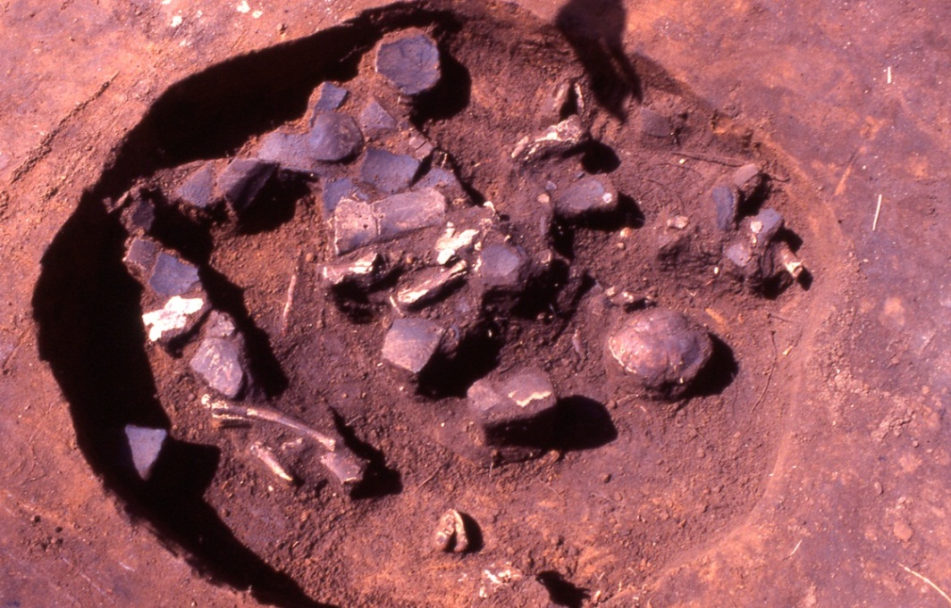One of the Block-Sterns site pit features, recorded as Pit Feature 4, is used here as an example. While the top portion of the pit was lost to agricultural plow disturbance, its remaining contents show the importance of docu-menting the associa-tive context of cultural material found in such pit features. While most of its artifacts are sherds (broken pieces) from a single cooking pot, the pit also included deer leg bones, a turtle shell, sheets of mica, and stone tools.

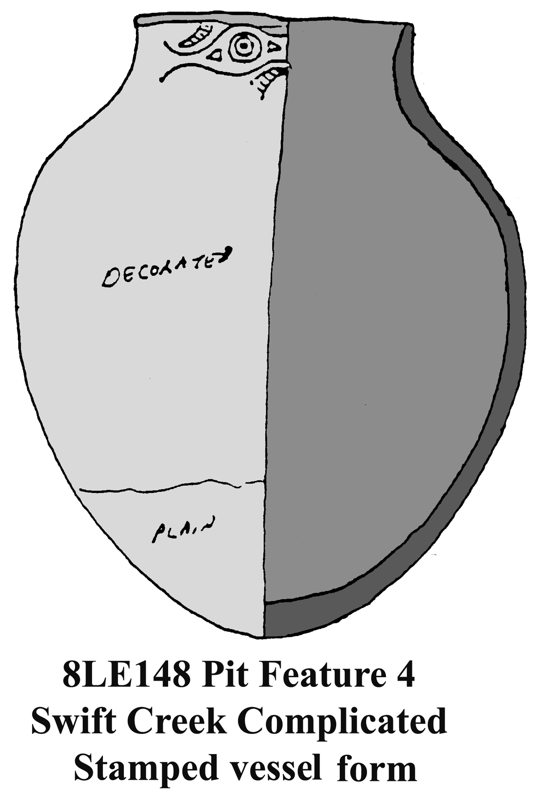 The two sheet mica pieces (center and left silver-white reflecting surface in above photo) came from the mountains in Georgia. Their shape indicates that they began as a single piece that was separated between two of its sheets and deposited in the pit. Swift Creek people used mica as a reflector (like a mirror) or cut its layers into flat image outlines of birds and other animals or into geometric forms for ceremonial use. The turtle shell with its bottom removed was used as a serving bowl and discarded in the pit at the end of the ceremony. It and the many others found in other pits were carefully placed with their top up in the pit; and not simply thrown into the pit as trash. The deer shoulder blade (scapula) and leg bones indicate the front leg of a butchered deer was cooked and eaten near the pit. The deer bones were randomly placed in the pit, much like discarding animal bones at a family cook-out. The stone tools were primarily unmodified, sharp-edged flakes used as knives intended to be discarded at the end of their use, much like our disposable razor blades. They are known as expedient tools in contrast to those made for continued use and maintenance. They were probably used to cut meat from the cooked deer leg; and, some of them may have been used to ritually cut ceremony participants.

The pottery is from a Swift Creek Complicated Stamped bell-shaped cooking vessel that held about 2-3 gallons. It apparently broke or was intentionally ceremonially broken and discarded in the pit. The vessel had earlier developed a stress crack that was successfully repaired. We know this because of the two sherds in the pit that are joined together with drilled holes on each side of the crack. While the evidence had burnt or weathered away on this vessel, from other archaeologically recovered vessels and replication studies we know that pine sap served as glue and that wet sinew generally was used to bind cracked vessels, since it shrinks and becomes tighter when it dries. Sinew, obtained from deer muscle tendons, was also used to bind stone points to their shafts, knives to their handles, and so forth.

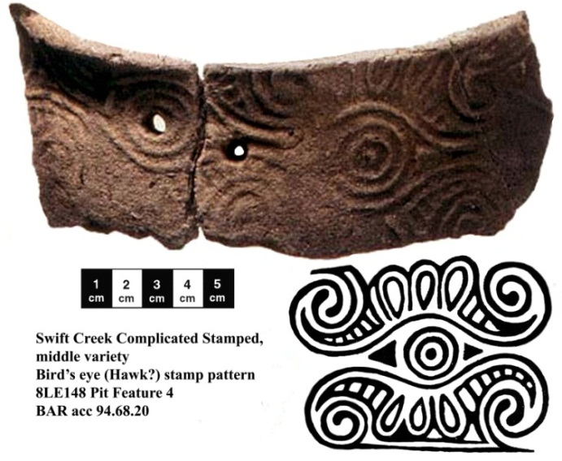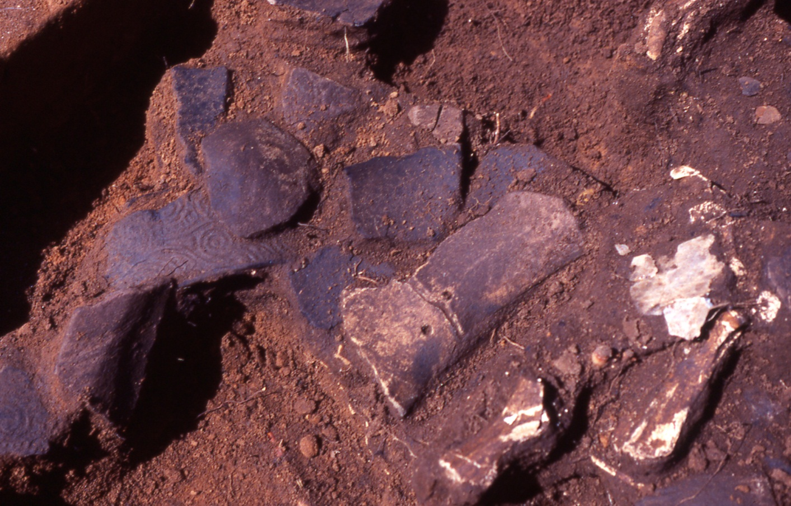If someone else had dug Pit Feature 4 without documenting the artifact contextual association and brought the pit artifacts to an archaeologist for identification and comment, while the archaeologist could identify the repair holes, he/she would have no evidence to determine whether the repair was successful or whether the vessel broke during an attempted repair. The complicated stamp pattern on the vessel represents a bird eye, probably that of a hawk based on the feather pattern around the eye. Hawk-head shaped stone pendants also occur at Swift Creek sites.

The stamped decoration was made with a carved wood paddle. We know this because the paddle developed a drying crack that was revealed by a hairline ridge formed by clay that squeezed into the crack when the paddle was pressed against the vessel surface. The decoration was carved into the paddle surface. When the paddle was pressed against the then soft clay vessel surface the clay squeezed into the cut areas and was displaced by the raised areas. That made the vessel clay surface more compact and helped finish bonding the coiled clay material used to make the pot. Because the clay was still soft when the paddle was pressed against its surface the design was subject to being smeared or flattened from handling as the vessel was turned to stamp its remaining exterior surface. After the decoration had been applied the vessel was set aside to dry, as it had to be completely dry when it was placed in an open pit fire to change the clay to ceramic. Any moisture in the clay would turn to steam and its resulting expansion would crack or shatter the vessel during the firing process.

The point of all this is that by carefully recording the association of the artifacts in Pit Feature 4 we learned that a cooking vessel with a hawk eye surface decoration had been repaired before being used in a ceremony at which it was accidentally or intentionally broken. We also learned that a turtle shell was fashioned into a serving bowl and following its use was intentionally placed in the pit with the shell-side up as it would have been when the turtle lived. (Similarly modified and deposited turtle shells occurred in many other pit features at the site and have been found at other sites.) Further, a front leg and shoulder area of a butchered deer was cooked and after the meat was eaten the bones were discarded in the pit. Finally, the pit contained two large sheets of reflective mica that likely was obtained in exchange from people in central Georgia and for unexplained reasons was discarded in the pit.

By studying the artifacts and the contextual association in Pit Feature 4 and in the 78 other pit features, as well as in the site midden remains, we gained more information on the manner in which Swift Creek culture people made and used their artifacts, including the manner in which they resolved problems linked to that manufacture and use. The classes of material that occurred in repeated patterns in the pit features suggest that most of the pits were prepared and used as part of ceremonial events likely directed by religious leaders using the nearby earthen platform mound.

The features appear to be linked to rites of passage, such as a young male becoming recognized as an adult following his first successful hunt. The many unbroken arrow points found in many of the pits likely were used in successful hunting activities and sacrificed/discarded to commemorate the events. Food remains and other artifacts in the pits indicate that feasting was an important part of the ceremonial event. Feasting has also be documented as an important aspect of ceremonial events among historic natives in the Southeastern US.

About ten years before the project, the property owner let the FSU Department of Anthropology conduct an archaeological field school at the site and one of their excavation units was in one side of the mound (Mound 2) on the middle school tract. The excavation revealed construction fill and structural level clay floors and was not a human burial mound. The middle school project holding ponds were redesigned to permit preservation of the mound and no excavation of the mound occurred during the middle school project.

Unfortunately, a couple of years after the project, it was learned that someone illegally looted the central portion of the mound, thereby destroying the cultural data contained in that portion of the mound. Looting an archaeological site is the same as tearing pages out of the only copy of a hand-written journal or diary of the people who lived at and formed the site. The perpetrators of that illegal looting activity are rightly called “thieves of time.”

The people identified with the Swift Creek archaeological culture occupied much of Northwest Florida (west of the Aucilla River) and extended inland into southwestern Georgia and southeastern Alabama. While Swift Creek people shared common traits they did not represent a single native tribe, but rather groups of people with a common religion and social system. They were also part of a larger exchange network in which finished items and raw material (and ideas) were exchanged. The network extended from Illinois to central Florida and from the Atlantic Ocean to the Mississippi River Valley. It was somewhat like today’s European Common Market in which people with different languages and customs decided to peacefully exchange material and goods that each desired to acquire. Nonetheless, archaeological evidence also shows that they periodically went to war with each other, perhaps as a result of over-population or depletion of essential natural resources.

While some of the stamp patterns likely had religious significance, it has been suggested that many of the patterns may represent family or clan symbols. Regardless, hundreds of different Swift Creek Complicated Stamped patterns have been identified. Further, some vessels or vessel fragments made with the same paddle have been found at different sites, suggesting trade and/or movement of people from one community to another. Also, at site 8LE148 parts of different ceramic vessels made with the same paddle stamp were found in different pit features.

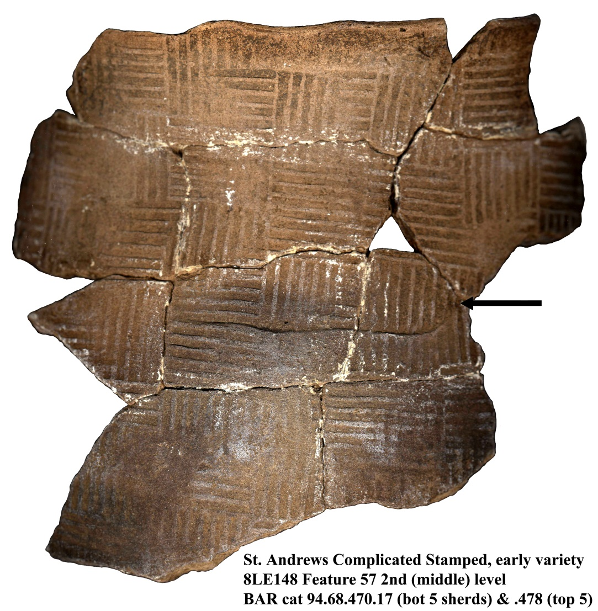In addition to Swift Creek Complicated Stamped surface decoration, Swift Creek people also made vessels using other style surface patterns. These include the type known as Crooked River Complicated Stamped, which features a zigzag chevron stamp pattern, and St. Andrews Complicated Stamped, which features in one style rectangular groups of alternating parallel lines that suggest a thin lathe basket surface. Examples of both types were found at the Block-Sterns site.

Somewhat surprisingly, until the functional reason was deduced, the sherds from one St. Andrews Complicated Stamped vessel exhibit rectilinear pattern impressions and a curved paddle end (see above photo). The curved paddle end represents a solution to vessel shape distortions that can occur when pressing the flat paddle surface against the soft clay vessel surface. The vessel curve can be accidentally flattened and pressing the curved paddle end against the distorted vessel interior facilitates restoration of the vessel form.

There are different ways to convert clay to ceramic using pit fires. The two primary ways used by Florida’s Swift Creek people and their ancestors and descendants are known as oxidation and reduction firing. In an oxidation firing event the dried clay vessels are gradually heated and then placed directly on a bed of coals or broken potsherd layer that includes maintenance of a ring of fire around the vessels until their clay becomes glowing red as the chemical change occurs that converts the material to ceramic. The interior and exterior surface of vessels placed upright or on their side become light colored beige, reddish, or brown depending on the amount of iron and other minerals in the clay. If the firing event is incomplete and the vessel breaks, the break will reveal a dark colored central area between the lighter colored outer and inner surface. Reduction firing begins in the same way but after the vessels have been placed in the fire pit they are covered with twigs and grasses, and perhaps dried Spanish moss to restrict the air (oxygen) reaching the vessel surface and this results in vessels with a gray to black surface color. The third method is another variation on the first open pit firing in which the vessels are placed upside down which results in a light colored oxidized exterior and a dark colored reduction fired interior. Interestingly, Swift Creek cooking pots often have reduction fired interiors.

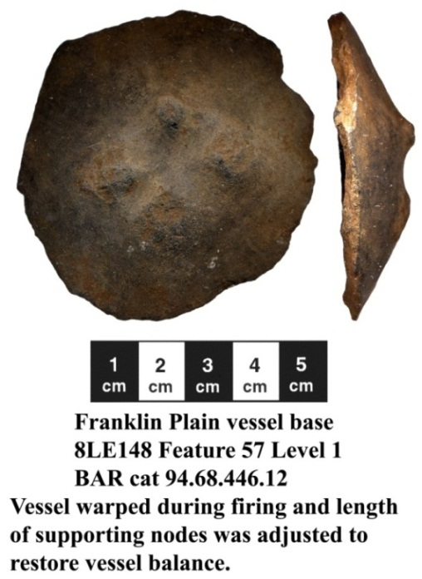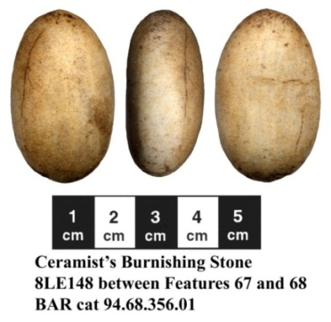 When a vessel surface becomes leather dry, a stone pebble can be repeatedly rubbed over its surface until it becomes compact and glossy. This is done on the interior of vessels that are used to contain liquid and slows the absorption of moisture by the vessel. Cooking vessels frequently have pebble burnished interior surfaces. The exteriors of plain undecorated vessels, such as Swift Creek period Franklin Plain vessels often feature exterior burnished surfaces that almost appear polished once they have been fired. The process also leaves overlapping pebble surface impressions that somewhat resemble the whittle marks of a wood carver. After a period of use, the micro-abrasion of the sand-tempered ceramic clay results in surface polish on the stone pebble tool—called a ceramist’s burnishing stone.

Uneven heating of a ceramic vessel surface can result in the occurrence of stress cracks. Native Americans developed solutions for various problems. A solution to stress cracking was seen in the Pit Feature 4 joined vessel sherds and the solution described. If a clay vessel becomes too hot when it is being fired its material softens and its shape may warp changing its form and balance slightly. An example of a solution to restore the balance of a vessel that warped during firing is shown here. It is the base of a Franklin Plain vessel that had the length of three of its four podal supports adjusted to so that the vessel would remain upright. Making the support adjustment also tells us that the vessel was intended for use on a firm flat surface, such as a shelf or compact clay floor, since without corrective modification the bottom of the vessel could have been pushed into soft sandy soil or nested in a shallow hole and used that way.

The making of ceramic vessels was a learned skill. When Europeans arrived and began recording their observations on various North American native people they consistently noted that ceramic vessels were almost exclusively made by native women. We believe that custom extended into the past. Thus, Swift Creek culture women likely made the ceramic vessels used by members of their family. However, woodworking has consistently been a craft conducted by men as was the fashioning of stone tools. Thus, we believe that Swift Creek men designed and fashioned the carved paddles used to make surface impressions on the vessels made by women. Further, repairs to vessels were also activities likely conducted by men.

As with our own culture until the late 20th century, most cultures of the World assigned some tasks to men and others to women. The making of domestic items, like ceramic vessels, baskets, woven material, and the like, along with food preparation and the care of young children generally was performed by women, while making weapons and tools and using them to make homes, dug-out canoes, and other items of wood, bone and shell was the work of men, as were hunting and the catching of large fish. Children assisted the women in the gathering of shell-fish and wild plant foods and material to make string and cord, and in other domestic tasks.

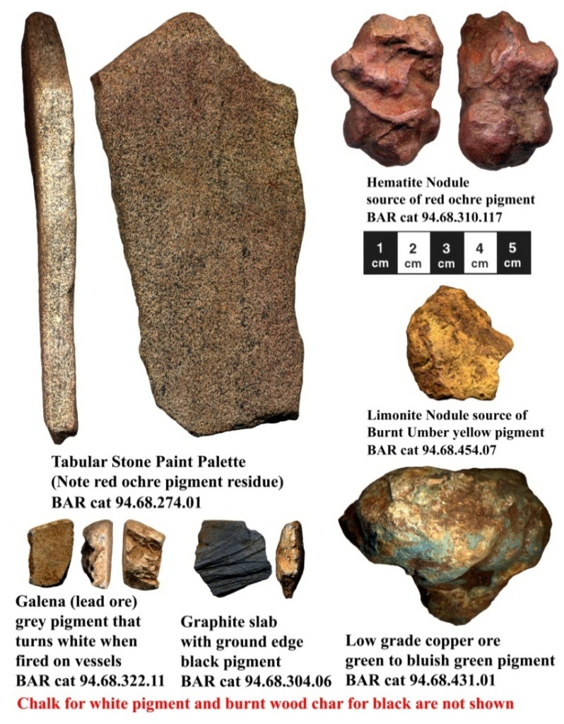Judging by the range of pigments found at the Block-Sterns site and at other Swift Creek sites, they painted many objects commonly used by them, as well as themselves during special ceremonial events. Among minerals they used chalk to make a white pigment, charcoal and graphite for black colors, lead ore (galena) for a dark grey pigment (that turned white if painted on a ceramic vessel that was then fired). Limonite was used for yellow to burnt umber colors, while red ochre ranged from brownish brick red to vermillion colors. Copper ore was imported to obtain green, bluish green and blue colors. They also used plant dyes to produce colors ranging from yellow through various brown color hues.

Swift Creek people in Florida did not have iron or other metal tools. As did their ancestors, they made their spear and arrow heads, knives, adzes, axes, drills, scrapers and shaves primarily of chert (silicified limestone) or fossil coral. They also fashioned animal bones into fishing spear points, awls, and so forth. Further, people living near the Gulf of Mexico made tools and containers using marine conch shells, and along with other items they traded for ground-stone basalt celts (a type of ax) made by native people living in Georgia and interior states. People living inland in river valleys, such as the Apalachicola-Chattahoochee River, made beads, spoons and other items using fresh water clam shells.

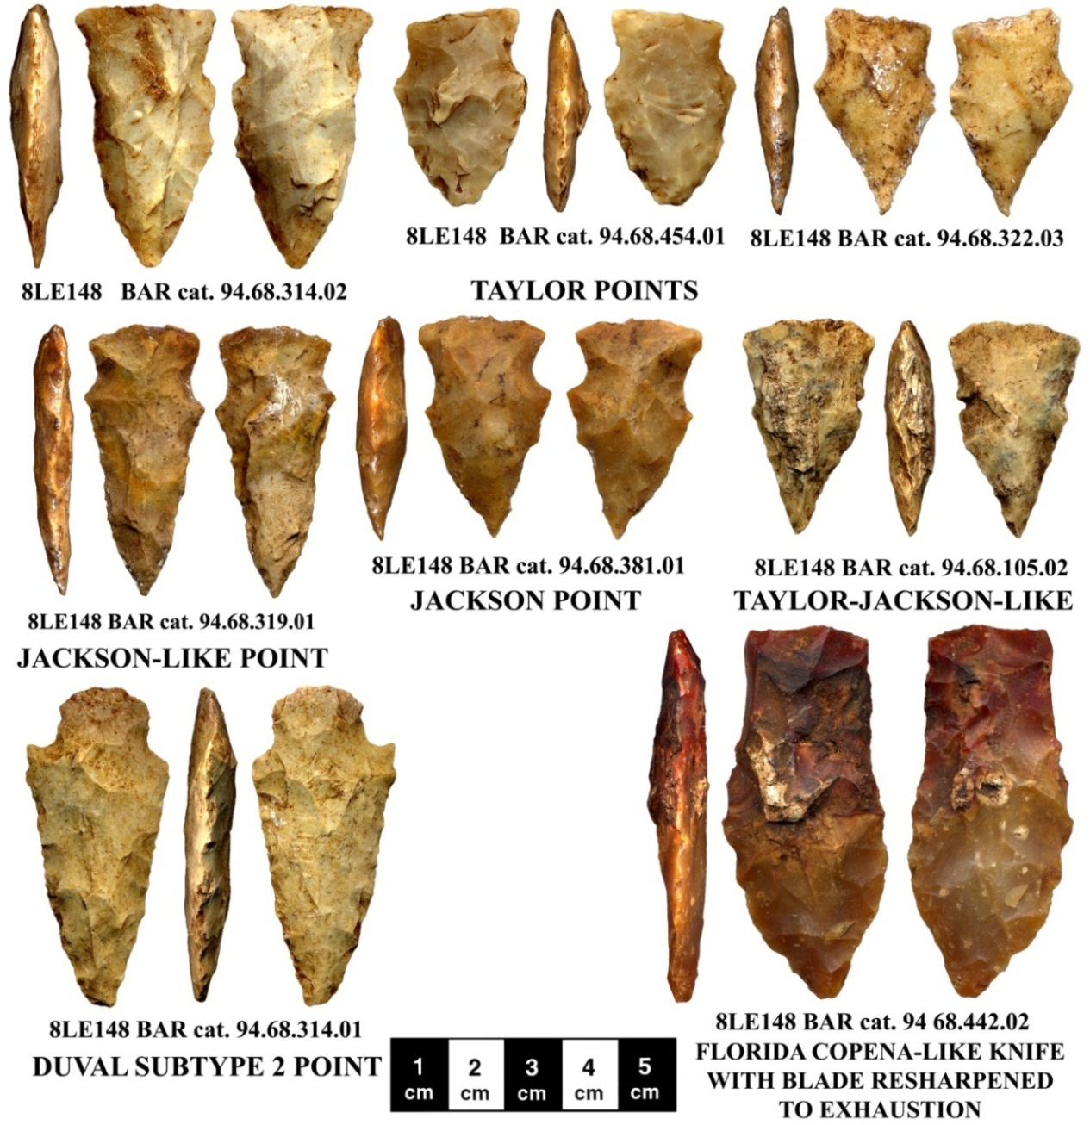The transition from using spears and atlatl darts as weapons and for hunting began with the introduction of the bow and arrow during Swift Creek times and spread across Eastern North America. We do not know where in Eastern North America the bow and arrow was invented, but its spread was rapid and included similar shaped arrow points. The form and size of arrow points changed as hunters sought to improve the effectiveness of the arrows. Generally the size of the points became smaller through time.

At the Block-Sterns site and other Northwest Florida Swift Creek sites, the style of point known as a Taylor Point was the most common. Taylor Points are generally triangular shaped with shallow corner notching shaping an expanding flat-based stem and producing small blade shoulders. The variation in the point base and other point attributes indicate that the point form had not yet become standardized at the Block-Sterns site; or, that a flint knapper used that variation to distinguish his points from those made by others. Indeed, many locally made Taylor Points and Copena Knives have sloping rather than the horizontal bases of the described types.

The styles known as Jackson and Duval Points also occur but did not become common until the end of the period when Swift Creek transitioned into early Weeden Island. Jackson Points have shallow side-notching and a rounded base, while Subtype 2 Duval Points have a narrow stem and generally rounded base. Here also the point form was not as standardized as it became at later early Weeden Island period sites.

Block-Sterns site people also made various stone knife forms. One was the Columbia Projectile Point/Knife (PPK) which has a base like a Taylor Point and a longer blade. Another was the Copena bifacially flaked knife. The Copena Pentagonal Knife is copied from contemporary knife forms of people living along the Chattahoochee River above its fall line. The name is derived from two of their important trade items—copper and galena. The point style was probably copied from knives of traders coming from the Copena area. The examples found at Block-Sterns are made of locally obtained chert.

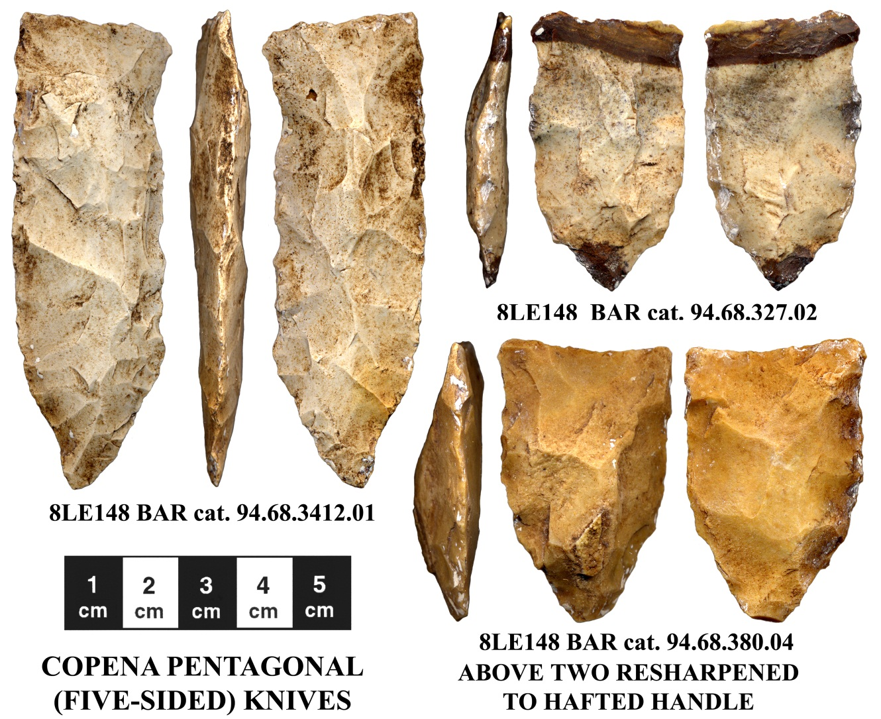Taylor, Columbia, Jackson, Duval and Copena points and knives are all bifacially flaked, which means that they were made with flakes removed from two sides. They were made by knapping, which is the term used to refer to detaching flakes by percussion with a hammer stone or wood or antler billet, although some pressure flaked edge retouching also occurred. The sharp basal edges of these points and knives usually were dulled for hafting, which means being bound to an arrow shaft or knife handle. When the knife blade became dull it was resharpened by detaching more flakes. Resharpening was repeated as needed until the blade became too short, as it neared the handle, for continued practical use (see above right examples). It was then unfastened from the handle and replaced with a new knife blade.

The broken bases of many arrow points were discarded at the site. These are the result of shot arrows striking a firm surface and the kinetic energy bending the arrow shaft. Since stone does not bend, the arrow points broke across the hafted area upon impact. The arrow shafts were brought back to the site where the broken base was removed and a new point fastened to the shaft. Replication studies have assisted in recognizing and properly interpreting this sequence of events. The distinctive form of break across the point base is known as a “bend break.”

The pale yellow to yellowish brown colored translucent chert found exposed in the dissolved limestone basin of Lake Lafayette near the Block-Sterns site likely contributed to the establishment and maintenance of the site. The naturally glass-like stone was relatively easy to knap and likely also served as a trade item to people living in areas where only poorer quality stone was available to fashion projectile points, knives and other tools.

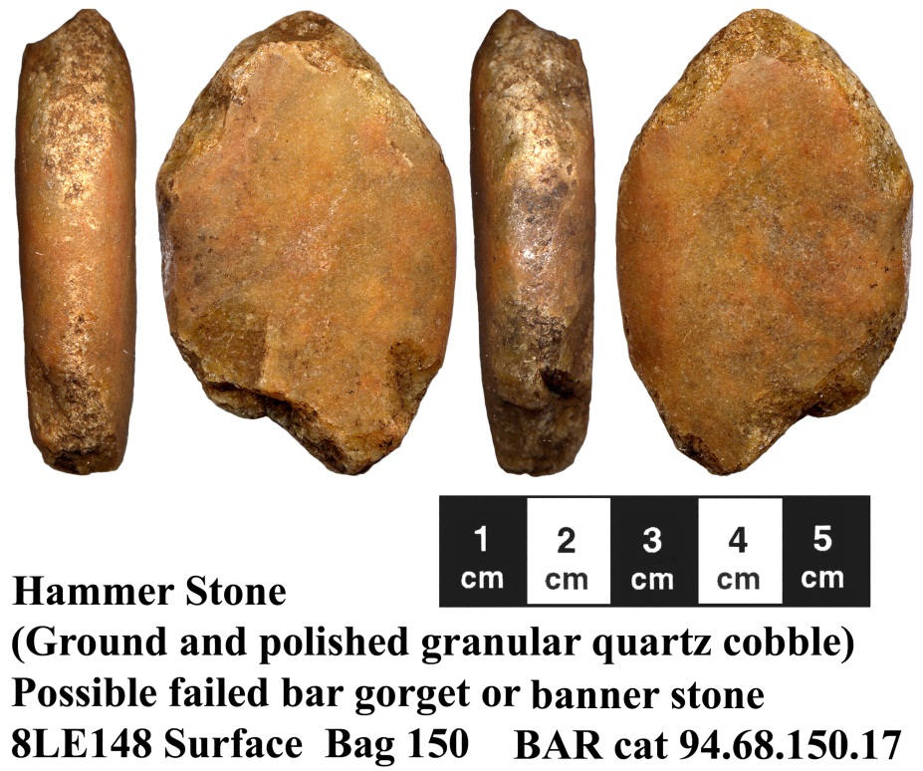 Granular quartz cobbles originating in Georgia, Alabama and the Upper Apalachicola River Valley were commonly used as hammer stones by Northwest Florida Native Americans, including the Swift Creek people at the Block-Sterns site. They are distinguished from ceramist’s burnishing stones by their battered and often broken ends. Wood and antler billets and hammer stones are firm but slightly softer material than the stone that they strike to detach flakes. That results in micro-crushing of their impact edge such that it clings to the edge of the struck stone while the imparted striking force detaches a flake from the struck stone. The micro-edge crushing on the stone eventually produces a pitted surface and with further use creates enough stress fractures that the hammer stone end will break off during use. When the fractured stone end becomes too irregular for controlled striking of the edge of the chert or other stone being shaped, it is generally discarded.

Native Americans depended upon hand-made items that they made themselves or bartered with other people to obtain; they did not use money. Making flaked or pecked-ground-and-polished stone artifacts, ceramic vessels, and items of wood, leather, bone, shell and fiber requires skill, takes time, and access to needed material that may only be available during certain seasons or be found miles away from where the people live. Thus, in addition to the knowledge, skill and ability to make needed items and access to the material needed for their manufacture, Native Americans generally maintained and repaired items, and recycled broken items for alternative use.

Two examples of vessel repair and examples Copena Pentagonal Knife blades resharpened until no further resharpening flake detachment was possible are shown above. Likewise, the hammer stone shown above is an example of recycling. The granular quartz cobble was being ground and polished to make a banner stone, gorget or some other item, when it broke. We know this because the friction heat that occurred when the surface was being ground to shape it caused the iron impurities in the stone to turn the surface color slightly red and the fabrication abrasion also somewhat polished the object’s surface.

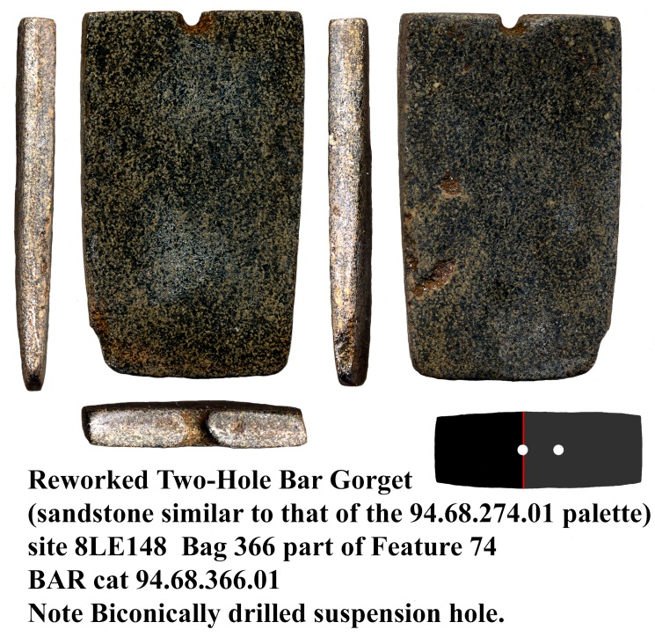 Another example is a broken two-hole bar-gorget. It is made from the same type of central Georgia tabular stone as the paint palette shown above. When the gorget broke, the end with the hole remnant was ground flat. The slight rounding at the opposite end suggests that the object may have been used in pottery making, but more likely was used in processing the hides of small animals (scraping and stretching the interior surface) to produce leather used in making clothing, containers or other such items.

The holes in the gorget were drilled with a stone drill with a tapered tip. Based on use wear and breakage patterns hafted arrow points were frequently used as drill bits. The holes were usually drilled from one side until the drill tip reached the opposite surface and then the tip was placed in that hole and drilled in the opposite direction. Thus, the native drill holes are biconical, while our modern metal drills produce a cylindrical (tubular) shaped hole. The mechanism used to drill the hole was probably a bow-drill.

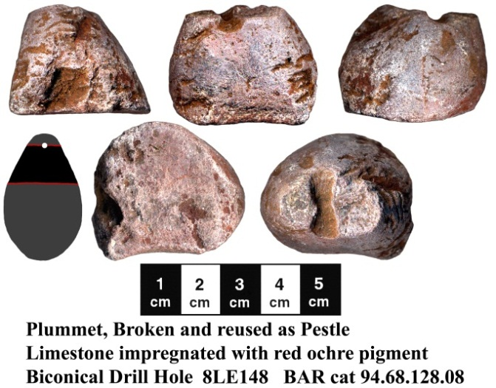 A plummet made of limestone also has a biconical-shaped drill hole and was recycled when it broke. The name is derived from European artifacts with that shape and we do not believe that prehistoric Native Americans used their “plummets” as we do. Rather they were used as fishnet weights and for other purposes. When the example shown here broke, it was used as a pestle to grind red ochre pigments. Grinding the pigment against the surface of a mortar also resulted in grinding smooth the end of the plummet and in staining its surface red.

When spear points, arrow points and knives broke across their blades, if the remaining blade was too short to be bifacially reworked for continued use as a point or knife, the broken ends were often unifacially (one direction) resharpened to facilitate their use as hafted end scrapers. No examples are shown in this brief summary report, although they were found at the Block-Sterns site.

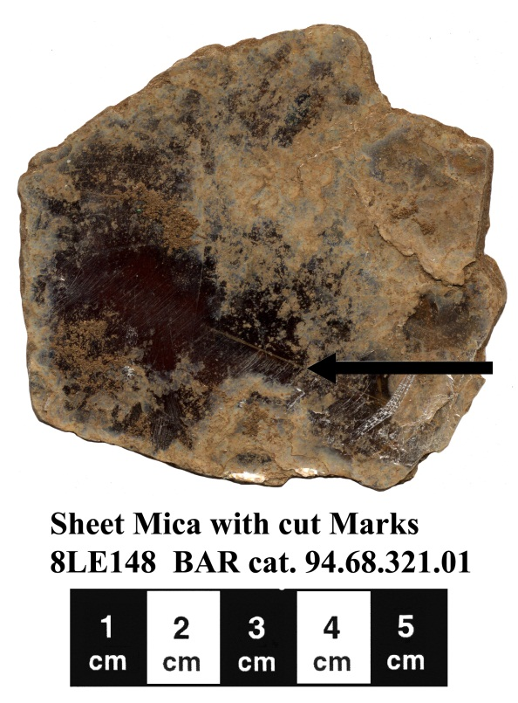 Mica from the Appalachian Mountains is a common trade item found at Swift Creek sites, especially in ceremonial settings. Over one hundred large and small examples of sheet mica have been found at the Block-Sterns site. While the layers (sheets) of mica are bonded together in their natural form they may be pried apart. Native Americans used mica in different ways. Swift Creek people used it as a mirror to reflect sunlight. They also drew and cut out designs of birds and other animals and geometric patterns on large sheets of mica. The process was somewhat like drawing a pattern outline in your writing notebook and then cutting it out with a razor blade. Near the center of the piece shown here you can see two joined cut-marks left over from that process. Swift Creek people also ground small scrap mica fragments and mixed that material with the clay used to make some of their ceramic vessels. The reflective ground mica may be seen in the burnished surface of those vessels.

A variety of stone tools suitable for the delicate work of cutting patterns in sheet mica were found during the Block-Sterns site excavation. Many of them are microlithic, which means small stone tools. Some of them feature raw (unmodified) edges, while others have been fashioned as serrated knife/saws or gravers. Gravers have a sharp wedge-shaped tip.

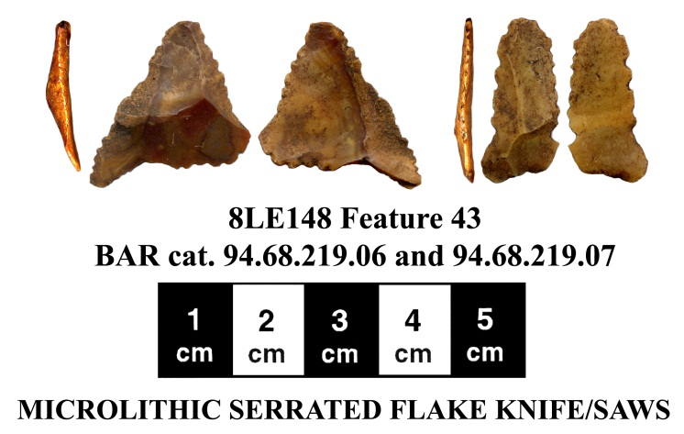Twenty-two microlithic serrated flake knife/saws, a tool kit, were found in one feature. Two examples of that group are shown here. Their wear pattern suggests that they were used as tools to fashion mica artifacts. That is to say that the serrated edges feature crushing from cutting moderately soft material such as mica. Similar tools used to cut skin (a very soft material) do not have such edge crushing. The cutting of skin for ritual blood-letting, tattooing, and so forth also appears to have occurred at native sites based on study of the cutting edges of many similar tools.

Sources of native copper have been found from northern Georgia, through the Carolinas into Michigan. While Native Americans did not learn blacksmithing or metal refining methods, they did learn how to remove chunks of native copper from larger boulder-size lumps and to “cold-hammer” it into forms that they wished, including thin sheets that were then cut and otherwise fashioned into various forms. Copper-foil covered pan-pipes, ear spools, gorgets and other items made by people living near the sources of native copper were traded among native people, including Swift Creek and other contemporary people in Florida. A fragment of a cut-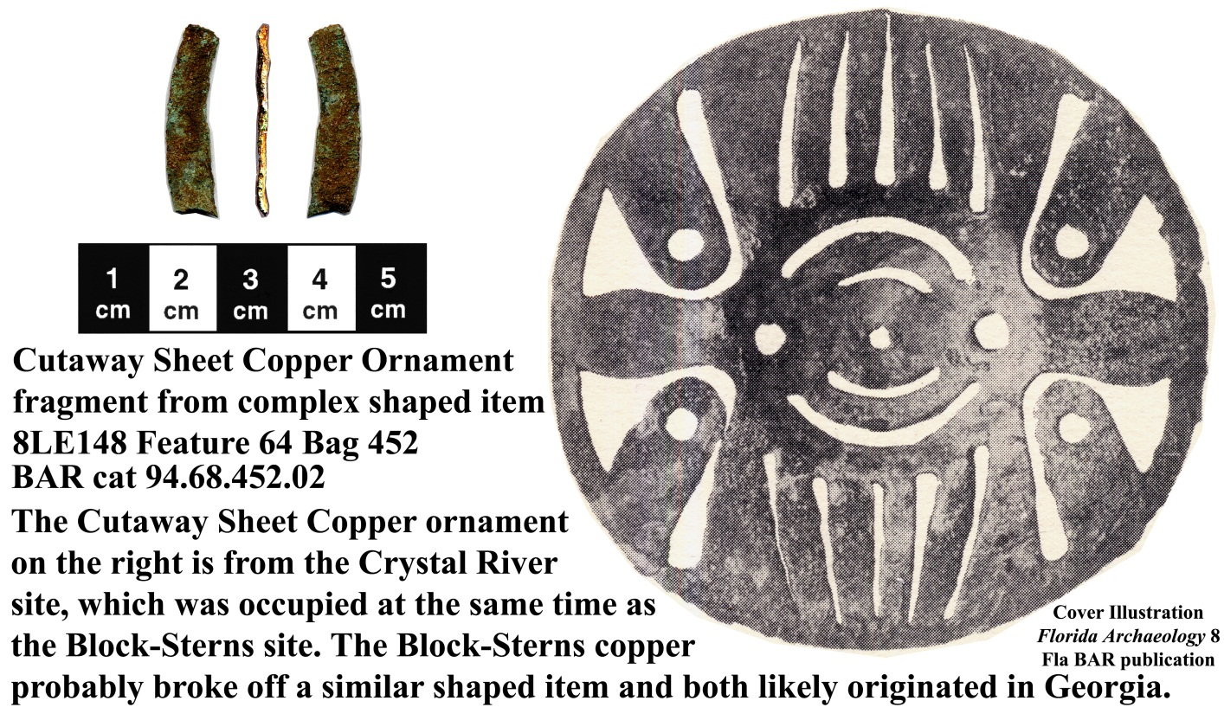away cold-hammered sheet copper artifact was excavated at the Block-Sterns site and appears to have come from an artifact similar to a cut-away copper ear spool inlay excavated at the contemporary Crystal River site in Citrus County.

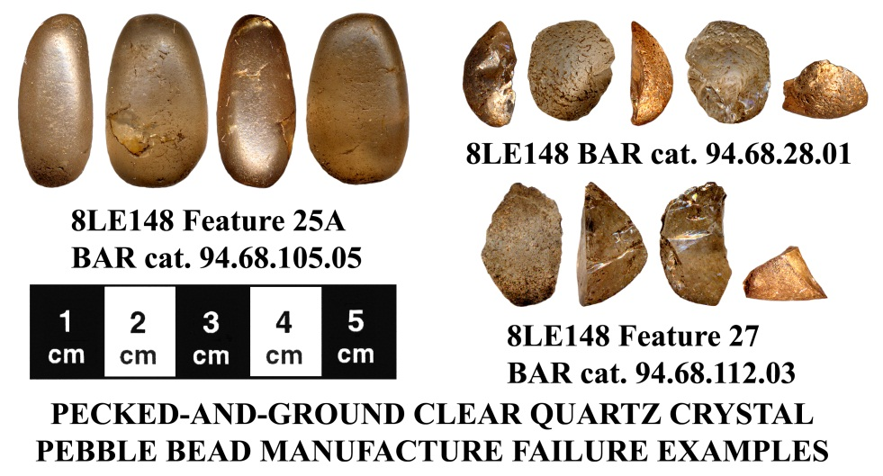 Among the items that Swift Creek people at the Block-Sterns site also received in exchange from people in Alabama and Georgia were clear crystal quartz pebbles and other glass-like clear quartz rocks that they fashioned into beads and other items. While no completed beads were found at the Block-Sterns site, items that broke and were discarded during bead manufacture are represented, as are other crystal quartz artifacts. Stone bead manufacture involved striking the pebble surface with a harder hammer stone to crush and remove material to shape it to a desired size and form. If the object did not shatter during this production phase, its pecked surface was next ground to smooth and polish it. The final production stage involved drilling a hole through the shaped and polished pebble. The fragments shown here are early bead production failures, while the polished complete pebble displays a later production failure from grinding heat thermal cracking.

The fabrication of stone beads using native techniques was very time consuming and obviously involved the trauma of failure. For that reason stone beads and especially those made from harder crystal stone were very valuable trade items. Native Americans did not know about glass manufacture. When Europeans arrived with their glass trade beads, the first native people that they encountered apparently believed that they were crystal stone beads and valued them accordingly.

Native Americans, including Swift Creek people, also made beads of bone, shell and pearls. A special type of abrader associated with bead manufacture is known as a circular 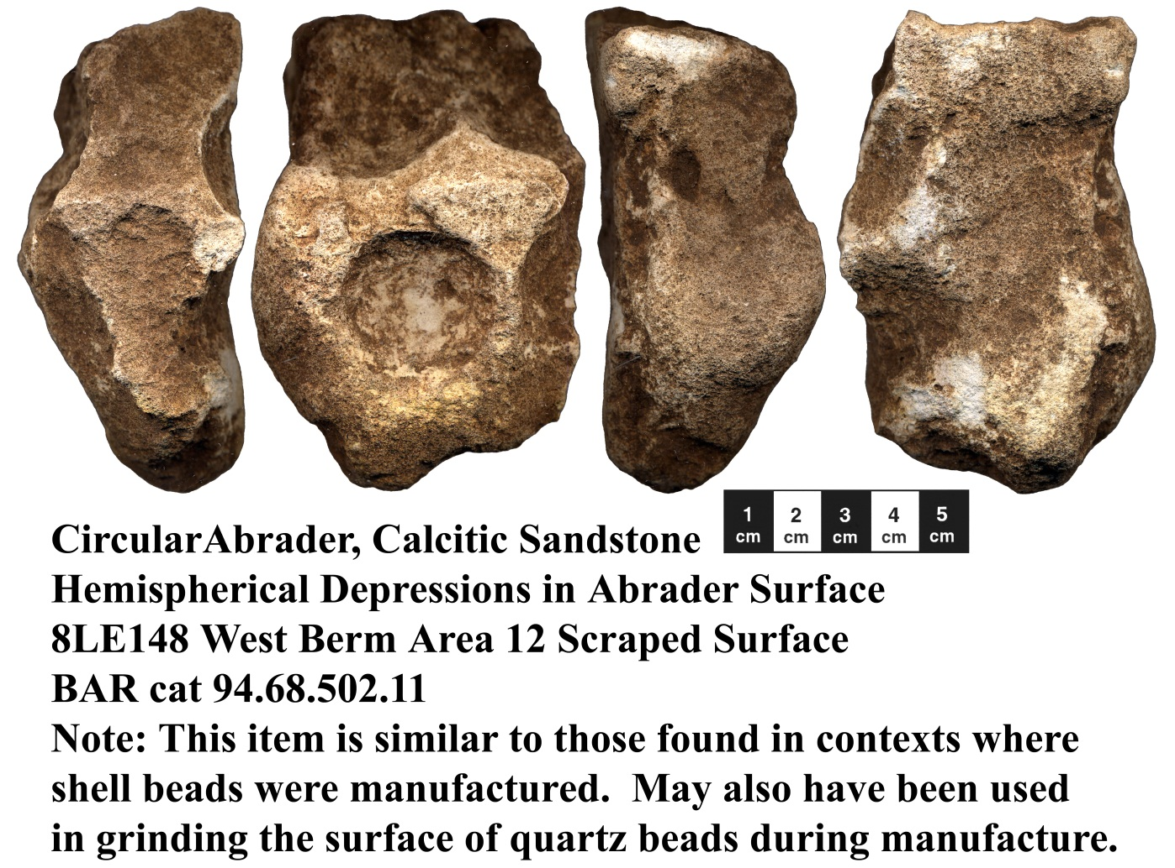abrader and features hemispherical depressions. The curved smoothed surfaces of beads were formed by repeatedly rubbing the “bead preform” surface around the inside of the circular abrader depression surface. Grooved abraders and smooth abraders were also used and have the surface features that their name implies.

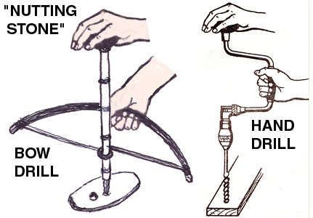Further, another class of stone artifact with a shallow basin-like depression is often referred to as a “nutting stone” because someone in the late 1800 noted that nuts could be placed in the depression and then struck with a hammer stone to break the nut hull to provide access to the “nut meat.” Actually friction and char discoloration in some of the basins indicates that they were used to start fires. The polished interior of other “nutting stones” indicates that they likely were used to regulate pressure on the drill shaft of a bow drill, much like the knob on a historic hand drill. While not shown in this illustration as it would obstruct viewing the drill tip, bow drills generally have a disc on the shaft above the bit to help contribute rotational force/energy to the shaft during use.

Swift Creek people acquired their food by hunting and gathering that which was available near where they lived. The hunting of white-tail deer was an important part of their diet and the deer also provided hides, sinew, antlers and bone for use making other needed items. Fish from the lake, rivers and coast, turtles, alligators, snakes, migratory and other birds, raccoons, possums, squirrels, rabbits, bears and other animals were also important subsistence items. At at Block-Sterns and other sites, in addition to collecting wild plant food, including hickory nuts, persimmons and blackberries in season, they likely had small garden plots at which they grew sunflowers, squash and beans. While corn (maize) may have had limited ceremonial use by Swift Creek people, as it did elsewhere among Eastern North America natives, it did not become important in the diet of Native Americans until after A.D. 1000, about 600 years after the end of people practicing the Swift Creek culture lifestyle.

While most of the people likely spent their life within 30-50 miles of their village, some Block-Sterns site people probably went to the Gulf coast (or else traded with other Swift Creek culture people living on the coast) to obtain salt, casina holly leaves for tea, smoked coastal fish fillets and sea turtle meat, oysters, clam, scallop and conch meat and conch shells. From partial skeletal elements we know that only processed coastal meat was brought to the site, while the more complete skeletal elements of fish obtained from Lake Lafayette indicate that they were prepared on site.

Casina leaves were used to make a special tea, known among historic Southeastern natives as the “black drink,” that was apparently served in *Busycon* conch shell bowls. Twigs and berries from casina plants have been excavated in pit features at Leon County, Florida Swift Creek sites, showing that the tea leaves were processed at those sites. Gulf Coast *Busycon* conch shells have been excavated at contemporary Hopewellian sites, such as the Knight and Norton mounds in Illinois and Michigan (see Griffin et al. 1970).

We do not believe that there were long-distance traders, traveling from Florida to Michigan or elsewhere. Rather, we believe that it is more likely that Northwest Florida Swift Creek people traded locally obtained coastal items and glass-like chert with inland neighboring people in Alabama and Georgia, who in turn traded with people to their north, while at the same time Hopewellian people in Illinois and Michigan traded with their neighbors to the south. Eventually some of the Hopewell exchange items reached Florida Swift Creek sites and some of the Swift Creek items reached Hopewell sites; and, exchange items from all of the interactive participants from North-South and East-West were dispersed across and among the people in the trade network.

Although Swift Creek people occupied portions of the Block-Sterns site during the entire year, the area near Mound 2 contains cultural pit features linked to ceremonial and other special use activities (such as trade and fabrication of high status [elite] artifacts) and essentially lacks the post-mold patterns that indicate Swift Creek residential structures. It is unfortunate that the site looter/looters illegally dug in and destroyed significant Mound 2 cultural data. We will now not be able to learn: 1) whether there was a structure built on the mound crest, 2) whether there was a ceremonial fire pit on the mound crest, 3) whether there was a post-mold pattern at the platform mound corners of mid-points of its sides where carved wooded bird and animals figures denoting the clan or other group totems of people linked to the site may have been erected and displayed, or 4) the answers to other socio-religious questions about Swift Creek people linked to activities on a platform mound.

In view of the numerous examples of maintenance, repair and recycling of artifacts used in their daily lives, we can say that the ritual activities indicated by the items in the pit features near Mound 2 indicate that the ritual participants sacrificed items of importance during the ceremonial activities. More broken vessels are represented then one would expect from accidental breakage. Numerous complete projectile points are present in the pits along with key animal bone and deer antler elements—such as do not usually occur in unbroken or otherwise usable form in Swift Creek trash pits, thus suggesting a linkage in the discard of the projectile points and the butchered animal elements. The careful removal of their bottom and preparation for using turtle shells as cups and bowls followed by their placement in upright positions individually or stacked in the pits also suggest ritual use and disposal. The occurrences of usable long-distance exotic trade items, including sheet mica, galena, graphite, and so forth, likewise implies the ceremonial sacrifice of those items. The repetition of the occurrence of those groups of artifacts in many of the pits suggests a ceremonial sequence of events linked to rites of passage ritual, such a community recognized transition from childhood to manhood.

The rituals likely included actions not present or identified in the pit features. For instance, if a rite of passage is the correct interpretation, do the broken vessels represent the release and purification in the pit fire of negative childhood actions and the receipt of a new special vessel, such as one used by adults in black drink or other adult male ceremonies? Likewise, was the individual cut to contribute blood to the ritual and the cut marks manipulated to produce decorative scarring or tattoos? In this paragraph, I have gone beyond that which may be determined by archaeological data and engaged in speculation based on reported events of other hunting-and-gathering peoples of the World.

Returning to matters of archaeological substance, through the study of Swift Creek culture artifacts we have determined how they were made and used, as well as the nature and extent of items prepared for trade and exchange by the and those received in that process. Florida sites with earthen or shell mound complexes such as Block-Sterns, the Pierce Mounds at the mouth of the Apalachicola River, and the Crystal River Mounds in Citrus County, seem to have been important sites in the southern end of the Hopewellian Interaction Sphere of Exchange Network. In addition to being focal points for the receipt and distribution of exchange items, they also were focal points for the introduction and dissemination of new ideas.

We determine such things by comparing the occurrence and spread of new artifact styles and culture change at sites within each cultural area. Sites with lots trade items experience culture change faster than sites with fewer exchange items, while sites in the cultural hinterland with essentially no exchange items continue with little change in the lifestyle of their occupants. This situation is in part linked to natural resource access, especially access to items of high trade value. Communities that control access to key natural resources or trade routes become important cultural nexus points.

During the centuries that people lived at the Block-Sterns site, the eastern portion of the site was occupied by people of the late Deptford culture as it transitioned into the Early Swift Creek culture. Mound 1 located in that area contained both Deptford and Swift Creek vessels, a cache of Swift Creek ceremonial knives covered with a stack of sheet mica, and a Swift Creek ceramic knelling female figurine. While some period figurines depict modeled hair, this one appears to have actual hair glued onto the head, as do some of our culture’s ceramic dolls. As with Mound 2, Mound 1 after the limited formal excavation it was set aside for preservation as a way of showing respect for that Native American ceremonial site. However, over the following years it was repeatedly looted by individuals seeking artifacts to sell to other people. Over 80% 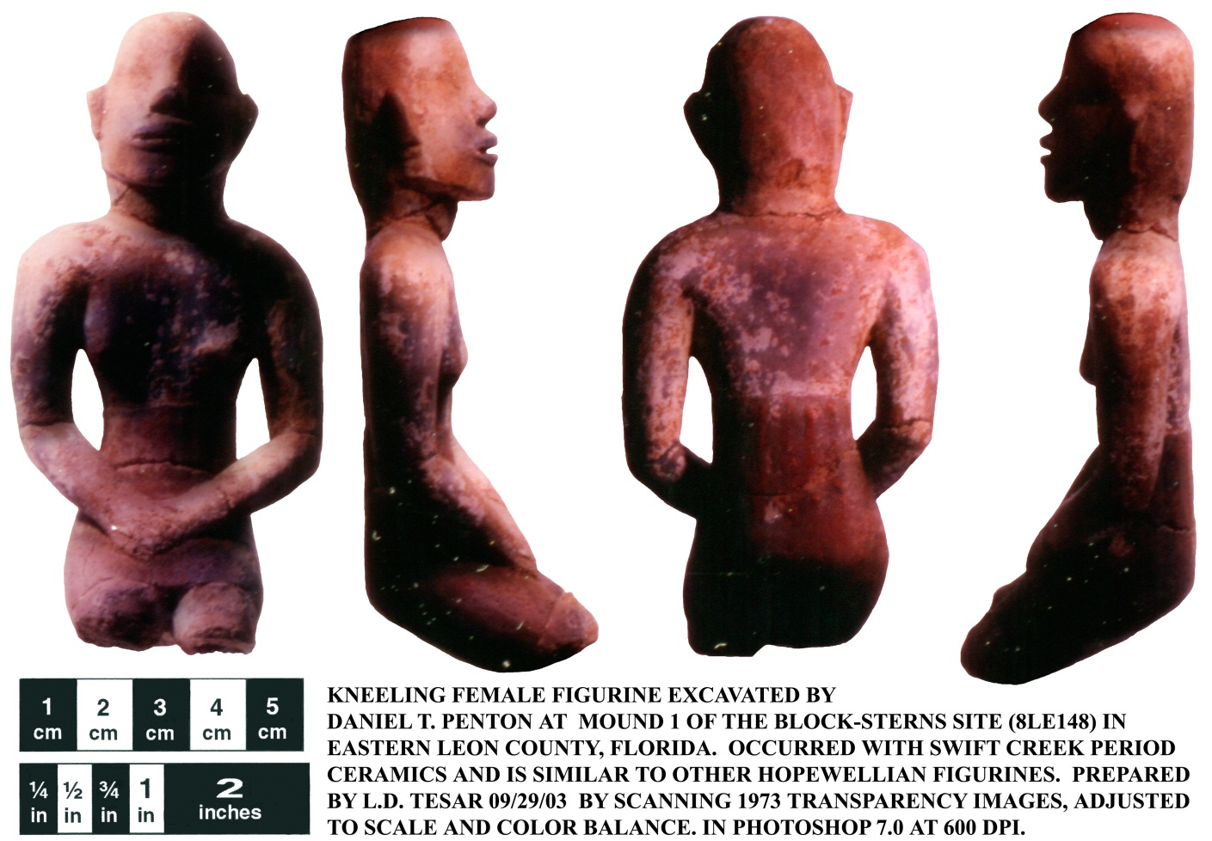of that mound site and its human burials were desecrated and destroyed by the artifact looters.

While the remaining portion of the mound has been set aside for preservation, the lost portions illustrate the problem of managing cultural resources in isolated locations. As occurs among neighborhood crime watch participants, public land managers depend upon citizens to help report illegal actions on public land. We must all become stewards of our cultural and natural resources.

If you wish to learn more about Florida’s archaeological and historical resources, please visit the Museum of Florida History in the R. A. Gray Building at 500 South Bronough Street, Tallahassee. You may also visit the headquarters of the Florida Bureau of Archaeological Research at the B. Calvin Jones Center for Archaeology at the Governor Martin House, 1001 deSoto Park Drive, Tallahassee. Finally, you may find further information about archaeological sites and other cultural resources by visiting the Florida Department of State, Division of Historical Resources web site at [www.flheritage.com](http://www.flheritage.com).