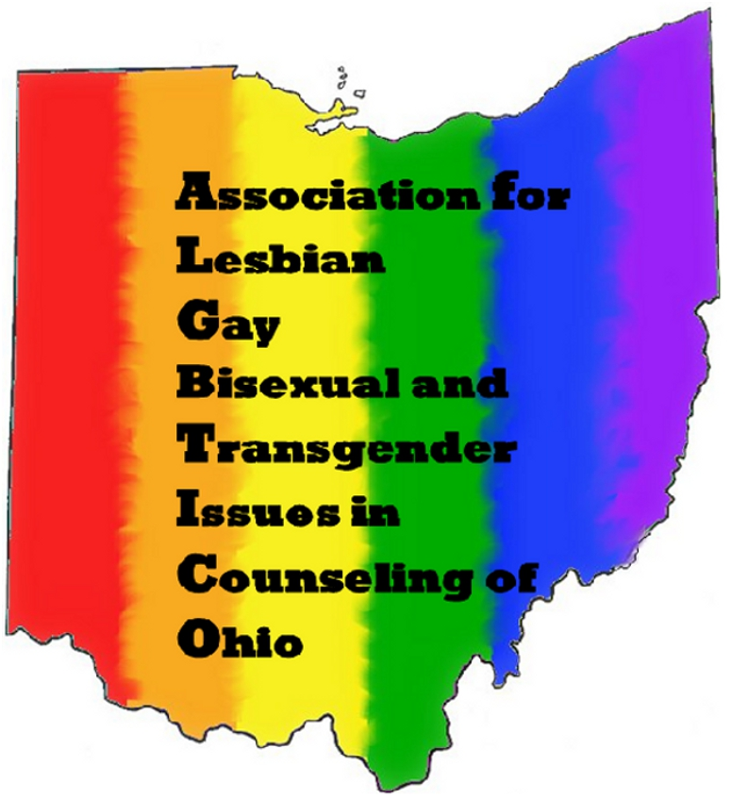

BYLAWS

**-Table of Contents-**

**ARTICLE I: Name, Affiliation, Mission, and Purpose**

Page 3 – 5 Section 1: Name

Section 2: Affiliation

Section 3: Mission

Section 4: Purpose

**ARTICLE II: Membership**

Page 5 – 6 Section 1: Overview

Section 2: Classes

1. Professional Members
2. Student Members
3. Retired Members

Section 3: Severance

Section 4: Dues

Section 5: Meetings

**ARTICLE III: Board of Directors**

Page 6 – 9 Section 1: The Board

Section 2: Officers

1. President
2. President-Elect
3. Immediate Past-President
4. Secretary
5. Treasurer
6. Information/Technology Support

Section 3: Regional Representatives

Section 4: Voting

1. Electronic Communication/Voting

Section 4: Nominations and Elections of Officers  
Section 5: Compensation and Expenses

Section 6: Removal

**ARTICLE IV: Committees**

Page 10 Section 1: Executive Committee

Section 2: Standing Committees

1. List
2. Appointment

Section 3: Special Committees

**ARTICLE V: Finances**  
Page 10 – 11 Section 1: Fiscal Year

Section 2: Dues and Assessments

Section 3: Contracting for a Fee

**ARTICLE VI: Non-Discrimination Statement**

Page 11   
 **ARTICLE VII: Bylaw Amendments and Revisions**Page 11

**ARTICLE VIII: Rules of Order**   
Page 11

**ARTICLE I: Name, Affiliation, Mission, and Purpose**

**Section 1: Name**

The name of the association shall be the Association of Lesbian, Gay, Bisexual and Transgender Issues in Counseling of Ohio, hereinafter referred to as ALGBTICO. ALGBTICO was established in 2010.

**Section 2: Affiliation**

ALGBTICO is a state branch of the national Association of Lesbian, Gay, Bisexual, and Transgender Issues in Counseling ([ALGBTIC] which is a division of the American Counseling Association [ACA]), and a division of the Ohio Counseling Association (OCA).

**Section 3: Mission**

The mission of ALGBTICO is to promote greater awareness and understanding of lesbian, gay, bisexual, and transgender (LGBT) issues among members of the counseling profession, students, the clients they serve, and related helping occupations. ALGBTICO also promotes greater awareness and understanding of persons of various sexual and/or affectional identities not represented within the identities presumed by “LGBT” such as queer, questioning, intersex, and ally.

**Section 4: Purpose**

Through the recognition of both individual and social contexts that represent the confluence of race, ethnicity, class, gender, gender identity and expression, sexual and/or affectional orientation, age, ability/disability, spiritual or religious belief system, or indigenous, cultural, and ethnic heritage, it is the purpose of ALGBTICO, within the State of Ohio, to:

* Promote greater awareness and understanding of lesbian, gay, bisexual, transgender, queer, questioning, intersex, and ally (hereinafter referred to as LGBTQQIA) issues among members of the counseling profession, students, and related helping occupations.
* Improve the standards and delivery of counseling and educational services provided to LGBTQQIA clients, professionals, students, and communities.
* Identify conditions which create barriers to the human growth and development of LGBTQQIA clients, professionals, students, and communities; and use counseling skills, programs, and efforts to preserve, protect, and promote such development.
* Develop, implement, and foster interest in counseling-related charitable, scientific, and educational programs designed to further the human growth and development of LGBTQQIA clients, professionals, students, and communities.
* Secure equality of treatment, advancement, qualifications, and status of LGBTQQIA members of the counseling profession and related helping occupations.
* Contribute to the publishing of journal and other scientific, educational, and professional materials with the purpose of raising the standards of practice for all who work with LGBTQQIA clients, students, and communities in the counseling profession and related helping occupations.
* Provide current information to enhance professional counselors’ awareness, knowledge, skill, and professionalism towards LGBTQQIA clients, students, and communities.
* Secure equality of treatment, advancement, qualification, and status of LGBTQQIA counseling professionals, students, and related helping occupations.

**ARTICLE II: Membership**

**Section 1: Overview**

* Membership in OCA shall be a condition of membership in ALGBTICO.
  + Membership in ALGBTICO can be added on when applying or renewing one’s OCA membership through the OCA website.
* Membership shall be individual.
* Membership includes agreement to abide by the *ACA Code of Ethics* (2014).
* Membership is valid for one year from date of processing (with the exception of severance of membership, see **Article II, Section 3: Severance**)
* Membership shall have three classes of voting membership: Professional, Student, and Retired.

**Section 2: Membership Classes**

***Section 2a: Professional Members***

* Professional members shall hold a master’s degree or higher in counseling, or a closely related field.
* Such degree must be from a college or university that was accredited when the degree was awarded, by an accrediting body recognized by the Council for Higher Education Accreditation.
* Professional members must present proof of academic credentials upon request by the Board of Directors, hereinafter referred to as the Board (see **Article III: Board of Directors**).

***Section 2b: Student Members***

* Student members shall be enrolled at least half-time in a college or university program in counseling, or a closely related field.
* Such programs must be in a college or university that is accredited during the student’s time in the program, by an accrediting body recognized by the Council for Higher Education Accreditation.
* Student members must present proof of academic enrollment upon request by the Board (see **Article III: Board of Directors**).

***Section 2c: Retired Members***

* Retired members shall include individuals who are retired from the counseling profession, or closely related field.

**Section 3: Severance**

Membership for a member can be severed for:

* Nonpayment of dues.
  + Membership may be reinstated by payment of dues.
* Any conduct that tends to injure ALGBTICO or to affect adversely its reputation, or that is contrary to or destructive of its mission or purpose, according to the ALGBTICO Bylaws and/or the *ACA Code of Ethics* (2014).
  + Any member charged with engaging in such conduct shall be given notice of the precise nature of the charges against them and provided with opportunity to present evidence on their behalf through witnesses or otherwise. Those accused shall be given opportunity to confront witnesses against them and have the right to appeal through a hearing before the Board. The Board shall have the power to determine whether the charges shall be dropped, the accused shall be permitted to resign, or whether the charges are true and the accused be removed from ALGBTICO.

**Section 4: Dues**

Annual ALGBTICO membership dues shall be established by action of the Board. The Board may authorize reduced dues or due waivers for special categories of members in accordance with the policies and procedures established by the Board. Current pre-established dues are as follows:

* Professional: Full dues ($10.00)
* Student: Full dues ($10.00)
* Retired: Full dues ($10.00)

**Section 5: Meetings**

ALGBTICO shall hold state meetings at a time and place fixed by the Board, which shall give reasonable notice to the membership of such a meeting.

**ARTICLE III: Board of Directors**

**Section 1: The Board**

The Board shall consist of officers (President, President-Elect, immediate Past-President, Secretary, Treasurer, and IT Support) and regional representatives. All officers shall be elected at large from among the members of ALGBTICO (see **Article III, Section 5: Nominations and Election of Officers**). Regional representatives shall be appointed by the officers.

All officers must be members in good standing of the national ALGBTIC (which includes membership of ACA), and ALGBTICO (which includes membership in OCA). Regional representatives must be in good standing with ALGBTICO (which includes membership of OCA).

**Section 2: Officers**

***Section 2a: President***

The president shall serve for a one year term from July 1 to June 30, or until their successor is elected. The president shall preside at all meetings of ALGBTICO, and shall chair and preside at meetings of the Board. The president shall also represent ALGBTICO as a member of, and at the meetings of, the OCA Executive Council.

The president shall, with the approval of the Board, create and fill positions on committees (or taskforces) to serve the needs of the division. In the event of a board member mid-term vacancy due to resignation, removal, or other circumstances, the president, in consultation with the Board, may appoint an individual to replace the vacated position to fulfill the remainder of the vacated position’s term.

The president shall perform the duties customary to that office and such additional duties as directed by the Board. The President also may call special Board or membership meetings when needed.

***Section 2b: President-Elect***

The president-elect shall serve for a one year term from July 1 to June 30, or until their successor is elected. The president-elect shall perform the duties of the president in the absence or incapacity of the president as determined by the Board. The president-elect shall assume the presidency of ALGBTICO upon the incapacity or resignation of the President. If the president-elect becomes incapacitated, the term is to be completed by the candidate with the next highest vote on the same slate of candidates.

The president-elect shall serve as chairperson of the Awards and Elections Committee, the duties customary to that office, and such additional duties as directed by the Board.

***Section 2c: Immediate Past-President***

The immediate past-president shall serve for a one year term from July 1 to June 30. The immediate past-president shall serve as the chairperson of the All Ohio Counselors Conference (AOCC) Committee, prepare the annual report to the national ALGBTIC Board, the duties customary to that office, and such additional duties as directed by the Board.

***Section 2d: Secretary***

The secretary shall serve for a two year term from July 1 to June 30, or until their successor is elected. The secretary shall keep record of all proceedings of the Board, and ensure such records are available to ALGBTICO members. The secretary shall serve as chairperson of the Technology and Resource Committee, the duties customary to that office, and such additional duties as directed by the Board.

***Section 2e: Treasurer***

The treasurer shall serve for a two year term from July 1 to June 30, or until their successor is elected. Shall represent ALGBTICO in assuring the receipt and expenditures of funds in accordance with the directives established by the Board, and shall be under such bond as may be determined by the Board. The treasurer shall provide financial reports to the Board during proceedings of the Board. The treasurer shall provide reports to the membership, ALGBTIC Board of Directors, and the OCA Executive Council; serve as the chairperson of the Membership Committee; perform the duties customary to that office; and such additional duties as directed by the Board.

***Section 2f: Information/Technology Support***

IT support shall serve for a two-year term from July 1 to June 30, or until their successor is elected. IT support will provide supportive technology services to ALGBTICO and the Board to accomplish the yearly goals. The IT support shall be appointed by the Board Officers based on ALGBTICO needs. Board members will contact the IT support to request technology services. Such services include website administration, Facebook page maintenance, Dropbox folder and files maintenance, activity and event flyer creation, mass communication to members, and other duties as directed by the Board.

**Section 3: Regional Representatives**

The regional representatives shall serve for a one year term from July 1 to June 30, or until their successor is elected. The regional representatives shall represent the needs and ambitions of ALGBTICO members throughout Ohio, with a special emphasis on the needs of members in areas that are not highly represented by our membership and/or Board officers. The regional representatives shall serve as a liaison for ALGBTICO in their respective regions with members, individuals, businesses, agencies, universities, and counties in Ohio to bring back relevant information, issues, and opportunities to the Board. The regional representatives are key components to gathering support and finding ways to get ALGBTICO involved in issues and events throughout Ohio. Regional area coverage and the respective representatives shall be appointed by the Board Officers based on needs throughout the state, and represent the following regions:

* Northwest Ohio (1)
* Northeast Ohio (1)
* Central Ohio (2)
* Central East Ohio (1)
* Southwest Ohio (1)
* Southeast Ohio (1)

**Section 4: Voting**

The ALGBTICO officers (i.e. the Executive Committee; see **Article IV, Section 1: Executive Committee**) holds the responsibility for voting rights. A majority of the voting officers shall constitute a quorum. Votes taken in face-to-face and live conference call meetings will be counted by simple majority vote. However, in order for issues that arise between face-to-face or live conference call meetings to be addressed in a timely manner, electronic voting may be initiated by the president.

***Section 4a: Electronic Communication/Voting***

* Roberts Rules of Order will be suspended in the case of electronic voting and email meetings.
* Votes will be cast by the “Reply All” option where all ALGBTICO officers will see the votes.
* The president will be responsible for regulating discussion to include all participating officers, verifying a quorum, and tabulating the final vote.

**Section 5: Nominations and Election of Officers**

Nominations and elections will be carried out by the Awards and Elections Committee, with the Board president-elect as its chairperson. The Awards and Elections Committee shall seek and select more than one nominee for each position (when feasible) to be elected for the next term, and submit a slate of candidates/nominees for approval by the Board at its regularly scheduled meeting.

Any ALGBTICO member can nominate and/or run for a Board officer position. The election procedures shall be published with the ballot, and the ballot will be sent to all members. In the event of a tie on the ballot, a run-off election shall be held to break the tie.

**Section 6: Compensation and Expenses**

None of the Board members of ALGBTICO shall receive any compensation for their services as such to ALGBTICO. Reimbursement of expenses, for business and supplies conducted on behalf of ALGBTICO, must receive approval by the treasurer and president prior to the expenditure.

**Section 7: Removal**

The president may remove a Board member from the Board for neglecting their assigned duties, for any conduct that tends to injure ALGBTICO or to affect adversely its reputation, or that is contrary to or destructive of its mission or purpose, according to the ALGBTICO Bylaws and/or the *ACA Code of Ethics* (2014).

* Any Board member charged with engaging in such conduct shall be given notice by the president of the precise nature of the charges against them and provided with opportunity to present evidence on their behalf through witnesses or otherwise. Those accused shall be given opportunity to confront witnesses against them and have the right to appeal through a hearing before the Board officers. The Board officers shall have the power to determine whether the charges shall be dropped, the accused shall be permitted to resign, or whether the charges are true and the accused be removed from the Board.

**ARTICLE IV: Committees**

**Section 1: Executive Committee**

Shall be comprised of the officers of the ALGBTICO Officers (president, president-elect, immediate past-president, secretary, treasurer, IT support). The Executive Committee shall act for ALGBTICO as a division body, prepare the annual budget for ALGBTICO, and shall report to the OCA Executive Council.

**Section 2: Standing Committees**

Standing Committees shall be comprised of at least one chairperson and at least one member to specifically address needs within ALGBTIC. All committees are required to report directly to the Board.

***Section 2a: List***

The Standing Committees of ALGBTIC shall be:

* Awards and Elections Committee – responsible for facilitating annual award and election process, nomination, and installation.
* Membership Committee – responsible for membership applications, maintenance of official membership list, recruitment of new members, and retention of existing members.
* Resource Committee – responsible for the collection, organization, and dissemination of ALGBTICO counseling and related fields LGBTQQIA resources for clients, professionals, students, and communities throughout the state.

***Section 2b: Appointment***

Committee members serve at the discretion of the president, with the approval of the Board, on a year-to-year basis.

**Section 3: Special Committees**

The president, with approval by the Board, may establish a time-limited Special Committee (or Task Force) for a specific temporary purpose or assigned task which is beyond the scope of the Standing Committees. Any such Special Committee (or Task Force) shall be responsible to the Standing Committee’s chairperson with the most closely related scope of responsibility.

**ARTICLE V: Finances**

**Section 1: Fiscal Year**

The fiscal year for ALGBTICO shall run July 1 to June 30 of each year.

**Section 2: Dues and Assessments**

Shall be established by the Board on an annual basis. Members will be informed about any changes.

**Section 3: Contracting for a Fee**

May be authorized and appointed by the Board, as may be necessary, to fulfill the objectives of ALGBTICO.

**ARTICLE VI: Non-Discrimination Statement**

There shall be no discrimination against any individual on the basis of race, ethnicity, class, gender, gender identity and expression, sexual and/or affectional orientation, age, ability/disability, spiritual or religious belief system, or indigenous, cultural, and ethnic heritage.

**ARTICLE VII: Bylaw Amendments and Revisions**

These Bylaws may be amended, revised, or both. Process for Bylaw amendments/revisions shall be:

1. The president shall review the Bylaws on a yearly basis for possible amendments/revisions.
2. The president shall make suggested possible amendments/revisions to the Board officers.
3. Board officers shall vote on any amendments/revisions, requiring a 2/3 majority vote to pass.
4. In accordance with the national ALGBTIC Bylaws, the president shall transmit the Bylaws to the ALGBTIC president for review and approval.
5. Upon national ALGBTIC approval, and in accordance with the OCA Bylaws, the president shall transmit the Bylaws to the OCA Bylaw Committee for final approval.
6. After approval from ALGBTICO officers, ALGBTIC, and OCA, the Technology Committee will ensure the amended/revised Bylaws are made available to ALGBTICO members through the ALGBTICO website.

**Article VIII: Rules of Order**

The current edition of Robert’s Rules of Order, Newly Revised, (edited by Henry M. Robert III and William J. Evans, and published by Perseus-Harper Collins) shall govern the proceedings of all bodies of ALGBTICO except where otherwise specified in these Bylaws.