-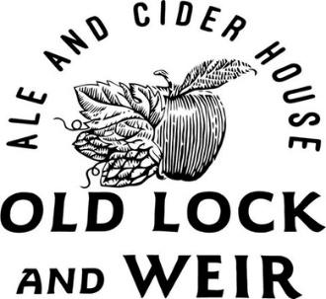-

Roast Topside of Beef £20

Served with roast potatoes, sage & onion stuffing, cauliflower cheese, carrots,

broccoli, Yorkshire pudding and homemade gravy. Smaller Appetites - £15.00

Half Roast Chicken £20

Served with roast potatoes, sage & onion stuffing, cauliflower cheese, carrots, broccoli, Yorkshire pudding and homemade gravy. Smaller Appetites - £15.00

Roast Leg of Pork £19

Served with roast potatoes, sage & onion stuffing, cauliflower cheese, carrots, broccoli, Yorkshire pudding and homemade gravy. Smaller Appetites - £14.00

Trio Of Roasts £25

Beef, pork and a quarter chicken served with roast potatoes, sage & onion stuffing, cauliflower cheese, carrots, broccoli, Yorkshire pudding and homemade gravy.

Chestnut Roast (V) £19
Served with roast potatoes, sage & onion stuffing, cauliflower cheese, carrots, broccoli and rich vegetarian gravy.
Mushroom & Leek Pie (Vegan) £19
Served with roast potatoes, carrots, broccoli, cauliflower and a rich vegan friendly gravy.
Cauliflower Cheese £5
Pigs In Blankets £6
Chips £5 -- Chips & Gravy £6.50
----------
Warm Chocolate Fudge Cake With Cream £7
Lotus Biscoff Cheesecake With Cream £7
Chocolate & Mint Pyramid Fondant £7
Raspberry Pavlova £6.50
Cadbury Flake Cone £3
----------
FOOD ALLERGIES & INTOLLERANCES – JUST ASK
GLUTEN FREE OPTIONS AVAILABLE – WHERE POSSIBLE
Please Be Aware If You Order Food Items On Separate Bills, We Can Not Guarantee They Will Be Served Together

