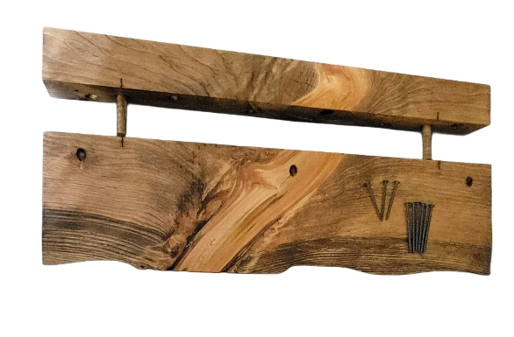
Little Wood Creations
Floating Shelf Mounting Instructions
(If shelves are screwed together first then please unscrew them before proceeding to mount.)

Step 1: First, carefully pull both sections apart exposing the dowels and mounting screw holes. Locate your studs in your wall for secure mounting.

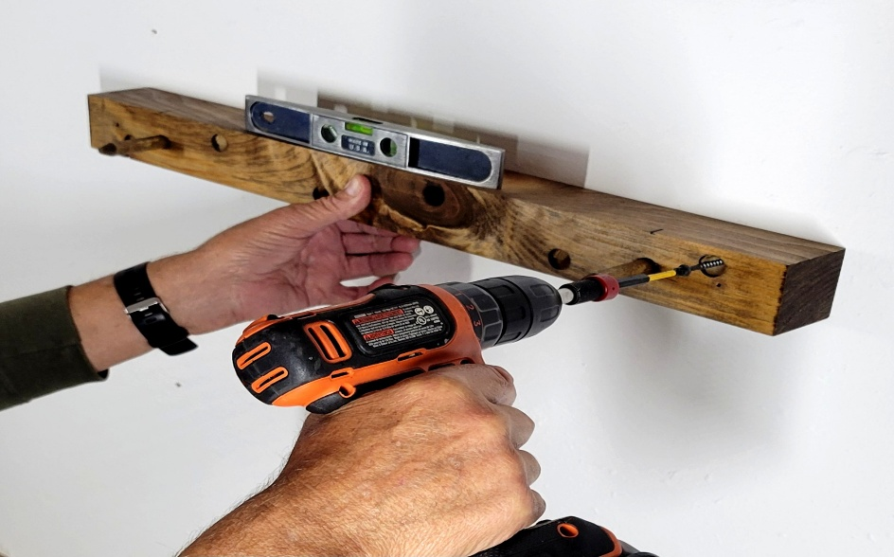
Alignment marks are the top part of the shelf to ensure the two sections join correctly during installation.
Step 2: The screw holes between the dowels are 4 inches apart to aid in aligning with your studs. Use a level on the rear section as shown. Be sure to use the longer 2 ½ “ screws for mounting the rear section of the shelf into your studs. Use all provided screws into the predrilled holes.

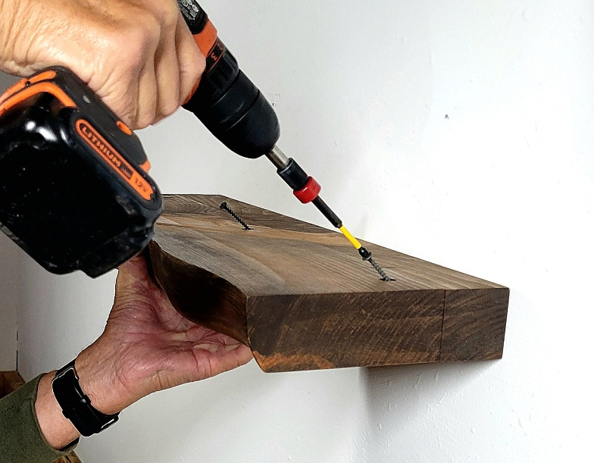
Step 3: Once the rear section has been mounted, slide the front section of the shelf over the dowels tight back against the rear piece. Lastly, fully insert the shorter 2” screws into the predrilled angled holes on top of the shelf.
Install Complete!

