Lynnbrook

Left to Center Field Center to Right Field

- It is a homerun if the ball is hit over the yellow or red line in the air.
- If the ball bounces and rolls past the yellow line, it’s a triple.
- If the ball bounces and rolls past the red line, it’s a double.

*Note: Defensive players must make an effort to field the ball. If a defensive player purposefully lets the ball bounce and roll past the yellow or red line, it’s an automatic homerun.

Stratton

Left to Center Field Center to Right Field
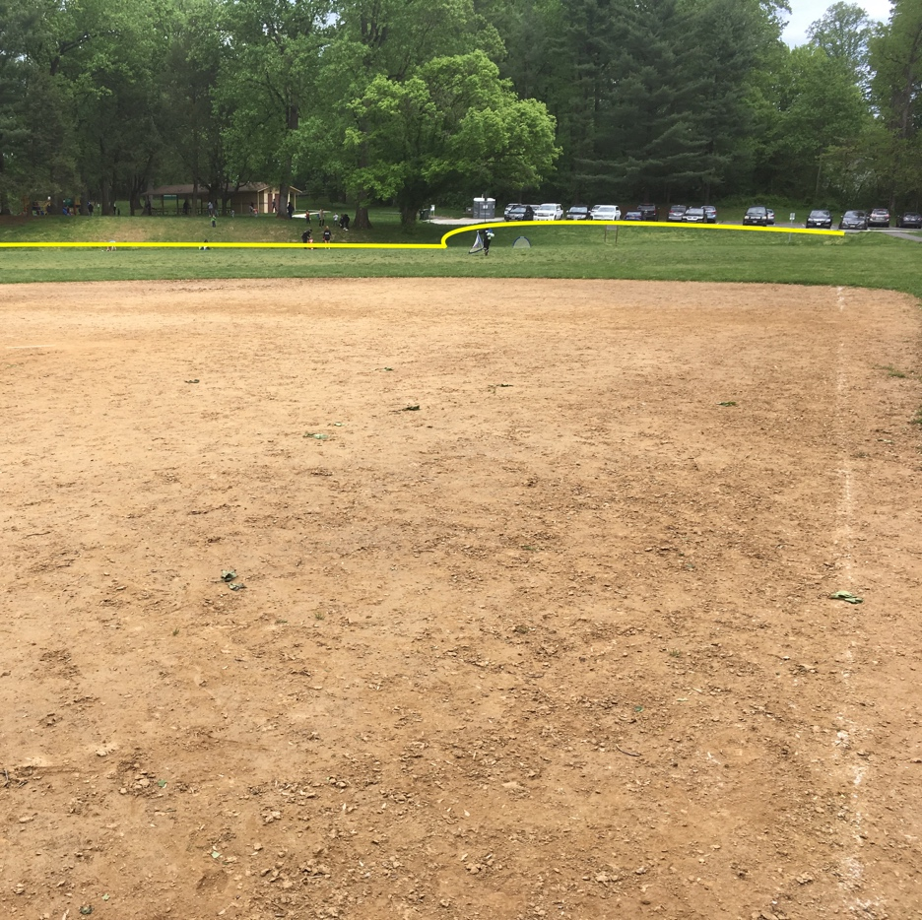

- It is a homerun if the ball is hit over the yellow line in the air.
- If the ball bounces and rolls past the yellow line, it’s a triple.

*Note: Defensive players must make an effort to field the ball. If a defensive player purposefully lets the ball bounce and roll past the yellow line, it’s an automatic homerun.

Burning Tree
#1

Left to Center Field Center to Right Field
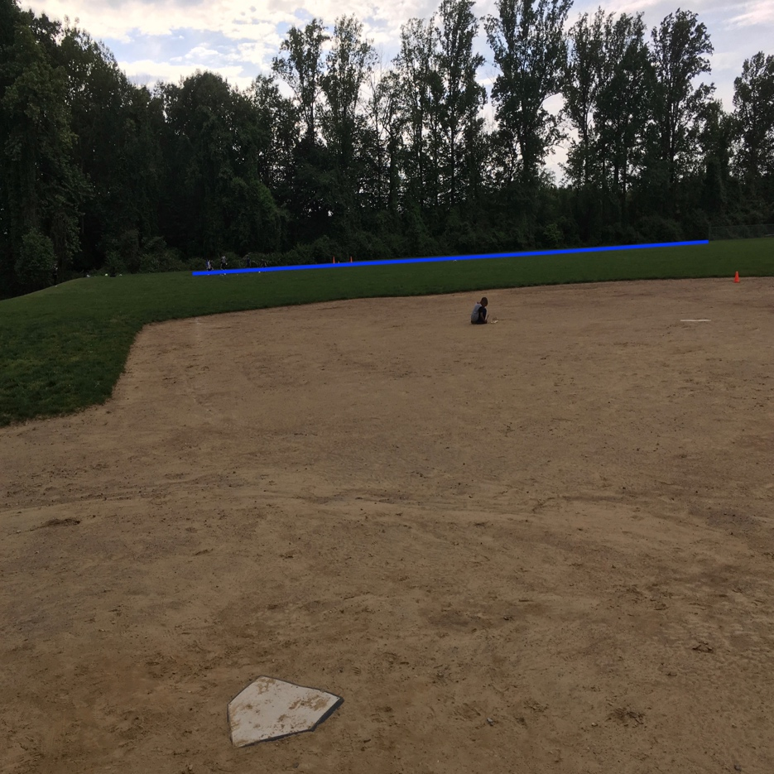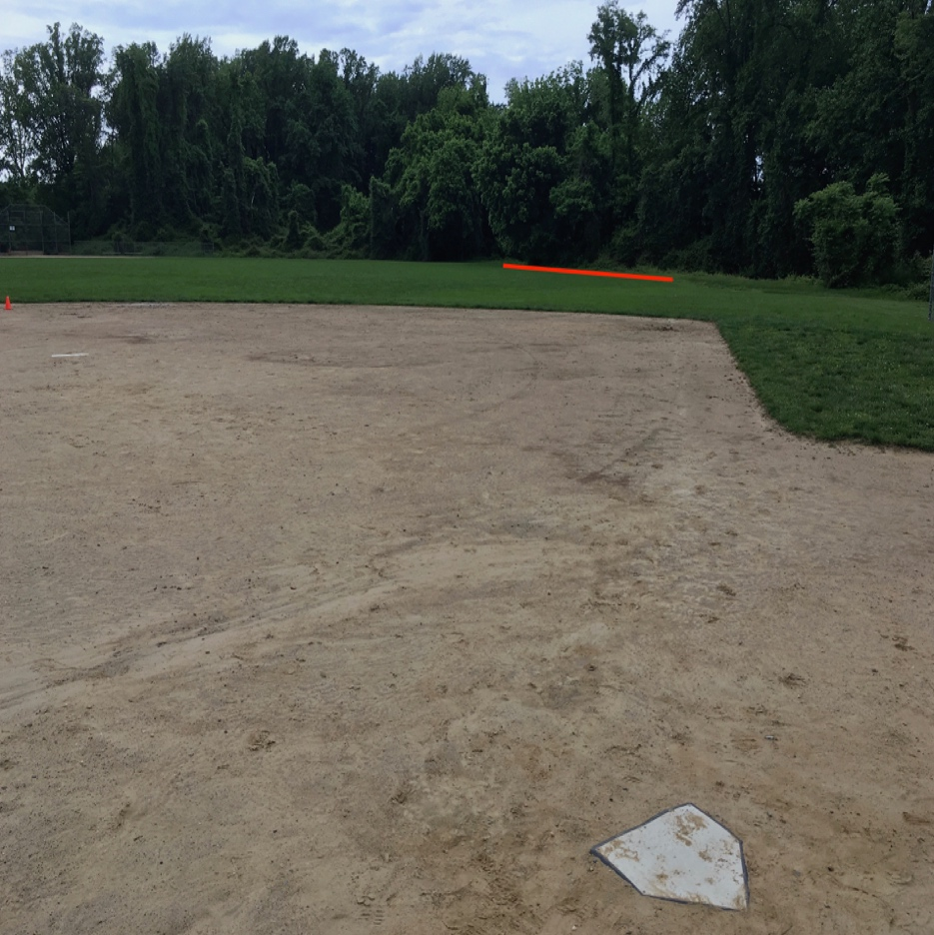

- It is a homerun if the ball is hit over the blue or red line in the air.
- If the ball bounces and rolls past the blue line, it’s a homerun.
- If the ball bounces and rolls past the red line, it’s a double.
- Everywhere else is all-you-can-play.

*Note: Defensive players must make an effort to field the ball. If a defensive player purposefully lets the ball bounce and roll past the red line, it’s an automatic homerun.
Burning Tree
#2

Left to Center Field Center to Right Field
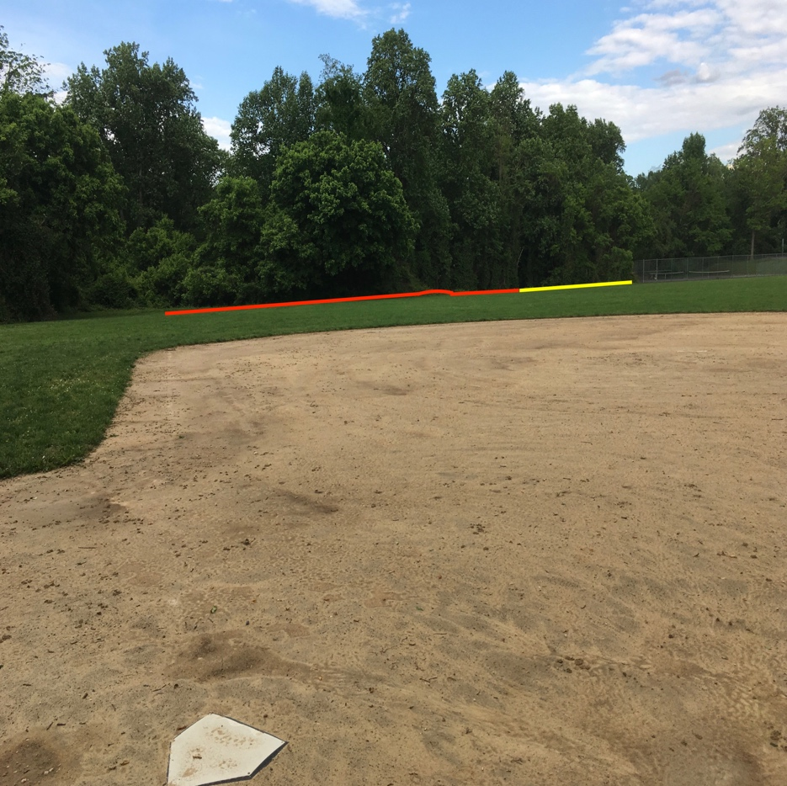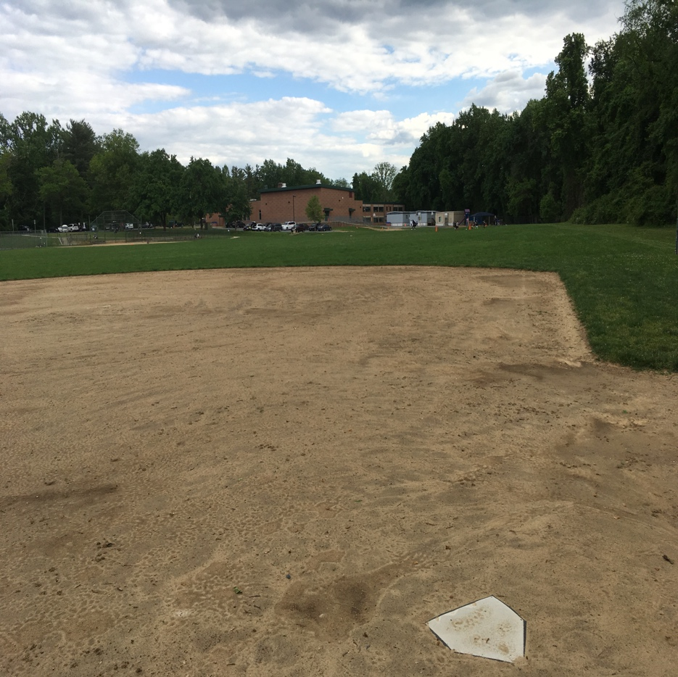

- It is a homerun if the ball is hit over the yellow or red line in the air.
- If the ball bounces and rolls past the yellow line, it’s a triple.
- If the ball bounces and rolls past the red line, it’s a double.
- Everywhere else is all-you-can-play.

*Note: Defensive players must make an effort to field the ball. If a defensive player purposefully lets the ball bounce and roll past the yellow or red line, it’s an automatic homerun.

