  https://scoc-consulting.com | 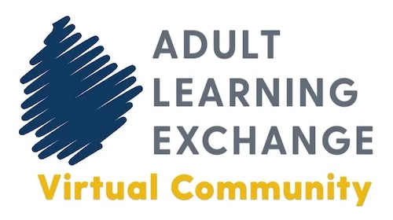  http://adultlearningexchange.org

Free Webinar Planning
[Insert the Name of the Webinar Here]

__________________________________________________________________________________________________________________________________________

Title: [Avoid long titles]

Suggested Date: [Allow at least 4 weeks for promoting the event]

Suggested Time: [Best times are noon, 12:30 pm, 1:00 pm, or 1:30 pm CST for reaching out to people from different time zones]

Duration: 30 minutes [Webinars can be longer than 30 minutes, but it depends on the audience and topic]

Type: Webinars may be about a strategy/method, books, or a current topic.

Audience: [Examples: Learning designers, instructors, administrators, and trainers in adult, continuing, and higher education.]

Speakers: [Please provide a short bio for each speaker and send JPG images]

Description [Please send a high-resolution image of the book’s front cover if the webinar is about the book]
In this webinar, …

Session Format
[Example: In this session, the authors will present key concepts and strategies from their book, followed by audience participation and Q&A.]
Capacity
- Maximum 100 registrants (including the presenters).

Webinar Logistics

- Registration: Registration will take place in the SCOC Consulting registration system. A web page will be created on the https://scoc-consulting.com website to promote the event. SCOC Consulting will handle registration and send reminders to registrants.

- Promotion: SCOC Consulting will develop promotional materials (e.g., flyers), send messages to listservs and via email marketing, post messages on social media (LinkedIn, Twitter, Facebook, Instagram, Google Business), and write blog posts.

- Webinar Evaluation: SCOC Consulting will conduct a webinar evaluation at the end of the session.

- Session Recording: Free webinars are recorded, and the session recording is shared with registrants, even if they do not attend. The recording is placed in the Adult Learning Exchange Virtual Community Digital Library. Please see the disclaimer below.

Disclaimer
The Adult Learning Exchange Virtual Community Digital Library is a subscription-based website that members can access. Facilitators and presenters of the free webinars do not receive compensation for the recording. Subscription funding enables the Virtual Community to offer more free opportunities to Adult Learning Exchange Virtual Community members.

