PATRICIA "PATTI" KRISTILEE BELTRAM
12107 West Eagle Ridge Lane · Peoria, AZ 85383 · E-Mail: pbeltram@cte-works.com
Cell: (602) 882-2817 · www.cte-works.com

SUMMARY OF QUALIFICATIONS
- Lead collaborative Strategic Plans to propel Peoria’s CTE programs to national-level with local and state political leaders, business and industry leaders, alumni, parents, and key stakeholders. Systems and programs management were implemented that have put Peoria CTE at the top in Arizona and, top 10 nationally, according to AdvanceCTE:
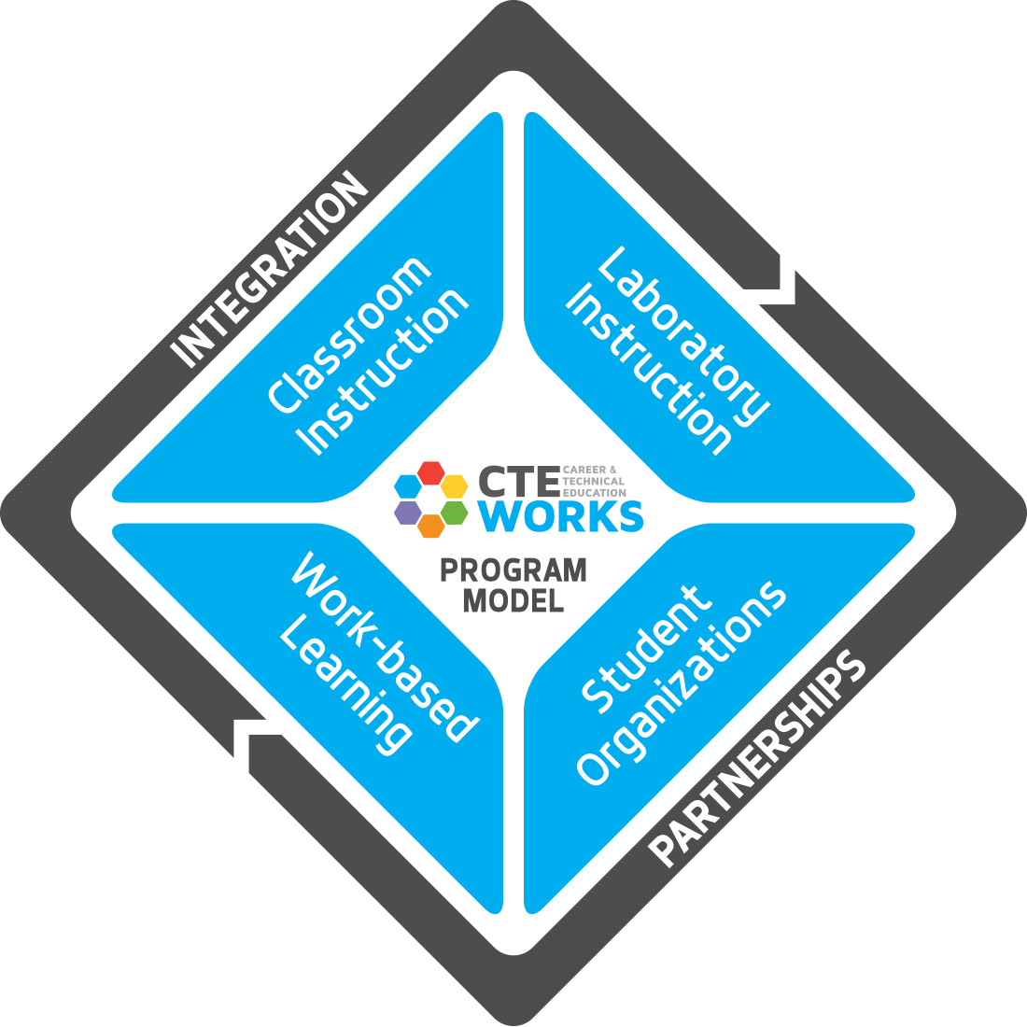
  - Award-winning Junior High CTE Program;
  - 100% of CTE programs provided the award-winning Total CTE Program Model (see awards);
  - Two programs of study were recognized nationally (see awards);
  - 95% of all graduates took 1 CTE course upon graduation, with 85% taking 2 or more CTE courses upon graduation;
  - Increased CTE concentrator high school graduation rate to 99%;
  - Increased overall high school graduation rate to 92%;
  - 98% of CTE programs had dual enrollment;
  - 95% of CTE programs had industry certifications;
  - Created CTE Graduation Endorsements where over 3,000 students were recognized; and
  - Students and Teachers were elected to state and national offices and recognitions.

RELEVANT LEADERSHIP WORK EXPERIENCE
October 2020 – U.S. Dept. of Education, Office of Career Technical and Adult Education, Peoria, AZ
Present Education Program Specialist
February 2019 – CTE Works! Owner, Peoria, AZ
October 2020 CTE Consulting, Speaking, Writing, Keynote
January 2010 – Peoria Unified School District, PUSD CTE Department, Peoria, AZ
October 2020 Director for CTE
May 2005 – Peoria Unified School District, PUSD Career Services Department, Peoria, AZ
January 2010 Career Services Instructional/Curriculum Specialist

EDUCATION
August 2000 - Northern Arizona University GPA: 4.00
December 2007 Ed.D. in Educational Leadership; Principal Certification
August 1996- Vocational Education Certification GPA: 4.00
December 1996
February 1993 - University of Phoenix GPA: 3.74
July 1994 Masters of Arts in Organizational Management
August 1991 - University of Phoenix GPA: 3.45
January 1993 Bachelors of Arts in Business Management and Business Administration

PUBLICATIONS & RESEARCH
Co-author. (November/December 2023). Unlocking Career Success for Native Populations. ACTE Techniques Magazine, Alexandria, VA: ACTE. Cross-Disciplinary Collaboration,. Pages 10-11.
Author (2020). The Power of Junior High CTE. ACTEonline.org. https://www.acteonline.org/the-power-of-junior-high-cte/.
Contributor. (2019). Outcomes of Youth Transitioning from Foster Care to Adulthood: A Literature Review. US Department of Education. Washington, DC: Office of Career, Technical and Adult Education.
Co-author. (May 2018). Celebrating Excellence in Action. ACTE Techniques Magazine, Alexandria, VA: ACTE. CTE Success Stories, Pages 40-43.
Author. (March 2018). CTE is Cooking at this Arizona School District. ACTE Techniques Magazine, Alexandria, VA: ACTE. Elementary and Middle School Career Exploration, Page 31.
Author. (July 2017). Peoria Junior High CTE and Career Readiness. Arizona Career Leadership Network, Phoenix, AZ: AzCLN. Middle Grades Edition, Page 1.
Author. (May 2011). Making Assessing CTE programs Meaningful. ACTE Techniques Magazine, Alexandria, VA: ACTE. Student Leadership, Pages 10-11.
Author (May 2010). Total CTE Program Model Makes CTE the Answer. ACTE Techniques Magazine. Alexandria, VA: ACTE. Preparing the New Workforce, Pages 10-11.
Co-author. (2003). Cooperative Education and Work-Experience Programs. NBEA 2003 Yearbook: Effective Methods of Teaching Business Education in the 21st Century. Reston, VA: NBEA, Pages 283-297.
Co-author. (December 1999). Business Student Organizations: Bridging the Gap. Business Education Forum, 54(2) (The official publication of the National Business Education Association), Pages 49-51.

CERTIFICATIONS

Expires Annually Grant License, ED

Expires 2026 Contracting Officer’s Representative (COR) Level II, ED

Expires 2032 Superintendent Certificate, Arizona ED

Expires 2032 Principal Certificate , Arizona ED

Expires 2032 Standard Secondary Education Certification, 7-12, Arizona ED
Teaching Field: Business and Marketing/Distributive Education

Expires 2032 Standard Vocational Education Certificate, Arizona ED
Teaching Field: Business and Marketing/Distributive Education with Cooperative Education Endorsement, K-12
Lifetime Arizona Community College Regular A.1.a Teaching Certificate, Arizona Community College
Teaching Field: Business Administration - Management

Administrative Experience
January 2002- Gilbert Public Schools, Summer School, Highland High School, Gilbert, AZ
July 2002 Administrative Internship – Summer School Principal
March 2002 – Gilbert Public Schools, Mesquite High School, Gilbert, AZ
May 2002 Administrative Internship
November 2000- Mesquite High School, Gilbert, AZ
May 2005 Business/Marketing Department Chairperson

TEACHING EXPERIENCE

Grand Canyon University, Adjunct Faculty Phoenix, AZ (April 2014-Present)
Northern Arizona University, Adjunct Faculty, Flagstaff, AZ (August 2006-October 2020)
Mesquite High School, Business/Marketing Teacher Gilbert, AZ (August 1999-May 2005)
Chino Valley High School, Business Teacher Chino Valley, AZ (August 1996-June 1999)
Yavapai College, Part-time Business Instructor Prescott, AZ (August 1994-June 1999)
US Naval Sea Cadets Corps (November 2017-October 2020); Region 8-8 Staff (2019-2020); Ensign (2019-2020) Officer in Charge for Petty Officer Leadership Academy (July 2020); Instructor for Petty Officer Leadership Academy (July 2019); Division Officer for Summer 2018 Recruit Training (July 2018); Instructor George Horvath Division; TS Indianapolis (November 2017-January 2019)
Peace Lutheran Church, Sunday School Co-Teacher Peoria, AZ (2010-2013)
Arizona Department of Education, Arizona Business Education and FBLA-PBL Paraprofessional Phoenix, AZ (June 1987-1989)

LEADERSHIP EXPERIENCE

Pathways to Leadership (24-Present)
Interagency Working Group on Career Pathways (20-Present)
- ED Co-Chair (21-Present)
PUSD CTE Advisory Commission (05-20)
- Education Chair 10-20
Western Maricopa Programs of Study Consortia (11-18)
- Secondary Coordinator (11-18)
Peace Lutheran Church (10-Present)
- Council (15-16)
PUSD Superintendents’ Council (10-17)
PUSD Superintendents’ Technology Advisory Council (09-17)
Governor’s Arizona Ready P-20 Council (12-14)
- Task Force on Graduation Rates (12-14)
Association of Career and Technology Education – Arizona (96-Present)
- Co-Chair Scholarships and Silent Auction 08-10
- Region V Conference Chair 07
- Past-Present 05-07

Association of Career and Technology Education – Arizona (96-Present) continued
- President 04-05
- President-Elect 04
- Senior Fellow 03-04
- Sophomore Fellow 02-03
- Freshman Fellow 01-02
- Board Member 00-02; 04-10
PUSD District Accreditation Team (11-12)
- Co-Team Champion for Community Connectedness 11-12
Peoria Education Endowment Foundation (10-12)
- Secretary 10-12
ACTE/ICLE Leadership Institute (10-11)
- Fellow 10-11
Arizona Business Education Association (94-05)
- WBITE Presenters/Keynote Chair 08
- AdHoc Committee to the CTE Board 03-05
- Secretary 00-01
- Membership Director 99-00
Arizona Cooperative Educators Association (99-05)
- Past-President 01-02
- President 00-01
- President-Elect 99-00

PROFESSIONAL ORGANIZATIONS

1996-Present Association for Career and Technical Education
2005-2020 Arizona School Administrators Association
2005-2017 Association for Supervision and Curriculum Development
2009-2017 National Association for Secondary School Principals
2006-2017 Vistancia Site Council
2008-2010 Arizona FBLA-PBL Steering Committee
2001-2005 Gilbert Unified School District Oversight Committee (Proposition 301)
2001-2005 Mesquite High School Improvement Committee (Proposition 301)
2000-2002 North Central Accreditation (Chairman of Writing Committee)

ASSOCIATION HONORS AND AWARDS

2018 Excellence in Action Award for Fire Science Stackable Credential by Advanced CTE
(formerly National Association of State Directors of CTE Consortium)
2017 Best of the West: Quality of Life Education, WestMARC
2017 Magna Award Honorable Mention, National School Boards Association
2016 Excellence in Action Award for Early Childhood Education Stackable Credential by Advanced CTE
(formerly National Association of State Directors of CTE Consortium)
2016 Innovative District Program by International Center for Leadership in Education
2016 Recognition for CTE Month by ACTE
2013 WestMARC Life Enhancement Award for Peoria’s MyLife Program
2012 ACTEaz Administrator of the Year
2012 Arizona FFA Administrator of the Year
2012 ABEA Administrator of the Year
2010 ASBA Golden Bell Winner for PUSD Technology Life Careers Program (Organization/Team Award)
2008 ASBA Golden Bell Runner-up for PUSD Total CTE Program (Organization/Team Award)
2005 NASDCTEc (National Association of State Directors of Career and Technology Education Consortia)
Distinguished Service Award for Secondary Teacher of the Year
2005 ACTE Teacher of the Year – National ACTE (Association for Career and Technical Education)
2004 ACTE Region V Career and Technology Teacher of the Year - Region V ACTE
2003 Arizona Career and Technology Educator of the Year - ACTEAZ
2002 Arizona Cooperative Education Teacher of the Year – AzCEA
2001 Gilbert Public Schools Cooperative Educator of the Year
2000 Arizona Secondary Business Educator of the Year - ABEA
1999 Mesquite High School December Teacher of the Month
1999 Nominee Yavapai County Outstanding Teacher of the Year (Top 5 Finalist)
1999 Chino Valley High School Outstanding Teacher of the Year
1999, 2000 Nominee Outstanding First Year Vocational Education Teacher of the Year
1997, 1998, 1999 Nominee Outstanding Local FBLA Adviser of the Year
1997 Service Award National FBLA-PBL Secretary/Treasurer Professional Division
1997 Nominee Yavapai County First-Year Teacher of the Year
1997 Chino Valley High School First-Year Teacher of the Year

