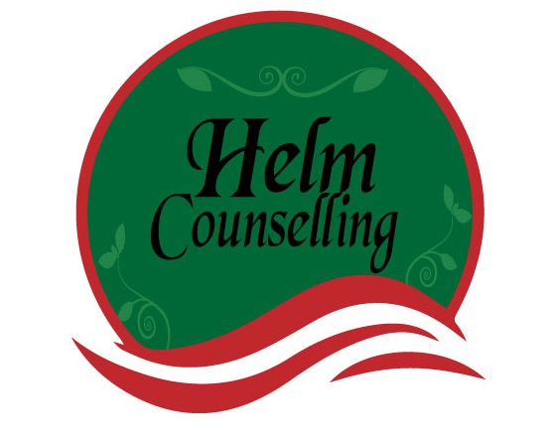

Attachment́ Questionnaire

Siegel, Daniel J. & Hartzell, Mar. (2004). Parenting from the Inside Out: How a Deeper Self-Understanding Can Help You Raise Children Who Thrive (pp. 133 - 134). New York: Jeremy P. Tarcher/Penguin

Name Date

Please use additional paper to answer these questions so your responses will not be limited.

- What was it like growing up? Who was in your Family?

- How did you get along with your parents early in your childhood? How did the relationship evolve throughout your youth and up until the present time?

- How did your relationship with your Mother and Father differ and how were they similar? A Are there ways in which you try to be like, or try not to be like, each of your parents?

- Did you ever feel rejected or threatened by your parents? Were there other experiences you had that felt overwhelming or traumatizing in your life, during childhood or beyond? Do any of these experiences still feel very much alive? Do they continue to influence your life?

- How did your parents discipline you as a child? What impact did they have on your childhood, and how do you feel it affects your role as a parent now?

- Do you recall your earliest separations from your parents? What was it like? Did you ever have a prolonged separation from your parents?

- Did anyone significant in your life die during your childhood, or later in your life? What was that like for you at the time, and how does that loss affect you now?

- How did your parents communicate with you when you were happy and excited? Did they join with you in your enthusiasm? When you were distressed or unhappy as a child, what would happen? Did your father and mother respond differently to you during these emotional times? How?

- Was there anyone else besides your parents in your childhood who took care of you? What was that relationship like for you? What happened to these individuals? What is it like for you when you let others take care of your child now?

- If you had difficult times during your childhood, where there positive relationships in or outside your home that you could depend on during those times? How do you feel those connections benefited you then, and how might they help you now?

- How have your childhood experiences influenced your relationships with others as an adult? Do you find yourself trying not to behave in certain ways because of what happened to you as a child? Do you have patterns of behaviors that you’d like to alter but have difficulty changing?

- What impact do you think your childhood has had on your adult life in general, including the ways in which you think of yourself and the ways you relate to your children? What would you like to change about the way you understand yourself and relate to others?

