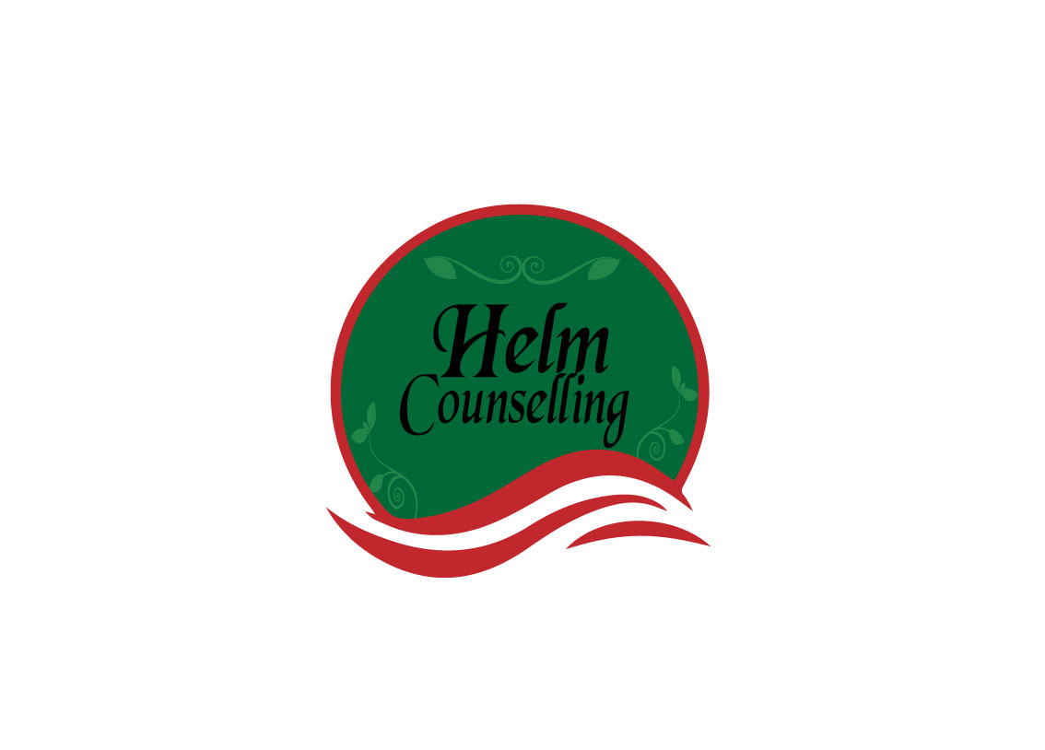
Breaking Down Our Walls Couples

What attitudes and behaviors may get in the way of you forming or maintaining quality relationships?

Low self-esteem (including “false pride”)
Addictions, compulsions, illness (mental and physical)
Prioritizing work over relationships
Alienating or isolating tendencies
Super-independence from others
Overdependence on others or co-dependency (with addicts)
Worrying too much
Social anxiety or shyness
Feeling “different” from others

Fear of rejection, abandonment or being alone

Fear of failure

Fear of criticism, confrontation or anger

Oversensitivity (including defensiveness)

Excessive feelings of guilt

Martyrdom or “victim syndrome”

Frequently comparing self to others

Unrealistic expectations toward self or others

Perfectionism

Taking life or self too seriously, difficulty having fun

Chaotic or over flexible tendencies

Not being able to take things seriously enough

Procrastination or indecisiveness

Extreme loyalty to others

People-pleasing or approval-seeking tendencies

Non-assertiveness (passivity or passive-aggressiveness)

Ignoring or not expressing self and own needs and feelings

Caretaking or super-responsibility for others

Stereotyping people

Aggressiveness or resentment (holding grudges)

Jealousy or envy

Super-irresponsibility or not keeping agreements

Nondisclosure of self (including fear of “being found out”)

Dishonesty or manipulative tendencies

Avoidance of commitments (includes fear of feeling “trapped”)

Overuse of defense mechanisms (e.g., denial, blame)

Other:

