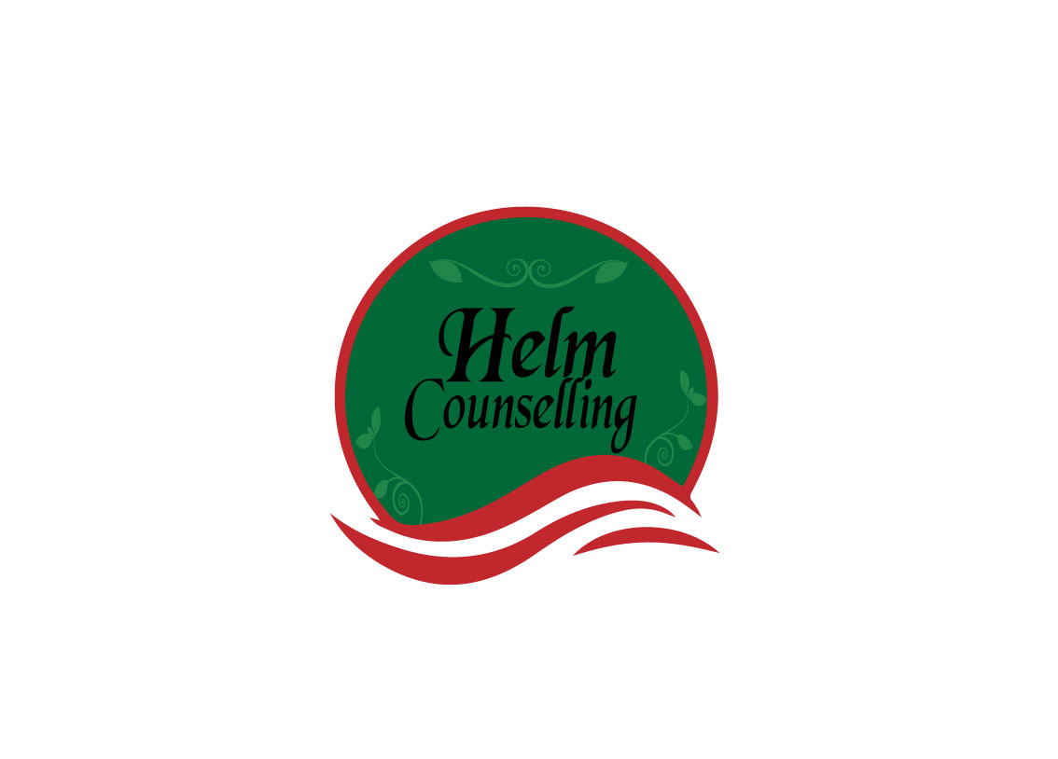
Breaking Down Our Walls

What attitudes and behaviors may get in the way of you forming or maintaining quality relationships?

Low self-esteem (including “false pride”).
Addictions, compulsions, illness (mental and physical).
Prioritizing work over relationships.
Alienating or isolating tendencies.
Super-independence from others.
Overdependence on others or co-dependency (with addicts).
Worrying too much.
Social anxiety or shyness.
Feeling “different” from others.

Fear of rejection, abandonment or being alone.

Fear of failure.

Fear of criticism, confrontation, or anger.

Oversensitivity (including defensiveness).

Excessive feelings of guilt.

Martyrdom or “victim syndrome.”

Frequently comparing self to others.

Unrealistic expectations toward self or others.

Perfectionism

Taking life or self too seriously, difficulty having fun.

Chaotic or over flexible tendencies.

Not being able to take things seriously enough.
Procrastination or indecisiveness.

Extreme loyalty to others.

People-pleasing or approval-seeking tendencies.

Non-assertiveness (passivity or passive-aggressiveness).

Ignoring or not expressing self and own needs and feelings.

Caretaking or super-responsibility for others.

Stereotyping people.

Aggressiveness or resentment (holding grudges).

Jealousy or envy.

Super-irresponsibility or not keeping agreements.

Nondisclosure of self (including fear of “being found out”).

Dishonesty or manipulative tendencies.

Avoidance of commitments (includes fear of feeling “trapped”).

Overuse of defense mechanisms (e.g., denial, blame).

Other:

Focusing on developing healthy relationships is an important life skill!

Received
Satisfaction Yes No From where? How?
Making use of my talents and/or education
Having an opportunity to learn things
Getting a sense of personal accomplishment
Enjoying friendships through activities
Building financial security
Gaining a sense of Autonomy
Enjoying doing a task or project
Making contacts for the future
Other:

Insights:

- Is there any one area giving you many of your satisfactions?
- Did you have satisfactions in the past, which are absent now? Describe.
- Do you see some present sources of work satisfactions changing in the next few years?
- Other insights

