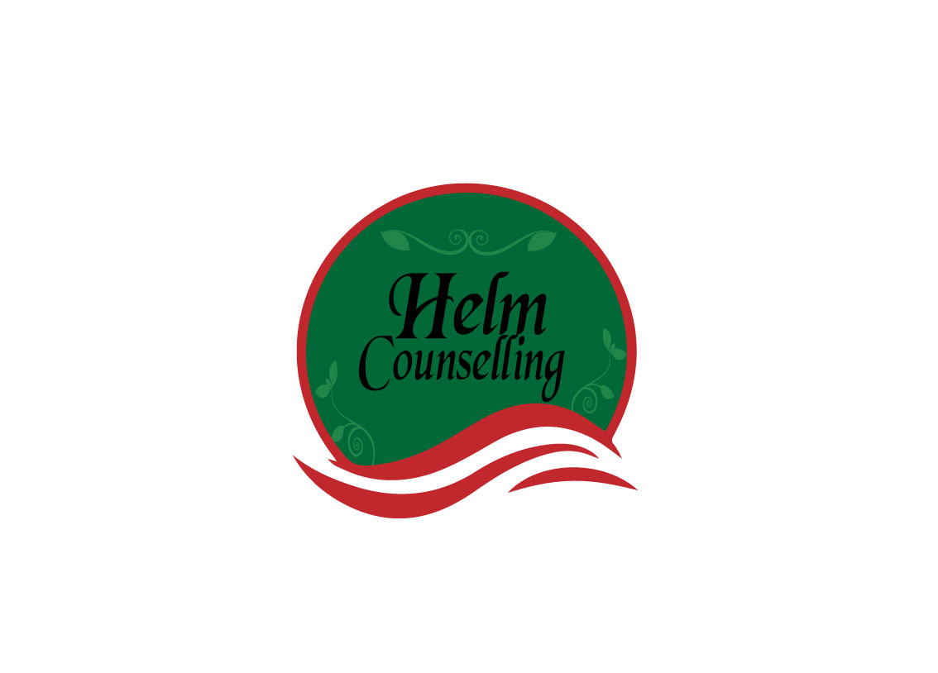

**Checklist for Relationship Health**

1. Are there any resentments or bad feelings that I am holding on to from the past?

2. Do I use manipulation tactics or are they being used on me?

3. Are we both learning from mistakes?

4. Am I in this relationship because it is convenient?

5. Do we have similar outlooks for the future?

6. If I knew then what I know now would I still choose them?

7. Am I keeping any secrets that I think could ruin my relationship?

8. Is the relationship harmful in any way?

9. Am I afraid of loneliness?

10. Do I feel loved and also, does my partner truly feel loved?

11. Am I still my own person?

12. If I could leave the relationship very easily and immediately with no implications, would I?