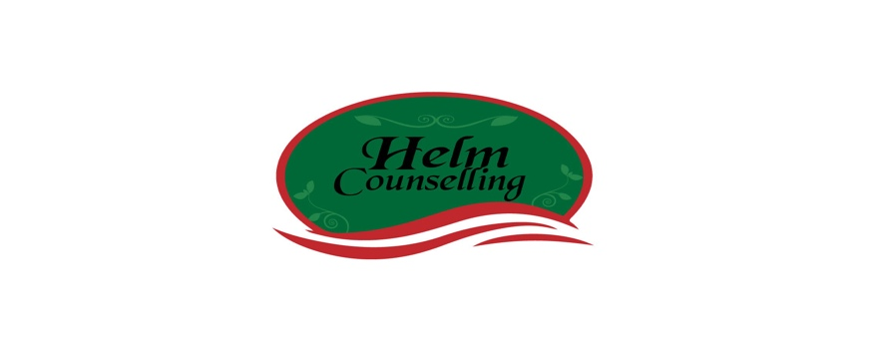
COMMUNICATION PATTERNS QUESTIONNAIRE

Andrew Christensen & Megan Sullaway

Directions: We are interested in how you and your partner typically deal with problems in your relationship. Please rate each item on a scale of 1 (= very unlikely) to 9 (= very likely).

A. WHEN SOME PROBLEM IN MY RELATIONSHIP ARISES,

Very Very

Unlikely Likely

1. Mutual Avoidance. Both my partner and I 1 2 3 4 5 6 7 8 9
avoid discussing the problem.

2. Mutual Discussion. Both my partner and I 1 2 3 4 5 6 7 8 9
try to discuss the problem.

Discussion/Avoidance.
3. I try to start a discussion while 1 2 3 4 5 6 7 8 9
my partner tries to avoid a discussion.

4. My partner tries to start a discussion 1 2 3 4 5 6 7 8 9
while I try to avoid a discussion.

B. DURING A DISCUSSION OF A RELATIONSHIP PROBLEM,

5. Mutual Blame. Both my partner and I 1 2 3 4 5 6 7 8 9
blame, accuse, and criticize one another.

6. Mutual Expression. Both my partner and I 1 2 3 4 5 6 7 8 9
express our feelings to each other.

7. Mutual Threat. Both my partner and I 1 2 3 4 5 6 7 8 9
threaten one another with negative consequences.

8. Mutual Negotiation. Both my partner and I 1 2 3 4 5 6 7 8 9
suggest possible solutions and compromises.

Demand/Withdraw.
9. I nag and demand while my partner 1 2 3 4 5 6 7 8 9
withdraws, becomes silent, or refuses
to discuss the matter further.

10. My partner nags and demands while I 1 2 3 4 5 6 7 8 9
withdraw, become silent, or refuse
to discuss the matter further.

B. DURING A DISCUSSION OF A RELATIONSHIP PROBLEM,

Very Very
Unlikely Likely

Criticize/Defend.
11. I criticize while my partner 1 2 3 4 5 6 7 8 9
defends himself or herself.

12. My partner criticizes while I 1 2 3 4 5 6 7 8 9
defend myself.

Pressure/Resist.
13. I pressure my partner to take some action 1 2 3 4 5 6 7 8 9
or stop some action, while my partner resists.

14. My partner pressures me to take some action 1 2 3 4 5 6 7 8 9
or stop some action, while I resist.

Emotional/Logical.
15. I express feelings while my partner 1 2 3 4 5 6 7 8 9
offers reasons and solutions.

16. My partner expresses feelings while I 1 2 3 4 5 6 7 8 9
offer reasons and solutions.

Threat/Back down.
17. I threaten negative consequences 1 2 3 4 5 6 7 8 9
and my partner gives in or backs down.

18. My partner threatens negative consequences 1 2 3 4 5 6 7 8 9
and I give in or back down.

Verbal Aggression.
19. I call my partner names, swear at 1 2 3 4 5 6 7 8 9
my partner, or attack my partner’s character.

20. My partner calls me names, swears at 1 2 3 4 5 6 7 8 9
me, or attacks my character.

Physical Aggression.
21. I push, shove, slap, hit, or kick 1 2 3 4 5 6 7 8 9
my partner.

22. My partner pushes, shoves, slaps, hits, 1 2 3 4 5 6 7 8 9
or kicks me.

C. AFTER A DISCUSSION OF A RELATIONSHIP PROBLEM,
Very Very
Unlikely Likely

23. Mutual Understanding. Both my partner 1 2 3 4 5 6 7 8 9
and I feel understood by each other.

24. Mutual Withdrawal. Both my partner and 1 2 3 4 5 6 7 8 9
I withdraw from each other.

25. Mutual Resolution. Both my partner and I feel 1 2 3 4 5 6 7 8 9
that the problem has been solved.

26. Mutual Withholding. Neither I nor my partner 1 2 3 4 5 6 7 8 9
is giving to the other.

27. Mutual Reconciliation. Both my partner and I 1 2 3 4 5 6 7 8 9
try to be especially nice to each other.

Guilt/Hurt.
28. I feel guilty for what I said or did 1 2 3 4 5 6 7 8 9
while my partner feels hurt.

29. My partner feels guilty for what he or 1 2 3 4 5 6 7 8 9
she said or did while I feel hurt.

Reconcile/Withdraw.
30. I try to be especially nice, and act
as if things are back to normal, 1 2 3 4 5 6 7 8 9
while my partner acts distant.

31. My partner tries to be especially nice, and
act as if things are back to normal, 1 2 3 4 5 6 7 8 9
while I act distant.

Pressure/Resist.
32. I pressure my partner to apologize or 1 2 3 4 5 6 7 8 9
promise to do better, while my partner resists.

33. My partner pressures me to apologize or
promise to do better, while I resist. 1 2 3 4 5 6 7 8 9

Support Seeking.
34. I seek support from others (parent, friend, 1 2 3 4 5 6 7 8 9
children, etc.)

35. My partner seeks support from others (parent, 1 2 3 4 5 6 7 8 9
friend, children, etc.)

