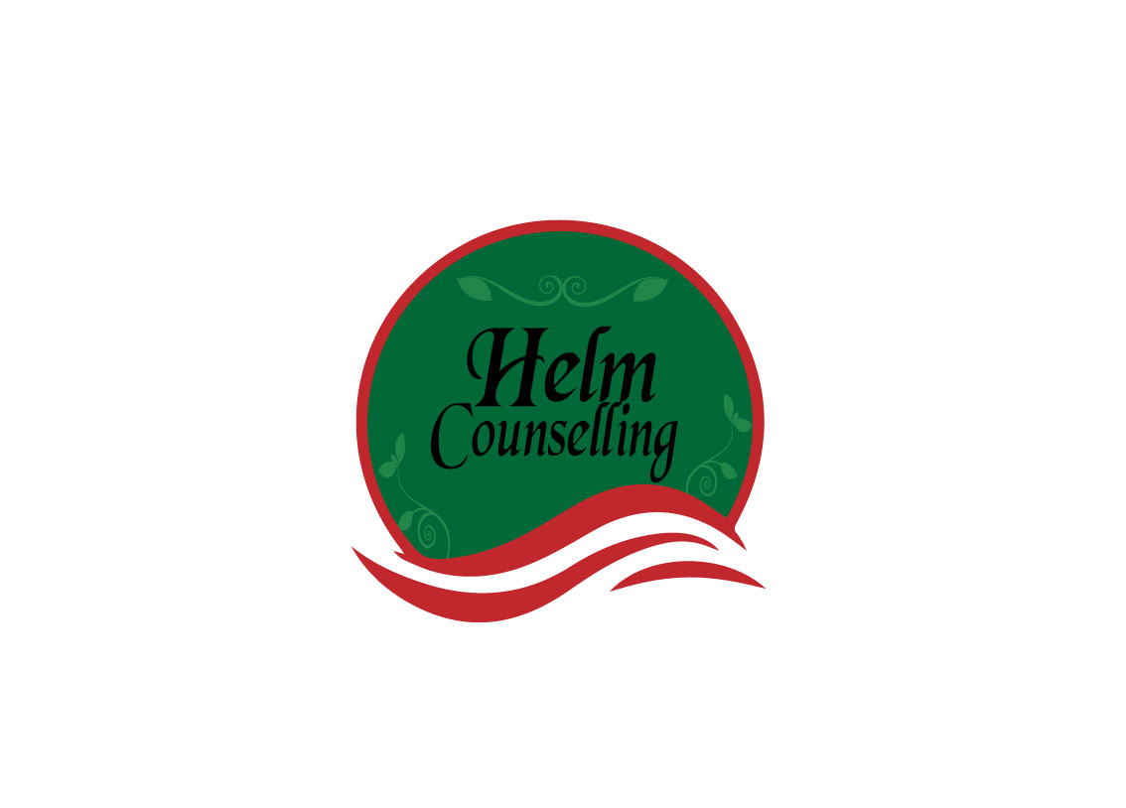

Write a one-page definition of what a relationship is.

If you have people in your life who are willing to do this exercise, share your definitions. How are they similar? Different?

