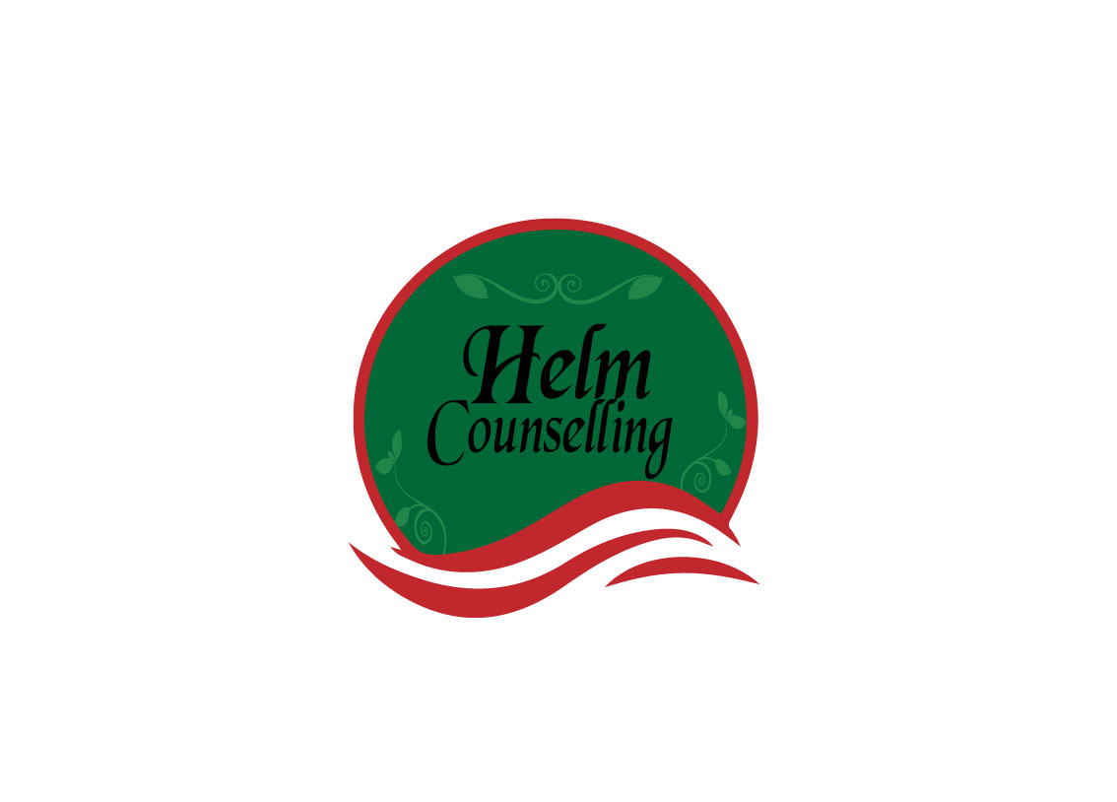
Questions for Couples

What models did you have for loving relationships when you were growing up?

What did you learn from them and what did you learn from those that weren’t healthy?

What did you learn about self-love?

How was love expressed in your childhood?

If you were a survivor of abuse, how have you done your healing work?

If addiction was present in your family, how has it impacted on you?

How do you want your relationship to mirror that of your parents and how do you want it to differ?

If someone disagrees with you, how do you face it?

When things don’t go the way you want, how do you handle disappointment?

How do you express emotion, most especially anger?

What was the best thing that ever happened in your life?

What was the worst thing that ever happened in your life?

How do you deal with change?

What brings you joy and satisfaction?

What are your values—particularly social?

How do you take care of yourself physically, emotionally, mentally and spiritually?

What is your take on child raising when it comes to discipline and consequences?

How do you face loss?

When the inevitable dark nights of the soul occur, what sustains you until the morning comes?

What are your spiritual beliefs? (For some who see themselves as atheist or agnostic, what enlightens and enlivens you and from where do you get your sustenance?)

Let’s talk about sexual desires, experiences and needs.

