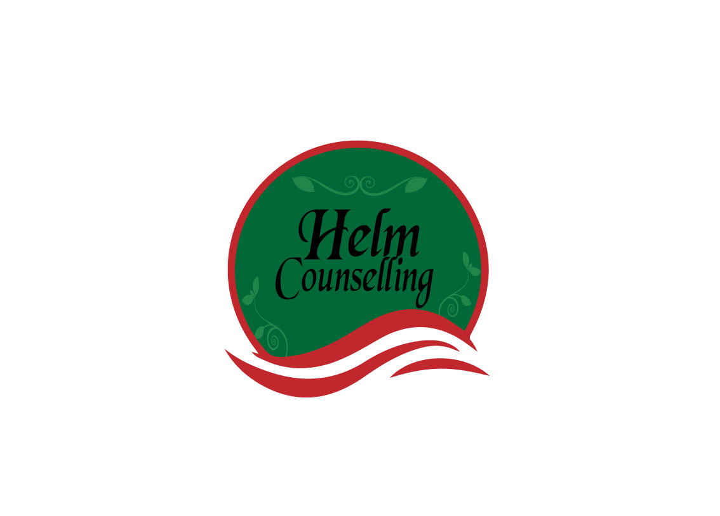
Relationship History Assessment

- (name)
What attracted you:
How you were hurt:
What you learned about yourself/opposite sex:

- (name)
What attracted you:
How you were hurt:
What you learned about yourself/opposite sex:

- (name)
What attracted you
How you were hurt:
What you learned about yourself/opposite sex:

- (name)
What attracted you:
How you were hurt:
What you learned about yourself/opposite sex:

- (name)
What attracted you:
How you were hurt:
What you learned about yourself/opposite sex:

- (name)
What attracted you:
How you were hurt:
What you learned about yourself/opposite sex:

- (name)
What attracted you
How you were hurt:
What you learned about yourself/opposite sex:

- (name)
- What attracted you:
How you were hurt:
What you learned about yourself/opposite sex:
Do you see any patterns? Yes No
How would you characterize your relationship with your opposite sex parent? (For instance, I felt very comfortable and accepted; I felt unwanted and pushed aside.)

How did your relationship with your opposite-sex parent influence your other relationships with the opposite sex? (For instance, I felt rejected by my father, and so I’ve always needed a lot of male attention; I felt controlled by my mother, and I let women control me.)

Summary
What have you learned about yourself in general through your relationships with the opposite sex? (For instance, that I get hurt a lot, that I desperately need to have a boyfriend/girlfriend to feel goo about myself.)

