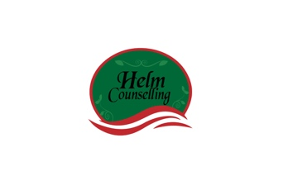
Understanding Your Negative Cycle

Couples get caught in “negative cycles” of interaction. A “negative cycle” is a repeating pattern of negative behaviors, thoughts, and feelings that causes distress. You react to your partner’s reactions and your partner reacts to your reactions. Understanding and untangling your “negative cycles” will stop the cycle. The exercise below will help you with this process.

When my partner and I are not getting along:

I often react by

My partner often reacts to me by

When my partner reacts this say, I often feel…

When I feel this way I, see myself as…

When I feel this way I long for or need…

When I react the way I do, I guess that my partner feels…

Describe your repeating negative cycle (include how you and your partner trigger each other’s feelings, thoughts, and behaviors)…

