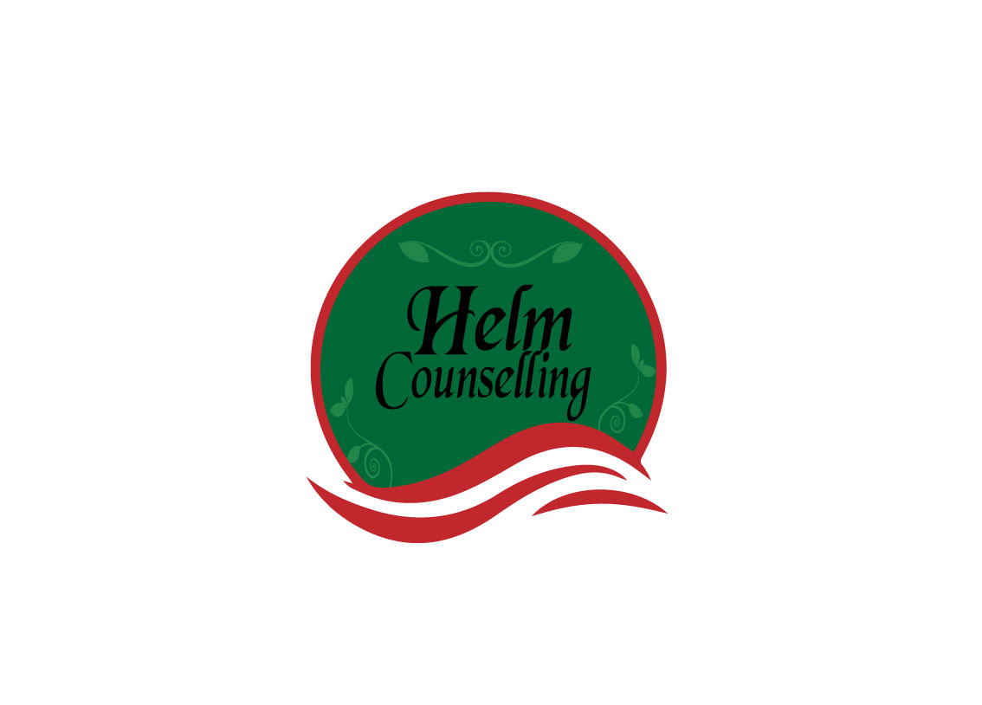
What do you want in a relationship?

What won’t you give?

What have you stopped risking?

