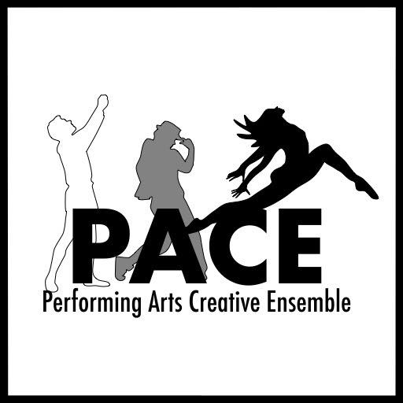
PERFORMING ARTS CREATIVE ENSEMBLE
“Barefoot In The Park” AUDITION FORM

Name:______________________________________ Birthdate:________________ Gender:________________

Phone:__________________________ Email:_____________________________________________________

Height:______ Weight:______ Hair Color:________ Sizes: Shirt______ Pant______ Dress______ Shoe______

Specific role(s) you are auditioning for:___________________________________________________________

Please check one: ______ I will accept any role

______ I will accept only the role(s) listed above.

If you are not cast, are you interested in helping behind the scenes? (Check all that apply)

_____Costumes _____Set Construction _____Stage Crew _____Props _____Sound _____Lights

Schedule Information
Rehearsals begin Monday, March 23. Rehearsals are Monday – Thursday, 7pm-10pm or 7:30pm-10:30pm.
**Some possible Sunday evenings, if necessary**
Tech Begins Sunday, May 10, time TBD. Tech rehearsals start at 6:30pm.

Performances:
May 14 – 17, 2020
Thu-Sat 8pm
Sun 3pm

Please list ALL KNOWN CONFLICTS: This section is VERY IMPORTANT (Use the back of this form if needed)
___________________________________________________________________________________________
___________________________________________________________________________________________
___________________________________________________________________________________________
Theatrical Experience
Please attach a resume or briefly summarize your theatrical experience on the back.

Do you have reliable transportation to and from rehearsals and performances? ____________

