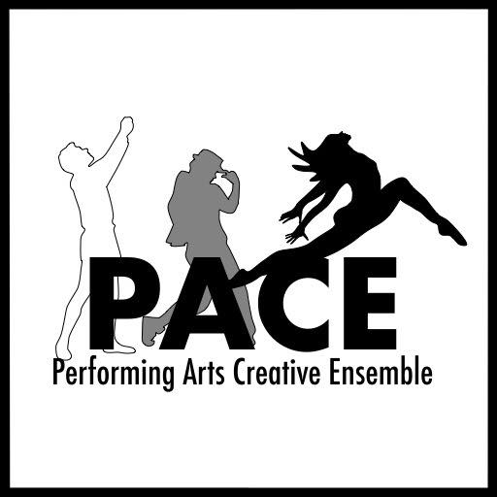
PERFORMING ARTS CREATIVE ENSEMBLE
“EQUUS” AUDITION FORM

Name:______________________________________ Birthdate:________________ Gender:________________

Phone:__________________________ Email:_____________________________________________________

Height:______ Weight:______ Hair Color:________ Sizes: Shirt______ Pant______ Dress______ Shoe______

Specific role(s) you are auditioning for:___________________________________________________________

Please check one: ______ I will accept any role

______ I will accept only the role(s) listed above.
**THE ROLES OF ALAN AND JILL REQUIRE FULL NUDITY ON STAGE**

If you are not cast, are you interested in helping behind the scenes? (Check all that apply)

_____Costumes _____Set Construction _____Stage Crew _____Props _____Sound _____Lights

Schedule Information
Read Thru scheduled for Thursday, January 9 7pm-10pm
Rehearsals begin Monday, January 13. Rehearsals are Monday – Thursday, 7pm-10pm or 7:30pm-10:30pm.
Tech Begins Sunday, March 15, time TBD. Tech rehearsals start at 6:30pm.

Performances:
March 19 – 22, 2020
Thu-Sat 8pm
Sun 3pm

Please list ALL KNOWN CONFLICTS: This section is VERY IMPORTANT (Use the back of this form if needed)
___________________________________________________________________________________________
___________________________________________________________________________________________
___________________________________________________________________________________________
Theatrical Experience
Please attach a resume or briefly summarize your theatrical experience on the back.

Do you have reliable transportation to and from rehearsals and performances? ____________

****Please read and initial to indicate agreement****
I understand that this production includes adult content, including nudity and adult language. I further understand that if I am cast in a role that requires nudity and adult language, I will perform the duties requested.

Initials___________________________ Date______________________

