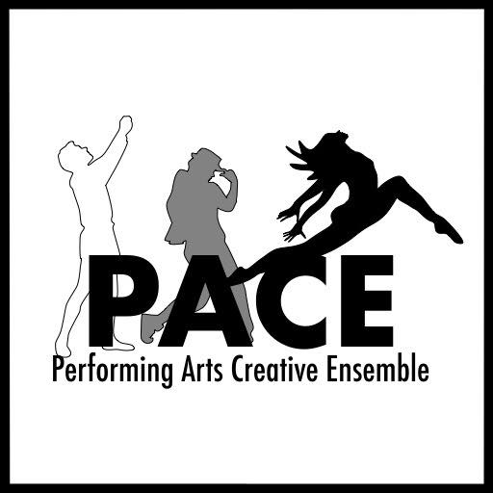
PERFORMING ARTS CREATIVE ENSEMBLE
“Wait Until Dark” AUDITION FORM
Please Print Legibly:

Name:______________________________________ Birthdate:________________ Gender:________________

Phone:__________________________ Email:_____________________________________________________

Height:______ Weight:______ Hair Color:________ Sizes: Shirt______ Pant______ Dress______ Shoe______

Specific role(s) you are auditioning for:___________________________________________________________

Please check one: ______ I will accept any role

______ I will accept only the role(s) listed above.

If you are not cast, are you interested in helping behind the scenes? (Check all that apply)

_____Costumes _____Set Construction _____Stage Crew _____Props _____Sound _____Lights

Schedule Information
Read Thru is Thursday, March 31, 7:30pm
Rehearsals begin Monday, April 7. Rehearsals are Monday – Thursday, 7:30pm-10:30pm.
Tech Load In is Sunday, June 5, time TBD. Tech Sunday is an ALL-DAY event.
Rehearsal locations are primarily:
- Columbus Dance Theatre, 592 E Main St, Columbus 43215
- Columbus Dance Theatre Bexley Location, 1039 College Ave, Columbus 43209

Performances:
June 9-12, 2022
Thu-Sat 8pm
Sun 3pm

Please list ALL KNOWN CONFLICTS: This section is VERY IMPORTANT (Use the back of this form if needed)
___________________________________________________________________________________________
___________________________________________________________________________________________
___________________________________________________________________________________________
Theatrical Experience
Please attach a resume or briefly summarize your theatrical experience on the back.

Do you have reliable transportation to and from rehearsals and performances? ____________

