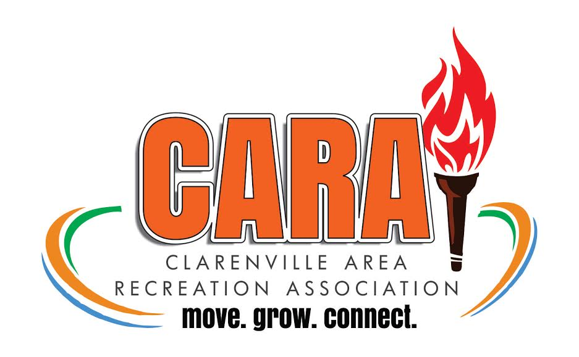
CARA Summer Program Fieldtrip!

The CARA Summer Program will be taking a Field Trip to Salmonier Nature Park on Wednesday July 24th! The bus will be leaving Clarenville Middle School at 9:00am sharp and will be returning to Clarenville Middle School approximately 4:45pm.
On the Field Trip, the kids will visit Salmonier Nature Park where they will spend the day exploring nature and learning about wildlife right here in Newfoundland. A packed lunch is required as we will be eating lunch at the park.
Kids will need to be equipped with the following essentials:
- Sneakers
- Sunscreen/Bug Spray
- Appropriate active wear
- A well packed lunch and snacks (we will be gone from 9:00am to 4:45pm and not stopping to purchase food)

Deadline for submission of permission slip is Friday July 19th
Price: $20 per child (Must be paid prior to July 19th)
CONSENT WAIVER
I ________________________ (parent/guardian’s name) give ___________________________ (Child’s name) permission to attend the CARA Summer Program Fieldtrip on Wednesday July 24th, to Salmonier Nature Park
__________________________________ ________________________________
Parent/Guardian Signature Summer Coordinator Signature

Emergency Contact: _____________________ Emergency Contact #: ________________

