BRIDAL CONTRACT

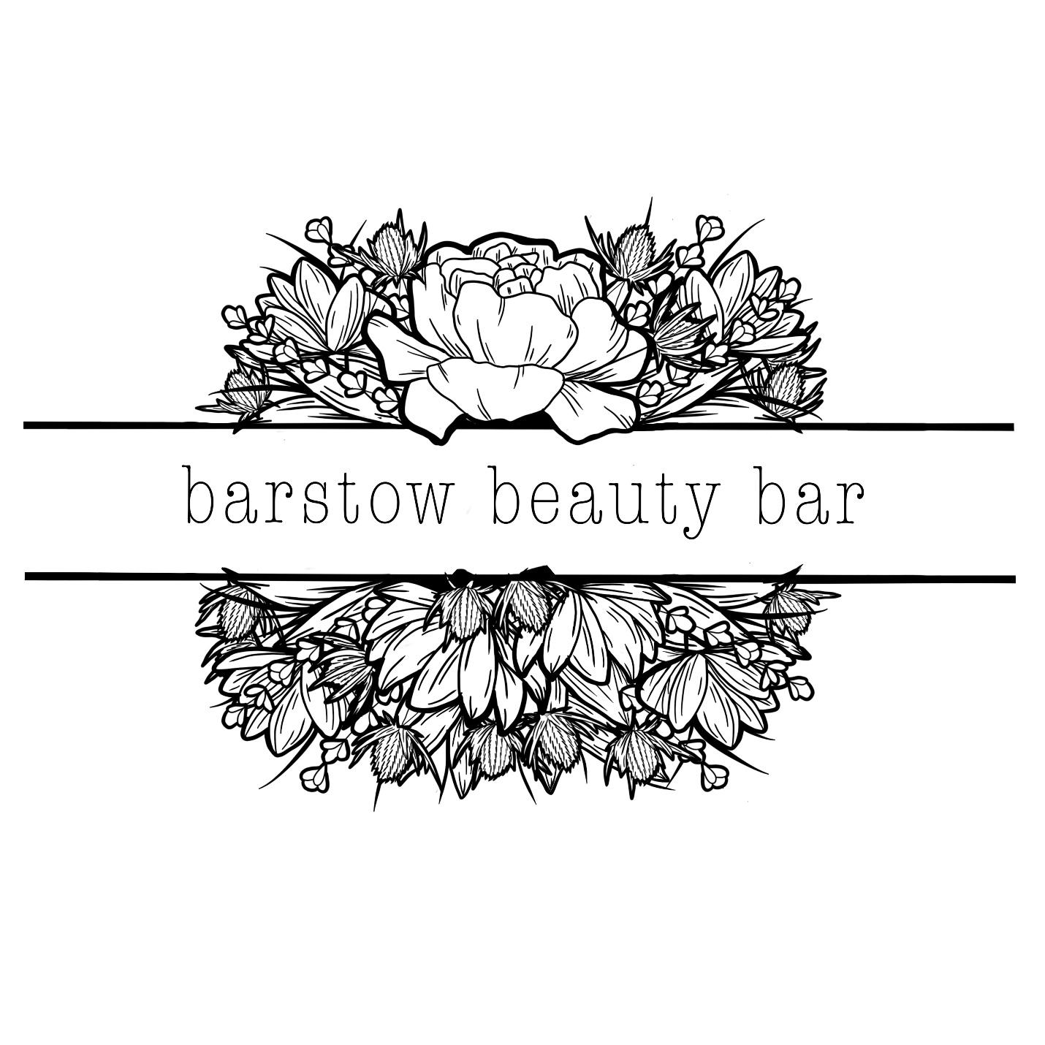

Check out our work on Instagram @barstowbeautybar
Follow along with us on Facebook at Barstow Beauty Bar.

Congratulations on your engagement and thank you for your interest in Barstow Beauty Bar! Our team has taken care of many beautiful brides over the years. We truly enjoy enhancing each and everyone’s natural beauty. Below you will find all the information you need to keep you well organized and prepared. Please read and review all policies. Please don’t hesitate to ask any further questions!

Thank you,

Caroline Leonardson
Owner and Licensed Aesthetician

DEPOSITS AND PAYMENTS
Immediate payment of a non-refundable, non-transferable $150 deposit is required before a date will be held (must be paid within 48 hours of receiving invoice.) Should no payment / deposit be received, I have the right to cancel all services and proceed with another inquiry.

We require 50% payment 6 months prior to your wedding, and payment in full up to 30 days minimum prior to your wedding date. All payments are a responsibility of the bride. We do not accept payments from any other bridal party members.

Deposit and payment requests will be sent through digital invoice via Square.

Makeup services or hair styling costs, as specified at the time of initial Contract, are non-negotiable and the agreed upon price will still be charged whether or not all services outlined on the booking form are required, or cancellations are made at a later date.

Changes to your booking such as adding another person onto your original booking, can only be accepted if time / resources allow on your wedding day. Full payment will be due at the time of add on.

The bride may choose from three package options. The bridal party / family members are welcome to register for services and come in the week of the wedding for any additional services. Please plan accordingly and schedule online using our booking site, Square.

FOR THE BRIDE…

Bridal Makeup Trial - $90
*REQUIRED AT A MINIMUM OF ONE MONTH PRIOR TO WEDDING DATE*

LEVEL ONE - $150
Bridal Makeup – wedding day cleanse & skin prep, makeup application, & choice of lip color to keep.

LEVEL TWO - $225
BEFORE the big day – glo & go facial, brow shaping & tint.
WEDDING DAY – cleanse & skin prep, makeup application, & choice of lip color to keep.

LEVEL THREE - $300
BEFORE the big day – signature facial, custom color spray tan, brow shaping & tint.
WEDDING DAY – cleanse & skin prep, makeup application, & choice of lip color to keep.

Bridal Hair Trial - $95+
*REQUIRED AT A MINIMUM OF ONE MONTH PRIOR TO WEDDING DATE*

Bridal Hair Styling/Updo - $120
please keep in mind, if you plan on wearing extensions the day of your wedding - bring them along (or have them installed) before your trial

FOR THE BRIDAL PARTY & FAMILY…

Bridal Party Member Makeup Application $90
(full glam makeup with false lashes & lip color available for purchase at 15% discount)

Hair Styling/Updo - $75
*If you are hoping to have 90 minutes of time spent on a very detailed hair updo like the bride, you will need to make us aware ahead of time so we can plan accordingly. You will also be charged for a bridal style for the extra time needed to accommodate your desired look.*
- If anyone brings clip-in extensions to be added in, there will be an additional $25 cost
Flower Girl Glam (blush & lip gloss, hair curled) $40

Men’s Clean Up (cleanse, clean up brows, conceal any blemishes) $30

MAKEUP & HAIR TRIALS
I strive to ensure that you are happy with the results of a trial before finishing. In the unlikely event that you, or any of your bridal party, decide after your trial that you are not satisfied, you are able to book another trial online. Trials are required and cost $90 for makeup and $100 for hair. Cost of the trial will be due the day of the trial appointment.

TRAVEL EXPENSE
Your entire party is welcome to have services at Barstow Beauty Bar. However, I do not travel to other salons out of professional respect for their team members. I will travel to approved wedding venues if discussed at time of booking. Location of services can only be changed at least 30 days prior to the wedding date. There is a cost of $150 for all offsite weddings (services that are not being performed at Barstow Beauty Bar) + $100/hour of travel time. All offsite weddings under one hour of travel will only be responsible for 80 cents per mile traveled from BBB (& $150 offsite fee) - please provide us your address upon inquiry.

We welcome additional hair stylists to our venue (if needed) & accommodate space for them to have a suitable working environment.

You will be expected to cover all costs for hotel accommodation where it is not practical for us to travel on the day of your wedding due to delay or severe weather.

TIMING AND PREPARATION
No refund or compensation will be offered for delays caused by the wedding party. One hour will be allocated for makeup per person, but may take less time depending on their desired look. If you suspect any member of your bridal party may pose a challenge in any way, we highly suggest a trial ahead of time. They can book their trial on our website as a “makeup application”.

If your hair is being styled, we advise washing the night before to ensure it is clean, free from product, and completely dry. If you show up with wet hair we will not be able to style you, and you will not receive a refund. Plan on 45 minutes-1 hour per person for bridal party members, and up to 90 minutes for the bridal hair styling.

If we are traveling offsite- you must ensure that we will be working in a suitable environment with adequate lighting. It is not practical for an entire wedding party to get ready in a small hotel room - please keep this in mind when planning. We require one counter height (bar) stool per makeup artist if we are traveling to a hotel, and a regular height (dining) chair for hair styling. Please ensure every member of your party arrives on time for their appointment. Late arrivals will not be guaranteed service.

CIVILITY
If we are made to feel uncomfortable in any way, or mistreated, we have the right to cancel the contract without refund. In the event of extreme weather, we reserve the right to cancel your booking. We will refund service fees as a gesture of goodwill, excluding trial costs and initial deposits.

FORCE MAJEURE
If performance of this Contract or any obligation under this contract is prevented, restricted, or interfered with by causes beyond either party’s reasonable control, under this Contract is prevented (“Force Majeure”), and if the party unable to carry out its obligations of the party invoking this provision shall be suspended to the extent necessary by such event. The term Force Majeure shall include, without limitation, acts of God, fire, or vandalism, pandemic, storm or other similar occurrence, order or acts of military or civil authority, or by national emergencies, insurrections, riots, or wars. The excused party shall use reasonable efforts under the circumstances to avoid or remove such causes of non-performance and shall proceed to perform with reasonable dispatch whenever such causes are removed or ceased.

CANCELLATION POLICY
If a cancellation occurs 31 days prior to your wedding date, your final payment will be terminated, but the initial deposit + 50% paid 6 months prior will not be refunded.

If a cancellation occurs without 32 days of notice - there will be no refunds. ALL PAYMENTS ARE FINAL AND NON REFUNDABLE.

EXAMPLE: Wedding date is January 1st, 2023. $150 deposit due at time of booking to hold the date. 50% is due by June 1st, 2022. If the wedding is canceled and we receive notice on December 1st, 2022 - your contract will be terminated & you will not be expected to make any future payments.

CONTRACT AGREEMENT
It is the responsibility of the named person on the booking form to understand and accept responsibility for all booking policies, including all payments to be made. Attached will be a payment plan form and appointment form. By proceeding to pay a deposit, you accept that you are entering into a contract, and you agree to be bound by these policies.

A digital invoice will be sent to pay your $150 deposit via Square.

Thank you again for your interest in services through Barstow Beauty Bar. I look forward to working with you!

________________________________________ _____________
SIGNATURE DATE

________________________________________
PRINTED NAME

________________________________________ _____________
SIGNATURE of Caroline, Owner DATE

________________________________________
PRINTED NAME

