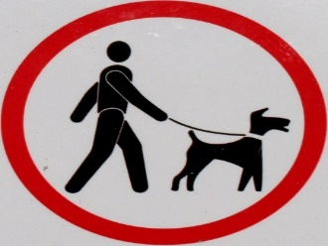

**DOG WALKING AREAS**

**All dogs must be on leashes. Do not let dogs out alone to relieve themselves.**

**All waste must be picked up and disposed of properly. Failure to do so is not only unsanitary, but it is an additional health risk, especially to all pets.**

**Authorized dog walking/relief areas are:**

* **The pine straw area to the right of the mailboxes**
* **Outside the front brick wall**
* **The three cul-de-sac islands**
* **In the woods.**

**Please refrain from walking your dogs in other homeowners’ yards or in the two large entrance islands. Continual violations can result in fines.**

**Thanks to our many responsible and considerate pet owners who follow community guidelines.**