Women of the ELCA
NW MN Synodical Women’s Organization
2026 Conference 8 Spring Gathering

Hosted by WELCA of Bethesda Lutheran Church
1204 N Nokomis St NE,
Alexandria, MN 56308

Saturday, April 18th

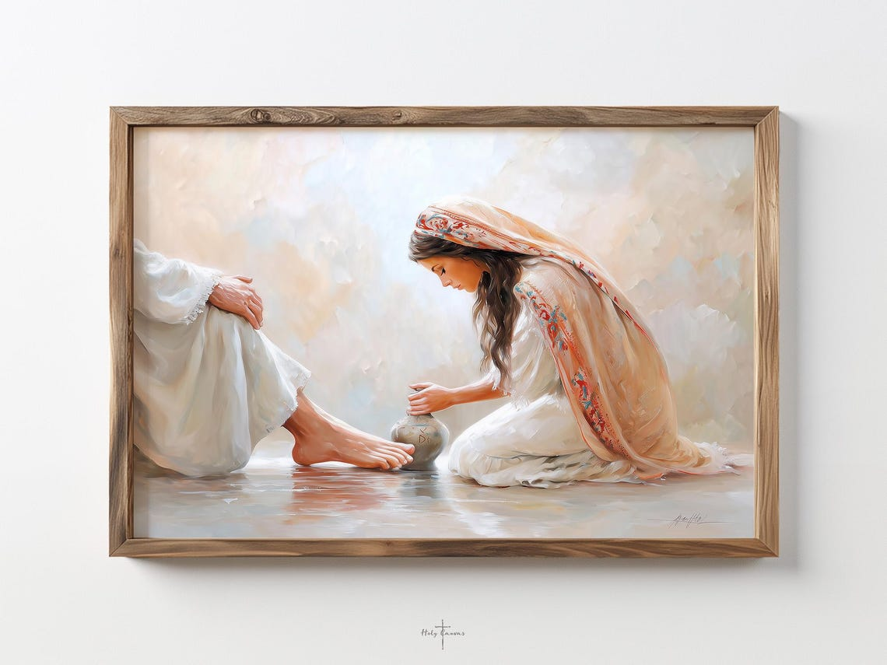

Theme: “ SERVING WITH LOVE”
Luke 10 vs 38-42:
As Jesus and his disciples were on their way, he came to a village where a woman named Martha opened her home to him. She had a sister called Mary, who sat at the Lord’s feet listening to what he said. But Martha was distracted by all the preparations that had to be made. She came to him and asked, “Lord, don’t you care that my sister has left me to do the work by myself? Tell her to help me!” “Martha, Martha,” the Lord answered, “you are worried and upset about many things, but few things are needed—or indeed only one. Mary has chosen what is better, and it will not be taken away from her.”

Guest Speaker: Peggy Kallevig
The Women of Valor

Bethesda WELCA is ask us to bring items for Life Connection of Alexandria. Suggestions: baby wash, ointment, wipes, Huggies or Pampers: Preemie to Size 12

Registration and fellowship: 8:15-9:00 am
Noon Lunch: Cost is $ 20.00 per person
Registration Deadline: Monday, April 6th
Send registration and fees to: Bethesda Lutheran Church, 1204 N. Nokomis St NE, Alexandria, MN 56308
Phone: 320-763-5164 Email: bethesdachurch1204@gmail.com

MAKE CHECKS OUT TO: WOMEN OF THE ELCA

