2022 CLUBMANS DINNER DANCE AWARDS

SATURDAY, 26th NOVEMBER
Dress code: Black Tie / Posh frocks

This year, the Clubmans Annual Dinner and Dance will be returning to The Sketchley Grange Hotel & Spa, on Saturday, 26th November in the Grove Suite.

Tickets - £65.00 per person

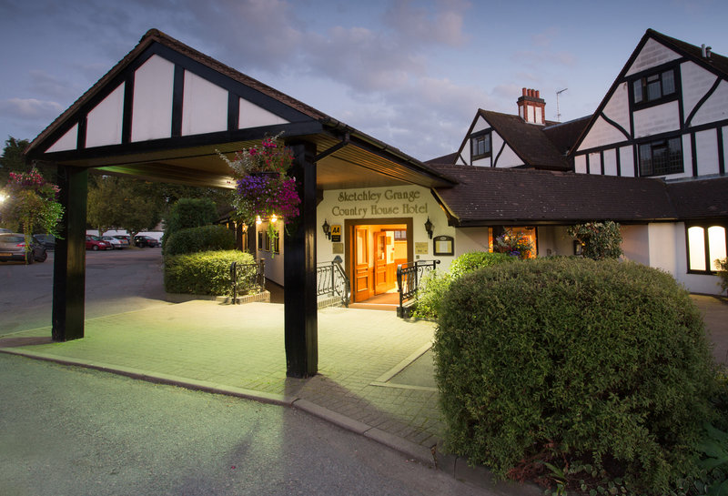

Sketchley Grange Hotel & Spa,

Sketchley Lane, Hinckley,

Leicestershire, LE10 3HU

Stunning country setting: In a pretty rural location on the borders of the East and West Midlands, Sketchley Grange Hotel & Spa lies just outside the charming market town of Hinckley. The original country house is designed in a black and white, mock Tudor architectural style, and the interiors are a blend of heritage features and contemporary design, with many rooms having just undergone a refurbishment.

Why not treat yourselves, and make a weekend of it - stay Friday and Saturday? :p

Soothing R&R: The spa and health club has an impressive 17-metre pool with Roman-style pillars and a poolside whirlpool. There's also a cedar wood sauna, an aromatic steam room and a solarium. Work up a sweat in the state-of-the-art gym or choose from a range of massages, facials and beauty treatments. Should you wish to take advantage of the Spa treatments, you will need to be book these separately with the Hotel.

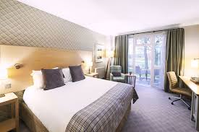 | 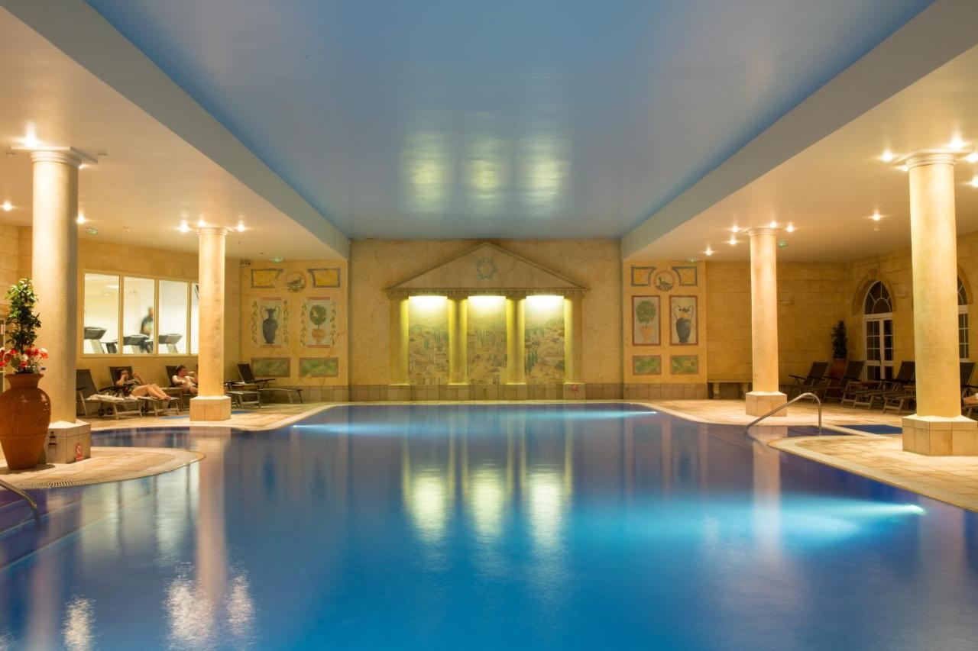 | 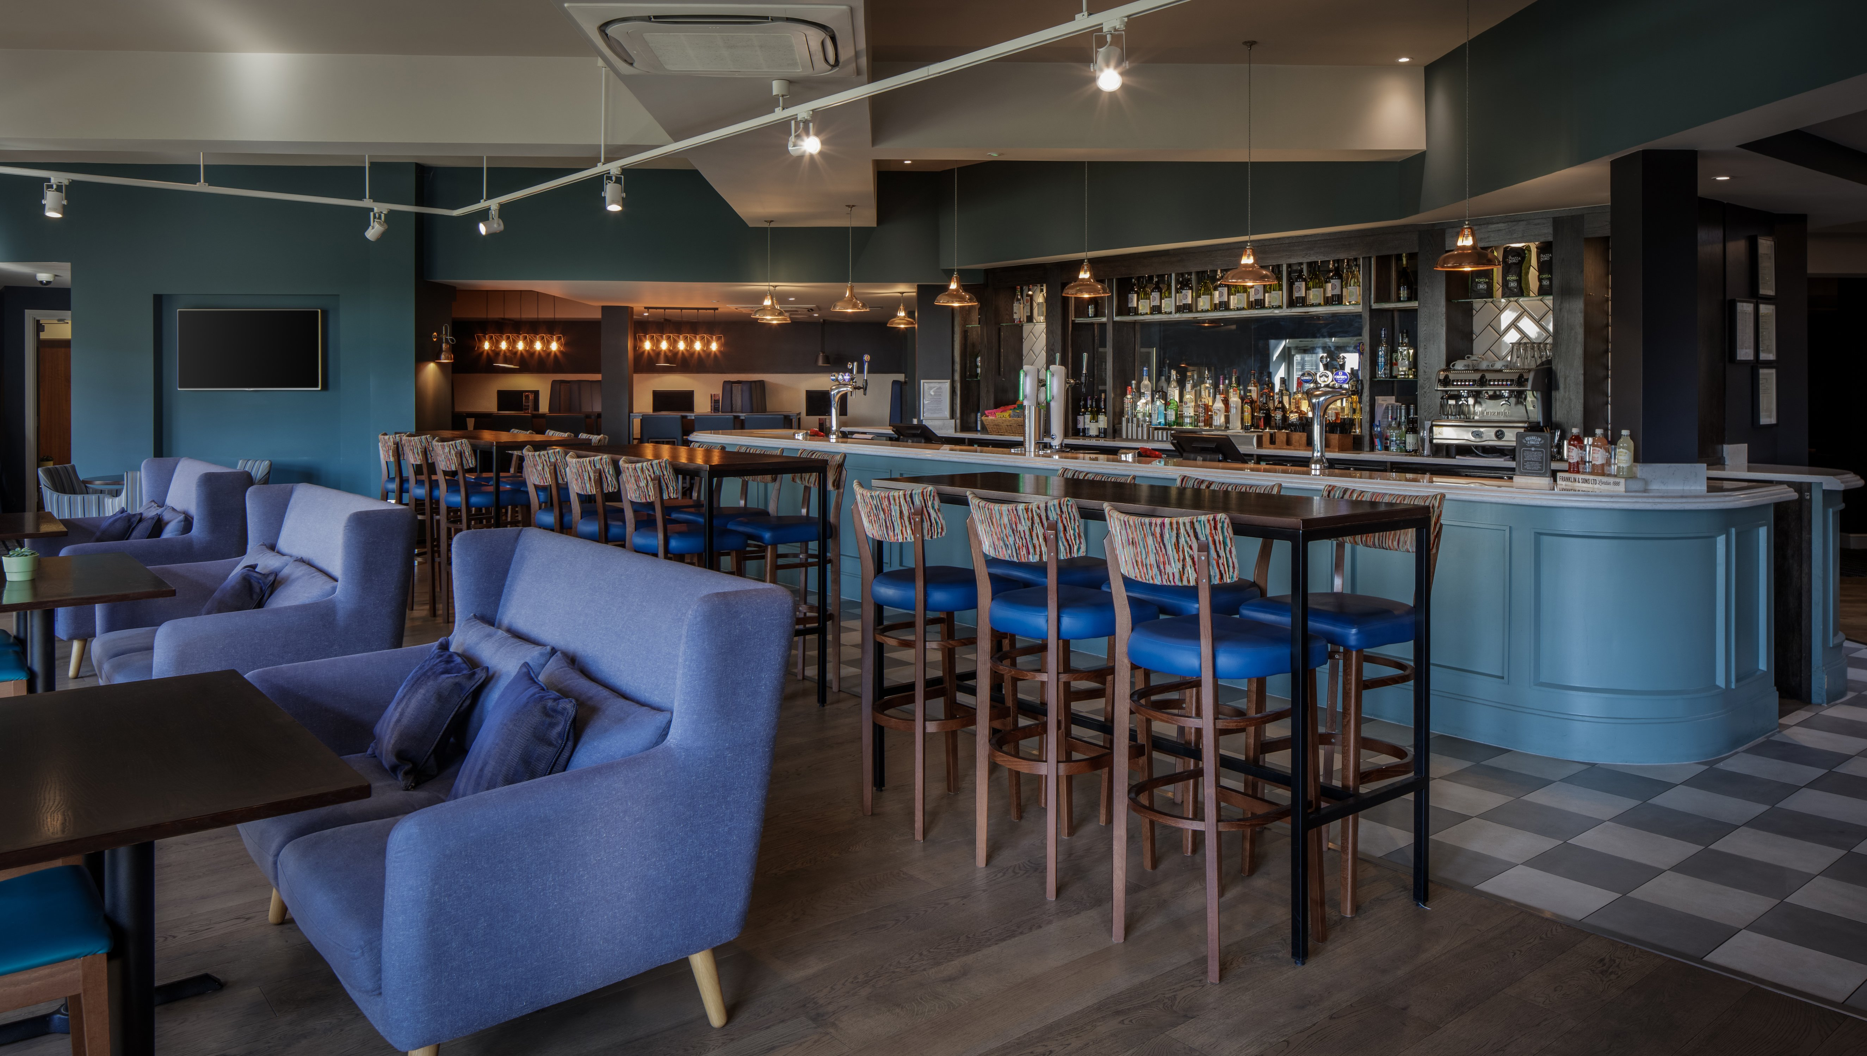

Evening Schedule

6:15pm - The evening will commence with pre-dinner drinks in Grove Suite bar. This will be your opportunity to purchase any wine or champagne before dinner, although The Clubmans Register will provide each table with 1 bottle of red, and 1 bottle of white as part of your ticket price.

7.00pm - 3-course banquet dinner (menu choices to be emailed back to Michelle).

9.00pm - The 2022 Championship Awards. Trophies will be presented during the course of the evening and there will be a raffle with some great prizes to win.

10.00pm – 1am – DJ / Dancing
Video highlights of the 2021 racing season will be on display courtesy of the Jacksons, the usual motorsport quiz competition, music and dancing.

Book and pay by 31st October for the ‘Early Bird discount price of £60’

Please send full payment for your DD tickets direct to the Clubmans Register account (in the same way as you do for race entries). Please copy Michelle & Peter Burnham on your email to confirm how many tickets you have purchased.

HOTEL ROOMS - B&B rates (for both Friday & Saturday evenings)

Classic Double Room - £109 per night
Single Occupancy Room - £99 per night

Please book your room by calling the hotel direct on 01455 251133 and quoting ‘Clubmans Dinner Dance’

Guests are required to make a £50.00 non-refundable deposit at point of booking with the rest of payment on checkout.

A total of 30 rooms are currently reserved at the agreed Clubmans rate on a first come first served basis, which will be released for general sale after November 11th. Rates are subject to availability so please be advised to book as soon as possible.

Bedroom Upgrades
There are a number of bedroom upgrades available, so it may be worth comparing with sites such as Booking.com and speaking with the hotel directly, should you wish to upgrade or take advantage of the Spa treatments. Please note the agreed Clubmans room rate is also eligible for Friday, for those wishing to make a weekend of it.

FOOD CHOICES
We are fortunate to be working with a hotel that is willing to offer us a choice, rather than a Set menu.
Please help me by emailing a list of your guest names in Full, along with their food choices as soon as possible.

Please be aware that the hotel will need final numbers and full payment for our event by November 11th. Whilst it may still be possible to get you a dinner ticket after that date, we cannot guarantee it, so please book as soon as you can, to help us organise the evening.

PAYMENTS

Preferably by Electronic transfer total payment to: Santander, S/C: 09-01-54. Account No: 40743486 Account Name: “Clubmans Register Ltd”

OR
- Cheque - please make cheques out to “Clubmans Register Ltd” or
- PayPal at treasurer@clubmansregister.com (See link on our Facebook page).

CONFIRM by email to clubmansregistersecretary@gmail.com and peter@pburnham.uk with advice of internet payment, or by
- post cheques to Vine Cottage, Lee Road, Saunderton Lee, Princes Risborough, Bucks, HP27 9NU.

If you have any queries regarding payment please call Peter Burnham on +44 (0) 7703 162141.

If you are able to donate a raffle prize for the evening, we would be extremely grateful. All proceeds go towards the continued running of our club.

Note: Cancellations/refunds – In the unfortunate event that you need to cancel your booking - cancellations received before November 11th - 100% refund, but we regret that full refunds might not be able to be made after that date.

