Xaltation |  | 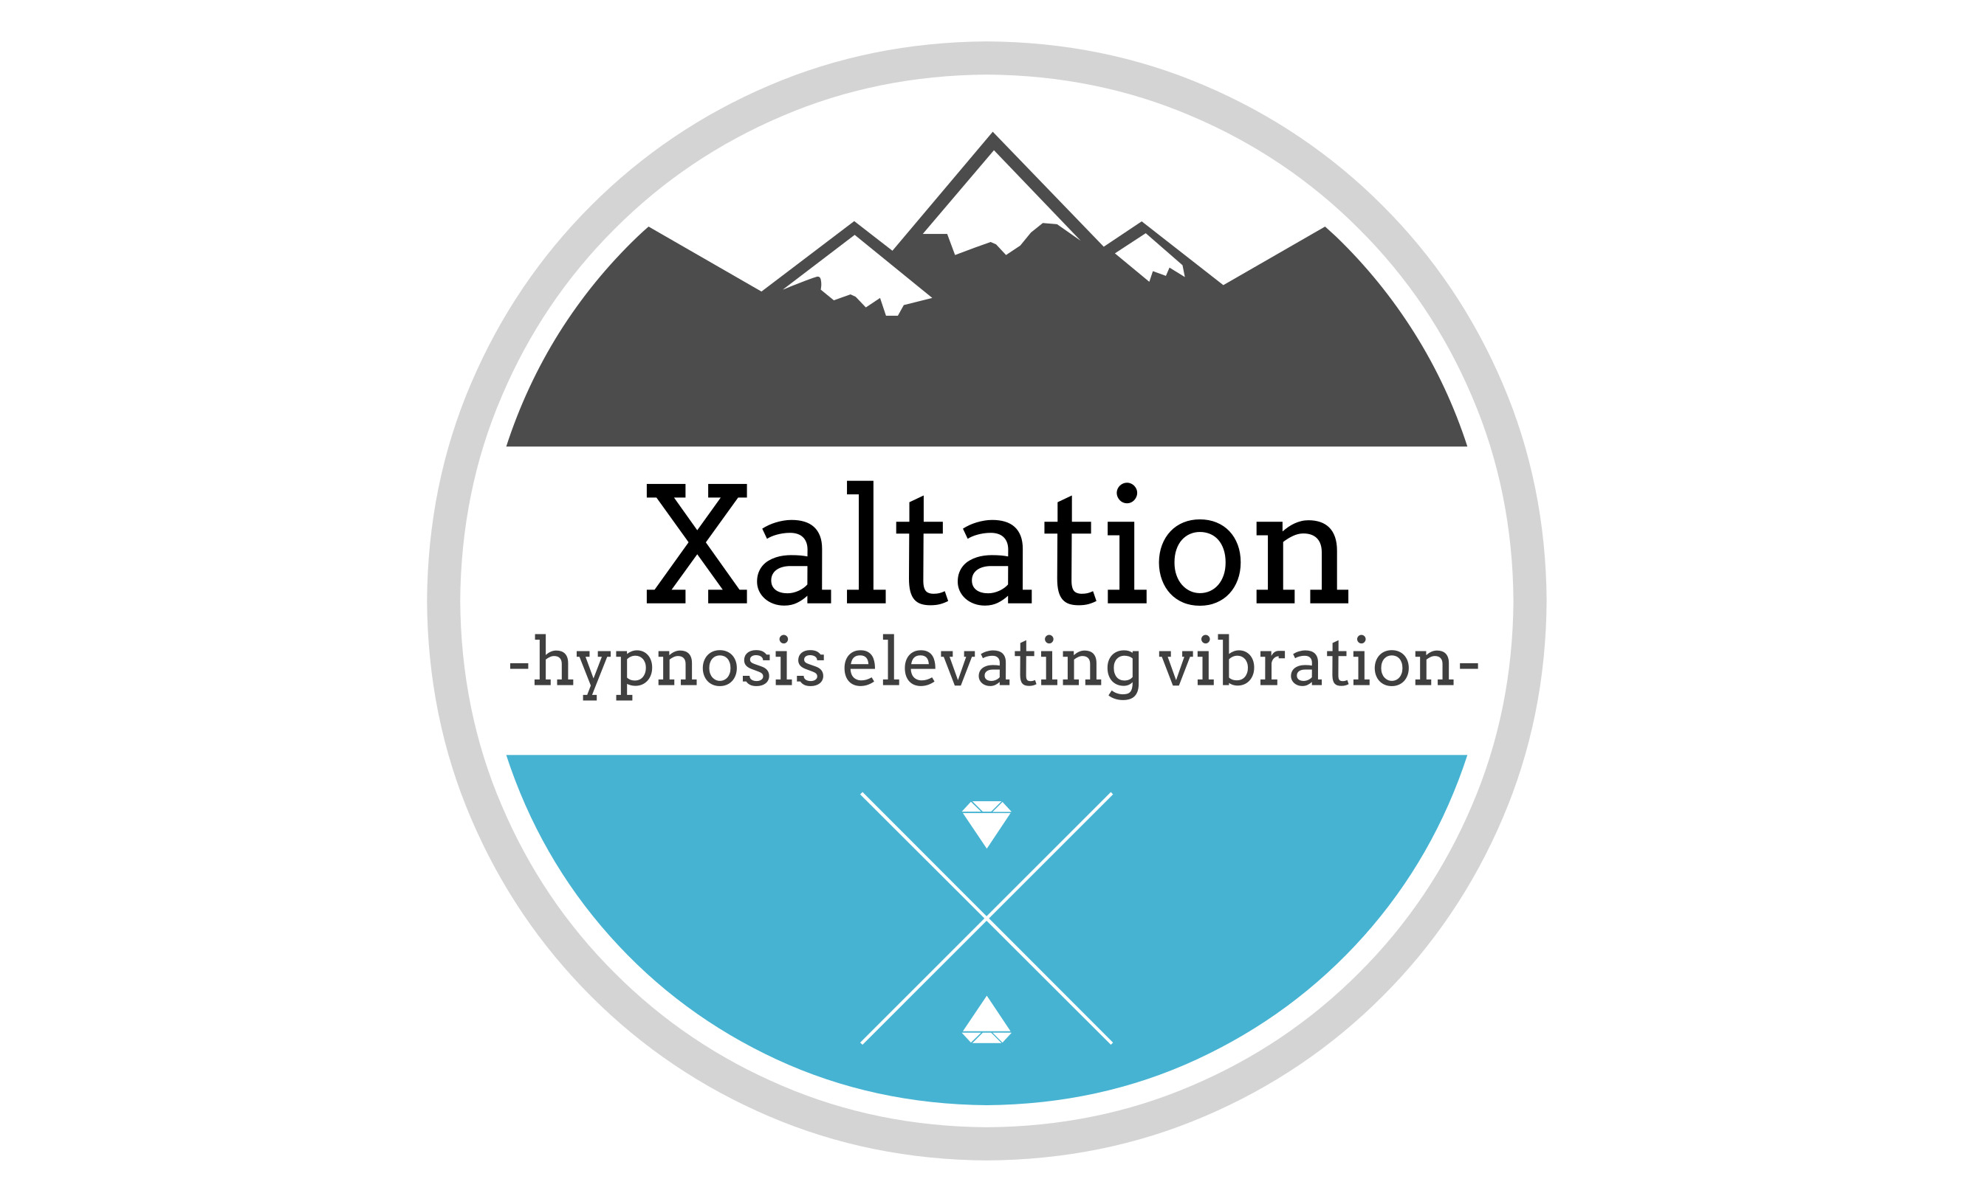  Coaching, Hypnotherapy, Time Line Therapy™, Psych-K™, Kinesiology,  Workshops and Inspirational Events
Client instructions:  Please provide this letter to your current healthcare professionals in request for a referral to our services and programs.  Jodie Bruce  Contact  PHONE:  +61 423 966 688  EMAIL:  jodie@xaltation.life  https://xaltation.life |  | Dear Medical Practitioner,  I have been approached by your client in relation to my services in the area of Hypnotherapy.  When I interview potential clients as candidates for this type of service I question if there is already participation with other medical professionals in regards to any other health concerns. As I am a certified Hypnotherapist and Coach I require a referral from the acting medical practitioner prior to any program participation being agreed upon.  Please feel free to contact me for further information or discussion in relation to your client’s treatment. A signed referral will be required, either by email or a letter given to the client that they can provide at their appointment, before any further programs are decided upon.  Kind regards,  Jodie Bruce


