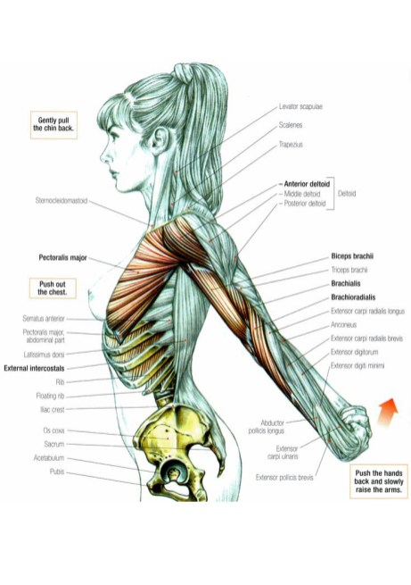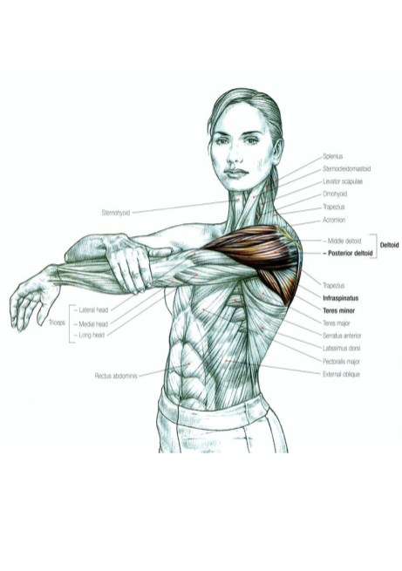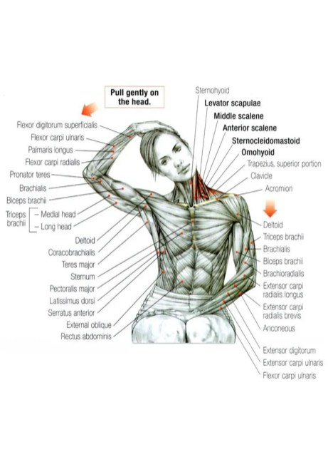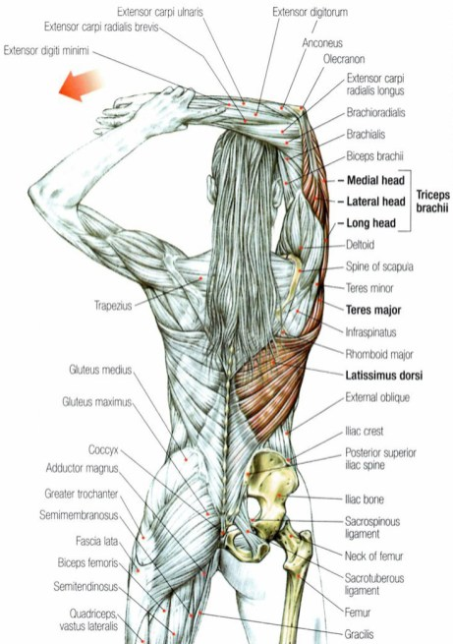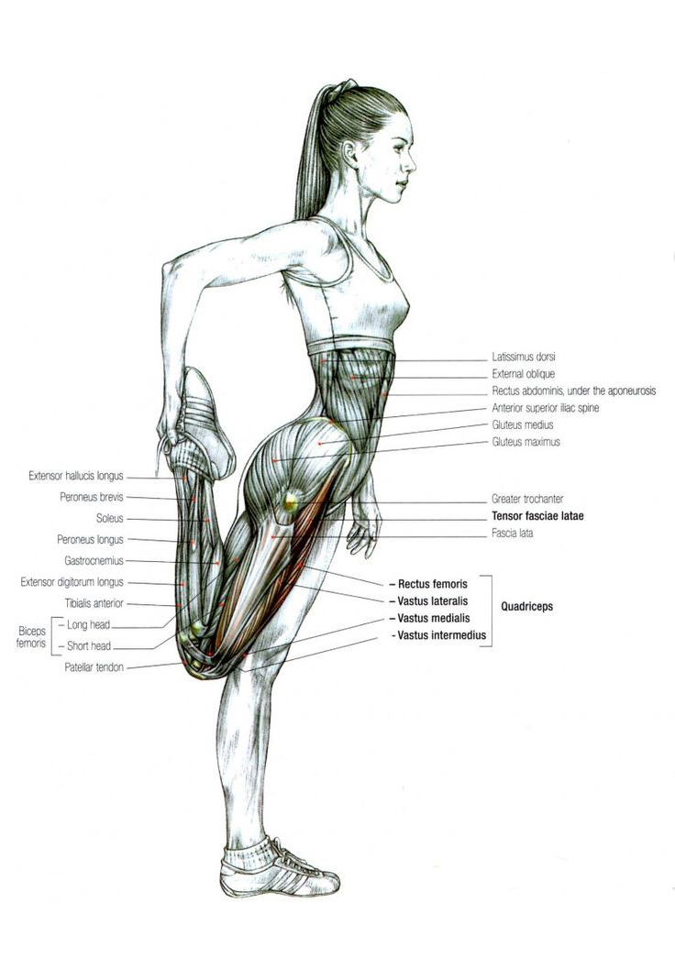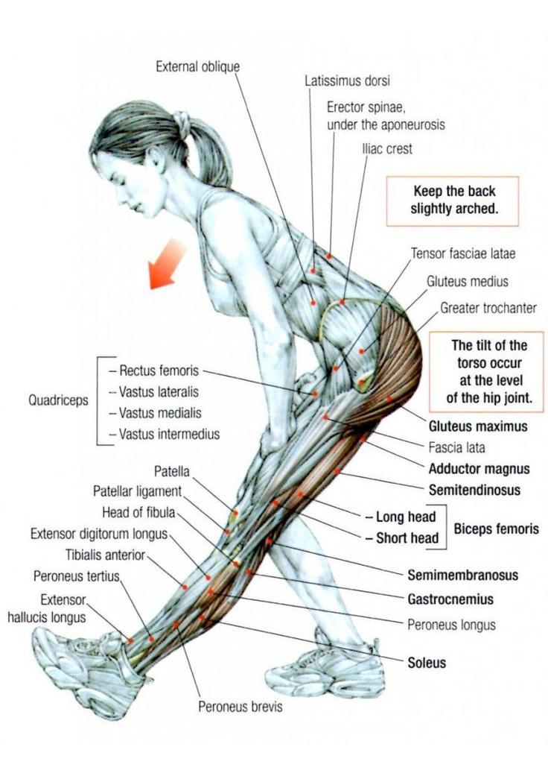

I’ve listed here the top 6 stretches for the end of your boxing sessions. Extra stretches are always good but these are the main stretches that should always be done. They cover the main muscle areas used in boxing! The muscles that are being stretched are in bold letters.

- Muscle groups that boxing strengthens are:

- Rotator Cuff, Trapezius – Shoulder Muscles

- Quadriceps – Leg Muscles

- Abdomen, Obliques, Hip Flexors – Core Muscles

Not only is it a great self-defence methodology, it’s also an amazing way to get in shape. People turn to boxing to lose weight, gain lean muscle, and ultimately look and feel better about themselves.

