Dowagers Hump

What is Dowagers hump?
Dowagers Hump refers to a curving of the spine that can result in an upper back that appears rounded or hunched, and can eventually lead to pain.

What causes this?
Bad posture is the most common cause of Dowagers Hump, which is why early intervention and treatment of this condition is most beneficial.
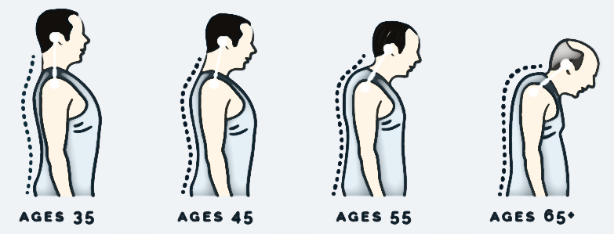
The muscles in the chest area become short and tight
The muscles in the upper back become long and weak
Source:https://www.humpalchiropractic.com/humpalchiropracticnorthlibertyiowa52317officeblog/dowagershumpexercises

YWLT Exercises - The purpose of these home stretches is to lengthen the entire thoracic spine, and to correct how your upper back relates to your neck. They help combat slumping, rounded shoulders, forward head and a weak back and abdomen (the main issues associated with poor posture). This condition will see the muscles of the back of the neck and upper back becoming ‘long’ and weak and the muscles in the front of shoulders and chest becoming ‘short’ and tight.
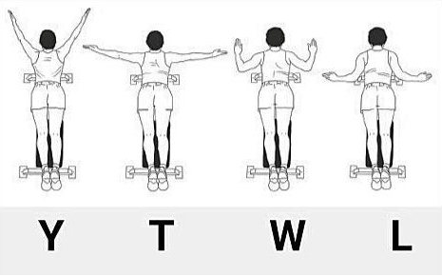

Keep Thumbs Pointed Back To Protect Shoulders.
Best Done standing.

Source: http://www.stangechiropractic.com/blog/100111-ytwl-exercises-for-upper-back-and-neck-tension

- Hold your arms above your head in a Y position, don’t let your elbows drop down. Make sure that your thumbs are pointing backwards.
- Lengthen your spine - imagine someone is pulling you up from your head.
- Tuck your chin in - do not allow it to jut forwards
- Tuck your tummy in - do not allow your lower back to arch or your tummy to stick out.
- Take a deep breath in for 3 seconds, then breathe out for 3 seconds, as you breathe out pull your shoulder blades closer together.
- Repeat another 2 times. On each subsequent breath out, pull your shoulder blades closer together.
- Each breath out is like a ratchet, do not let your shoulders come forward at all during the exercise, they become further back on each breath out.
- Repeat the above in the W, T and L positions.

- Don’t forget: Thumbs back, Lengthen spine, Chin in, Tummy in
- Try to do these exercises daily for around ten to fifteen minutes.
- While these stretches are effective at addressing the hump in your neck and upper back, we highly suggest contacting a remedial massage therapist to amplify the results. With routine care you’ll be able to work on improving your posture, as well as create a long-term plan to sustain it.

