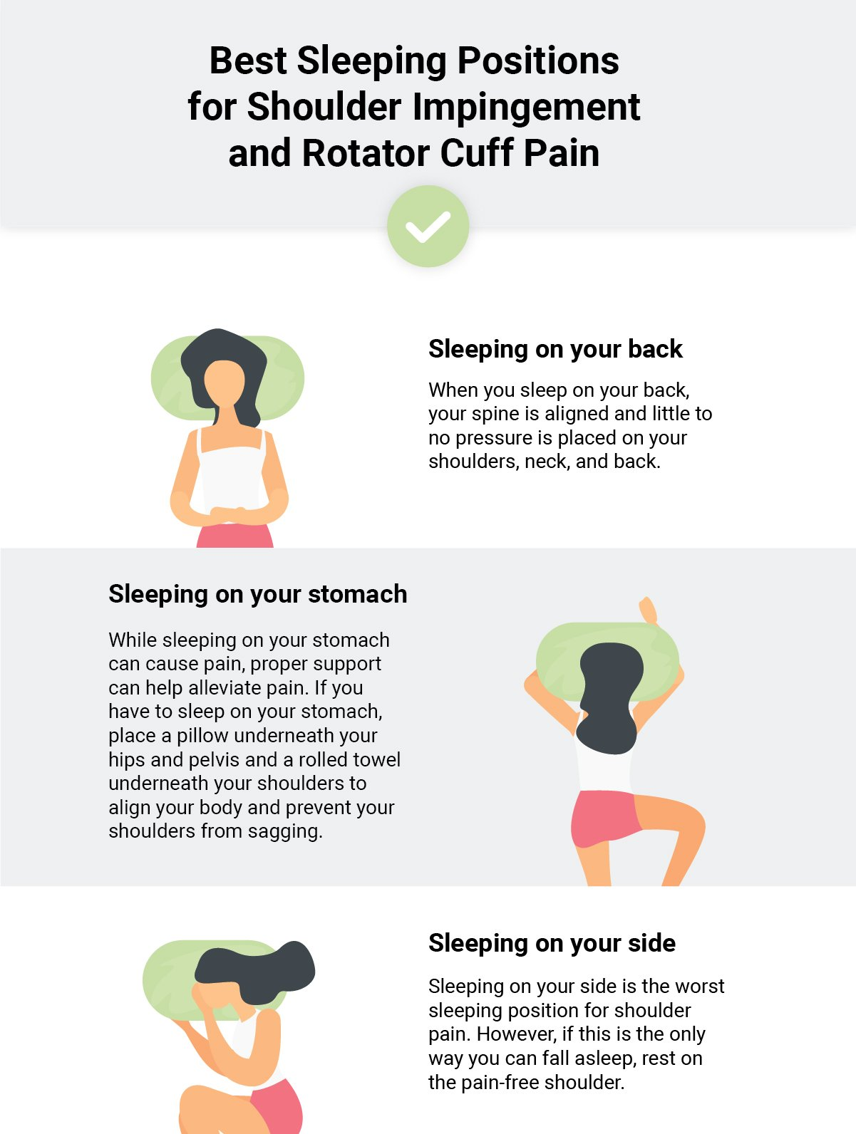

Better: Sleeping on Your Back
The supine position is the second most common sleeping position. Sleeping with your back flat on the bed enables the spine to stay in a more natural position. This prevents some of the neck, shoulder and back pain experienced with other postures.https://www.sleephealthsolutionsohio.com/blog/healthy-sleeping-position/
Is a firm mattress better for your spine?

A firm mattress may help alleviate back pain by distributing the body's weight more equally and supporting spinal alignment.
https://www.medicalnewstoday.com/articles/best-firm-mattresses-for-back-pain

What is the best type of mattress for a bad back?

The most commonly recommended beds for back pain are memory foam and latex.
https://www.health.com/condition/sleep/best-mattress-for-back-pain

How do you lay on a bolster?

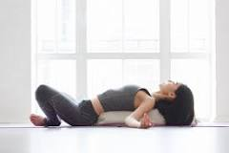
Bolstering
Assisting you in deep stretches,
particularly on the floor.

In yoga practice as a tool
for relaxation and revitalisation.

Serve as makeshift back support while
sitting in a chair or on your bed.
As an armrest while watching TV to help take the pressure of the shoulder.

https://www.yogaoutlet.com/blogs/official/how-to-use-a-bolster-to-open-up-unwind-after-a-long-day

Name of home bolster stretch:

Supported Savasana

- Lay flat on your back.
- Place the bolster underneath your back.
- Rest your arms out on the floor/bed, with your palms facing up.
- Allow your legs to fully relax.
- Feel the stretch through the shoulders and chest.
- Close your eyes and enjoy!

