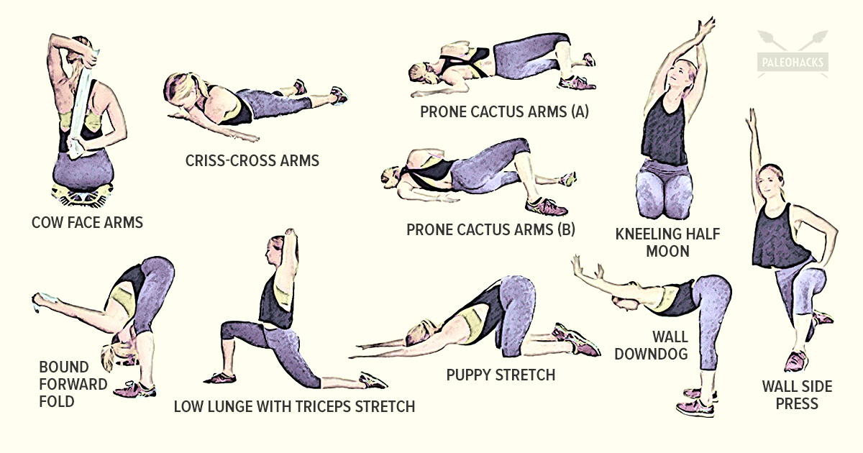

www.vrfitnessinsider.com

**WALL DOWNDOG STRETCH**

**Muscles involved:** Pectoral and Latissimus Dorsi (This stretch releases the front and top of the shoulders and the chest)

**How to do:** Position yourself as shown in picture and direct your chest down towards the floor feeling a stretch through the pecs and lats. Hold for 30 seconds.

**WALL SIDE PRESS STRETCH**

**Muscles involved:** Pectoral and Latissimus Dorsi (This stretch releases the top of the shoulder and the lats)

**How to do:** Start by kneeling down about a foot away from a wall. Turn your body so that your right shoulder is next to the wall, and place your left foot in front of your body in a low lunge position. Straighten your right arm above your head and place your right hand on the wall. Lean into your right hand and press the right side of your body towards the wall to feel a stretch through your right shoulder and lat. Hold for 30-60 seconds and then switch sides.

**PUPPY STRETCH**

**Muscles involved:** Pectoral, Triceps and Latissimus Dorsi (This stretch release the front, top, and back of the shoulders, the triceps, and the lats)

**How to do:** Start on the floor on your hands and knees in a tabletop position. Keep your knees stacked over your hips as you walk your hands out in front of you until you can bring your forehead to rest on the ground. Continue to walk your hands out until your arms are straight and you feel a stretch through your shoulders, triceps, and lats. Hold for 30-60 seconds. To come out of it, walk your hands back underneath your shoulders and press back up to a tabletop position.

**LOW LUNGE WITH TRICEPS STRETCH**

**Muscles involved:** Rectus Femoris, Iliacus, Psoas, Rotator Cuff (This stretch releases the top of the shoulder and triceps as well as the hip flexors)

**How to do:** Find a low lunge position with your right leg forward. Make sure that your right knee is stacked over your ankle and untuck your back toes. Engage your belly and reach your arms straight up above your head. Bend your left elbow and reach your left hand behind your head. Bend your right elbow and place your right hand on top of your left elbow. Apply gentle pressure to feel a stretch in your left triceps. Hold for 30 seconds and then switch sides by bringing the left leg to a low lunge and bringing your right hand down your back.