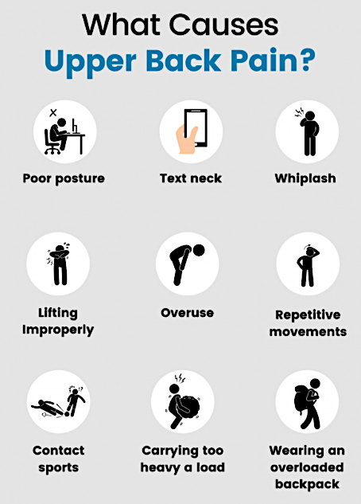

Upper back pain is usually caused by **soft tissue injuries**, such as **sprains or strains**, or **muscle tension** caused by **poor posture** or looking downward for long periods.

Symptoms of upper back pain:

* A sharp or burning pain
* A dull ache
* A stiffness or tightness in the joints and muscles
* A ‘nervy’ pain that refers to your neck, shoulder or arms

*See a doctor if the upper back pain is sharp, rather than dull. This could be **a sign of a torn muscle or ligament**, or a problem with an internal organ in the back or side.

Radiating pain to the arms, buttocks or legs may be a sign of **nerve compression or damage**.

Source: https://www.spineuniverse.com/conditions/upper-back-pain

**Use of you mobile phone and poor posture**

The use of **mobile phones** influences our posture and body mechanics in unhealthy ways that *contribute to neck, upper back, shoulder, and arm pain*. Furthermore, *poor posture while sitting, standing, walking, or in a static position can lead to more than upper body pain and stiffness*—poor posture affects other parts of the spine, such as the middle and low back.

**How do you do safeguard your neck when using mobile devices?**

* Firstly, don’t use your mobile phone or your tablet for extended computer work.
* Use your desktop or laptop computer for extended work and make sure these devices are arranged ergonomically.
* When you use a mobile phone, instead of bending your head to look down at it, raise your phone to eye level.
* Take frequent breaks.
* Stand up straight.
* Exercise regularly.
* Get regular massage from a qualified therapist.
* Don’t stop moving.
* Use a pillow that supports the natural curve of neck.
* Sit attentively.