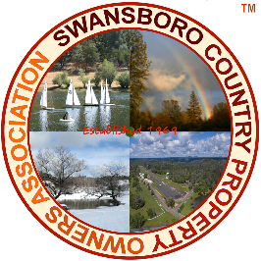 SCPOA MEMBER MAINTENANCE REQUEST FORM. Tracking M# ____
(Office use only)

Use this form to request ask for maintenance to which you may be entitled. (Roads, lakes, common areas.) Not all maintenance requests may be permitted. Requests for maintenance on your private property will not be considered. All requests are reviewed by SCPOA’s management company before being forwarded to the SCPOA Board for consideration. Verbal requests shall not be accepted unless required by law.
Complete all sections of the form – incomplete form will not be accepted. All member information shall be held strictly confidential by the SCPOA Board of Directors and The Management Trust.
(Use the red arrow (>) to type too.

Your Name >
Property Unit #, and Lot # >
Member’s Swansboro property address >

Phone: > Email: >
Best method to contact you: Phone > Email > Mail >
Requested information and reason for request. (Note: only those items allowed by law will be considered.)
>
>
>
>
>
Date > Member’s Signature >
(If the form is sent electronically, you affirm that any electronic signature is yours, used with your consent.)

Please email this form to sue.sherman@managmenttrust.com. Fax to Swansboro (916)985-3744 or simply mail to Swansboro, c/o The Management Trust, PO Box 1459, Folsom, CA 95763-1459. Emailed items should have “Swansboro Request” in the subject line.

