My Favorite Recent TV Series - IMDB Rankings
1.
Game Of Thrones 9.5 2011 - Emilia Clarke, Peter Dinklage 9 Noble Families fight over mythical lands of Westeros, while an ancient enemy returns after being dormant for thousands of years. Action, Adventure, Drama
2. 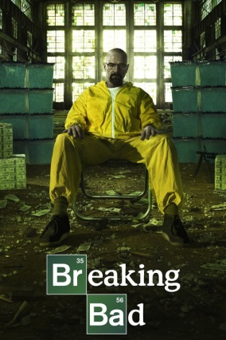
Breaking Bad 9.5 2008 - 2013 Bryan Cranston, Aaron Paul HS Chem Teacher with incurable cancer sells meth to secure his family's future. Crime, Drama, Thriller
3. 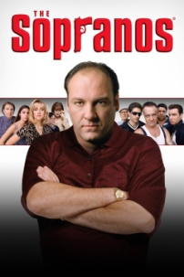
The Sopranos 9.2 1999 - 2007 James Gandolfini, Edie Falco N.J. Mob boss deals with personal and professional issues. Crime, Drama,
4. 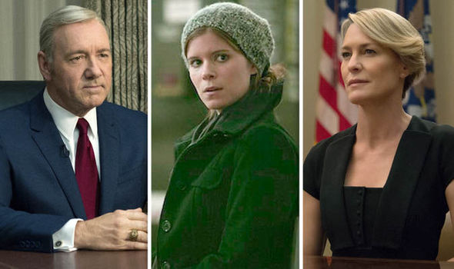
House Of Cards 8.9 2013 - 2018 Kevin Spacey, Robin Wright A congressman works with his conniving wife to exact revenge on those who have betrayed him. Drama
5. 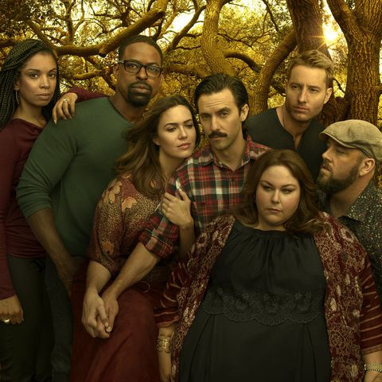
This Is Us 8.8 2016 - Milo Ventimiglia, Mandy Moore A heartwarming and emotional story about a unique set of triplets, their struggles, and their wonderful parents. Comedy, Drama, Romance
6. 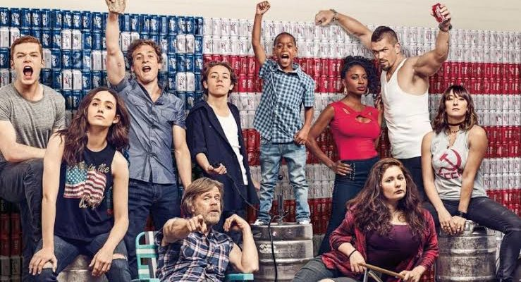
Shameless 8.7 2011 – Emmy Rossum, William H. Macy Alcoholic man lives in a perpetual stupor while his six children cope as best they can. Comedy, Drama
7. 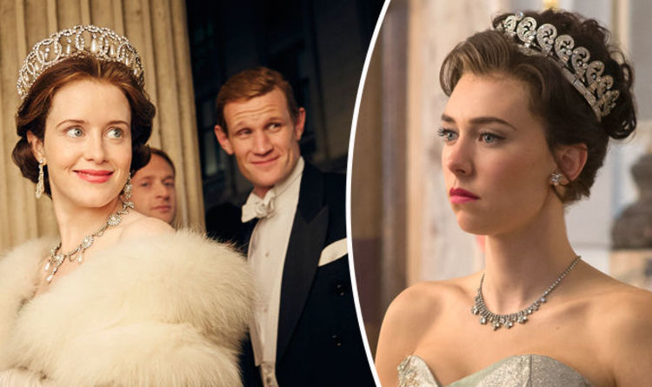
The Crown 8.7 2016 – Claire Foy, Matt Smith Follows the political rivalries and romance of Queen Elizabeth II’s reign and the events that shaped the second half of the 20th century. Drama, History
8. 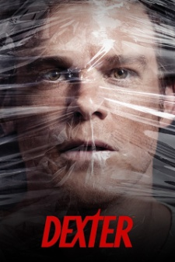
Dexter 8.7 2006 – 2013 Michael C. Hall, Jennifer Carpenter By day mild-mannered Dexter is a blood-splatter analyst for the Miami police. But at night, he is a serial killer who only targets other murderers. Crime, Drama, Mystery
9. 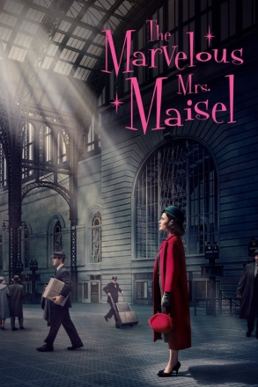
The Marvelous Mrs. Maisel 8.7 2017 - Rachel Brosnahan(HPHS Alum) A housewife in the 1950s decides to become a stand-up comic. Comedy, Drama
10. 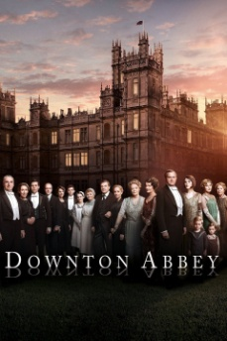
Downton Abbey 8.7 2010 – 2015 Hugh Bonneville A chronicle of the lives of the British aristocratic Crawley family and their servants in the early 20th Century. Drama
11.
Six Feet Under 8.7 2001 – 2005 Peter Krause, Michael C. Hall Dark comedy of a Cali family that runs a funeral home. My first binge watch while in Cancun during rainy season. Comedy, Drama
12. 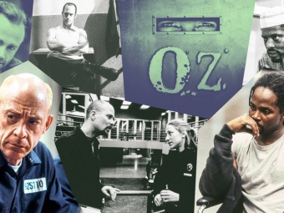
Oz 8.7 1997 – 2003 Ernie Hudson, JK Simmons A series chronicling the daily activities of an unusual prison facility and its criminal inhabitants. Crime, Drama
13. 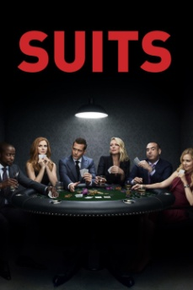
Suits 8.6 2011 – Gabriel Macht, Meghan Markle On the run from a drug deal gone bad, Mike Ross, a brilliant college dropout, finds himself a job working with Harvey Specter, one of New York City’s best lawyers. Comedy, Drama
14.
Sons Of Anarchy 8.6 2008 – 2014 Charlie Hunnam, Katey Sagal A man in his 30s struggles to find balance in his life between being a new dad and his involvement in a motorcycle club. Crime, Drama, Thriller
15. 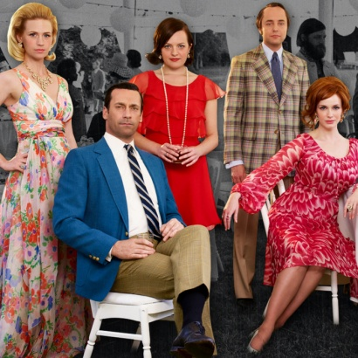
Mad Men 8.6 2007 – 2015 Jon Hamm, Elisabeth Moss A drama about one of New York’s most prestigious ad agencies at the beginning of the 1960s, focusing on one of the firm’s most mysterious but extremely talented ad execs, Donald Draper. Drama
16. 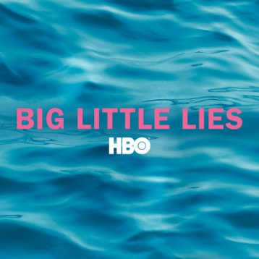
Big Little Lies 8.6 2017 – Reese Witherspoon, Nicole Kidman The apparently perfect lives of three mothers of first graders unravel to the point of murder. Crime, Drama, Mystery

17. 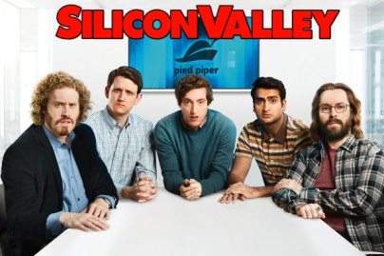
Silicon Valley 8.6 2014 – Thomas Middleditch, T.J. Miller Follows struggles of Richard Hendricks, a Silicon Valley engineer trying to build his own company called Pied Piper. Comedy
18. 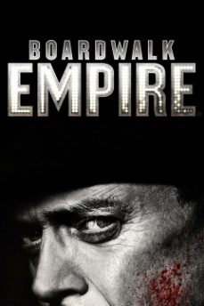
Boardwalk Empire 8.6 2010 - 2014 Steve Buscemi Michael Shannon An Atlantic City, New Jersey politician plays both sides of the law, conspiring with gangsters during the Prohibition era. Crime, Drama, History
19.
The Newsroom 8.6 2012 – 2014 Jeff Daniels, Emily Mortimer A newsroom undergoes some changes in its workings and morals as a new team is brought in, bringing unexpected results for its existing news anchor. Drama

20. 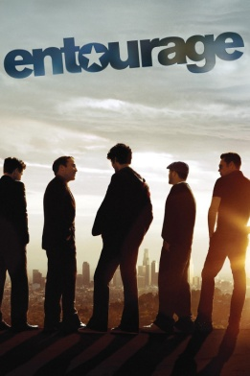
Entourage 8.5 2004 – 2011 Kevin Connolly, Adrian Grenier Film star Vince Chase navigates the vapid terrain of Los Angeles with a close circle of friends and his trusty agent. Comedy, Drama
21. 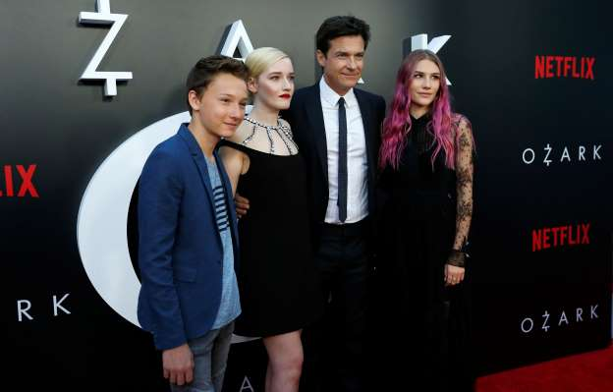
Ozark 8.4 2017 – Jason Bateman, Laura Linney A Chicago-based financial advisor relocates to the Missouri Ozarks when his dealings with a drug cartel go awry. Crime, Drama, Thriller
22. 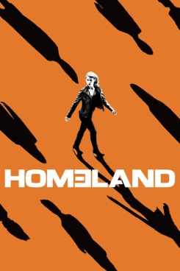
Homeland 8.4 2011 – Clare Danes, Mandy Patinkin A bipolar CIA operative becomes convinced a prisoner of war has been turned by al-Qaeda and is planning to carry out a terrorist attack on American soil. Crime, Drama, Mystery
23. 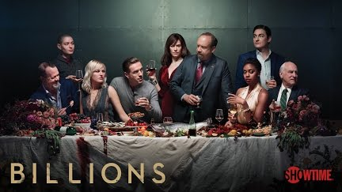
Billions 8.4 2016 – Damian Lewis, Paul Giamatti, Maggie Siff U.S. attorney Chuck Rhoades goes after hedge fund king Bobby “Axe” Axelrod in a battle between two powerful New York figures. Drama
24. 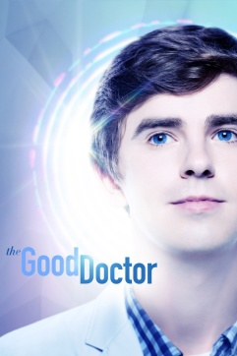
The Good Doctor 8.4 2017 – Freddie Highmore Shaun Murphy, a young surgeon with autism and Savant syndrome, is recruited into the surgical unit of a prestigious hospital. Drama
25. 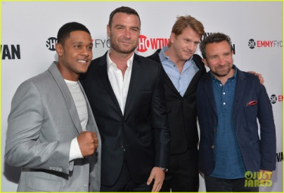
Ray Donavan 8.3 2013 – Liev Schreiber, Eddie Marsan Ray Donovan, a professional “fixer” for the rich and famous in L.A., can make anyone’s problems disappear except those created by his own family. Drama
26.
Goliath 8.3 2016 – Billy Bob Thornton A disgraced lawyer, now an ambulance chaser, gets a case that could bring him redemption or at least revenge on the firm which expelled him. Drama

27. 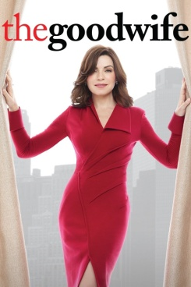
The Good Wife 8.3 2009 – 2016 Julianna Margulies, Chris Noth Alicia has been a good wife to her husband, a former state’s attorney. After a very humiliating sex and corruption scandal, he is behind bars. She must now provide for her family and returns to work as a litigator in a law firm. Crime, Drama, Mystery
28.
White Collar 8.3 2009 – 2014 Matt Bomer, Tim DeKay A white collar criminal agrees to help the FBI catch other white collar criminals using his expertise as an art and securities thief, counterfeiter, and conman. Comedy, Crime, Drama
29.
Californication 8.3 2007 – 2014 David Duchovny, Natascha McElhone A writer tries to juggle his career, his relationship with his daughter and his ex-girlfriend, as well as his appetite for beautiful women. Comedy, Drama

30. 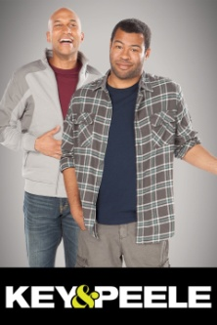
Key and Peale 8.3 2012 – 2015 Project sees Keegan-Michael Key and Jordan Peele in front of a live studio audience bantering about a topic weaved between filmed shorts and sketches. Comedy
31. 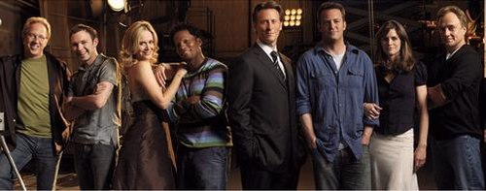
Studio 60 on the Sunset Strip 8.3 2006 – 2007 Matthew Perry, Amanda Peet A behind-the-scenes look at a fictional sketch-comedy television show. Comedy, Drama
32. 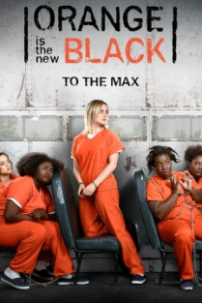
Orange Is The New Black 8.2 2013 - Taylor Schilling, Danielle Brooks Convicted of a decade old crime of transporting drug money to an ex-girlfriend, normally law-abiding Piper Chapman is sentenced to a year and a half behind bars to face the reality of how life-changing prison can really be. Comedy, Crime, Drama
33. 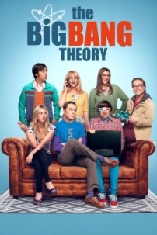
The Big Bang Theory 8.2 2007 – Johnny Galecki, Jim Parsons A Woman who moves into an apartment across the hall from two brilliant but socially awkward physicists shows them how little they know about life outside a laboratory. Comedy, Romance
34. 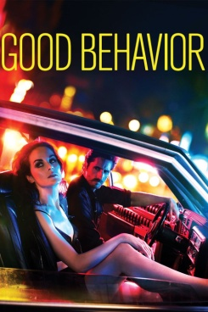
Good Behavior(Produced by HPHS Alum Chad Hodge) 8.2 Michelle DockeryLetty Raines is a thief and con artist whose life is always one wrong turn, bad decision, from implosion. Which is just how she likes it. Crime, Drama, Mystery
35. How To Get Away With Murder 8.2 2014 - Viola Davis A group of ambitious law students and their brilliant criminal defense professor become involved in a twisted murder plot that promises to change the course of their lives. Crime, Drama, Mystery
36. Castle 8.2 2009 – 2016 Nathan Fillion After a serial killer imitates the plots of his novels, successful mystery novelist Richard “Rick” Castle receives permission from the mayor of NYC to tag along with an NYPD homicide investigation team for research purposes. Comedy, Crime, Drama
37. Family Guy 8.2 1998 – Seth MacFarlane In a wacky Rhode Island town, a dysfunctional family strive to cope with everyday life as they are thrown from one crazy scenario to another. Animation, Comedy
38. 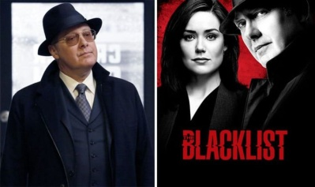
Blacklist 8.1 2013 – James Spader, Megan Boone A new FBI profiler, Elizabeth Keen, has her entire life uprooted when a mysterious criminal, Raymond Reddington, who has eluded capture for decades, turns himself in and insists on speaking only to her. Crime, Drama, Mystery
39. 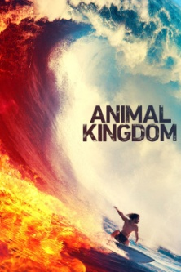
Animal Kingdom 8.1 2016 – Ellen Barkin, Shawn Hatosy Centers on a Southern California family, whose excessive lifestyle is fueled by their criminal activities. Crime, Drama
40.
The Big C 8.1 2010 – 2013 Laura Linney, Oliver Platt A suburban mom faces her cancer diagnosis while trying to find humor and happiness as well. Comedy, Drama
41.
Weeds 8.0 2005 – 2012 Mary-Louise Parker When a suburban mother turns to dealing marijuana in order to maintain her privileged lifestyle after her husband dies, she finds out just how addicted her entire neighborhood already is. Comedy, Crime, Drama
41.
Masters Of Sex 8.0 2013 – 2016 Michael Sheen, Lizzy Caplan Drama about the pioneers of the science of human sexuality whose research touched off the sexual revolution. Drama, Romance
42. How To Make It In America 8.0 2010 Brian Greenberg A Group of 20 somethings living in NYC. Ben and Cameron work on starting a fashion company, Comedy, Drama

Others I’ve Seen and Liked
Friends 8.9 1994 – 2004 Jennifer Anniston, Courtney Cox Lives of 6 friends living in New York. Comedy
Nurse Jackie 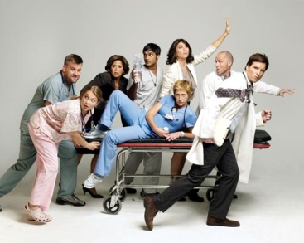
7.7 2009 - 2015 Edie Falco, A drug addicted nurse struggles to find a balance between the demands of her job at a New York hospital and an array of personal dramas. Comedy, Drama
Ballers 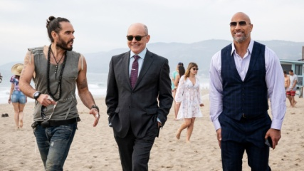
7.6 2015 - Dwayne Johnson Series centered on a group of football players and their families, friends, and handlers. Comedy, Drama
The Brink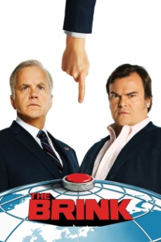
7.8 2015 Jack Black, Tim Robbins Top U.S. government and military scramble to prevent World War 3 from happening amidst the chaos of a geopolitical crises. Comedy
The Mick 7.9 2017 – 2018 Kaitlen Olsen Hard-living aunt is forced to take care of her wealthy sisters spoiled kids after mom flees country to avoid criminal charges. Comedy
The Orville 7.9 2017 – Seth McFarlane An exploratory ship from earth faces intergalactic challenges 300 years in the future. Adventure, Comedy
Revenge 7.9 2011 – 2015 Emily Van Camp, Madeline Stowe An emotionally troubled young women makes it her mission to exact revenge against the people who wronged her father. Drama, Mystery
United States Of Tara 7.9 2009 – 2011 Toni Collette A Woman struggles to find a balance between her dissociative identity disorder and raising a dysfunctional family. Comedy, Drama
Scandal 7.8 2012 – 2018 Kerry Washington A former White House Communications Director starts her own crisis management firm only to realize her clients are not the only ones with secrets. Drama,
Cheers 7.8 1982 – 1993 Ted Danson, Danny DeVito, Life in a Boston bar. Comedy
3rd Rock From The Sun 7.8 1996 – 2001 John Lithgow, Jane Curtin A group of aliens are sent to earth, disguised as a human family, to experience and report life on the 3rd planet from the sun. Comedy, Family
Transparent 7.8 2014 – Jeffrey Tambor L.A. family with serious boundary issues have their past and future unravel when a dramatic admission causes everyone’s secrets to spill out.
ER 7.7 1994 – 2009 George Clooney, Juliana Margulies The lives, loves and losses of the doctors and nurses of Chicago County General Hospital. Drama
New Girl 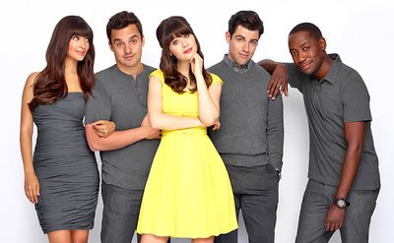
7.7 2011 – 2018 Zoey Dechannel
Law & Order 7.7 1990 – 2010
Nashville 7.7 2012 – 2018
Empire 7.7 2015 – Terrence Howard
Last Man Standing 7.6 2011 – Tim Allen
Madam Secretary 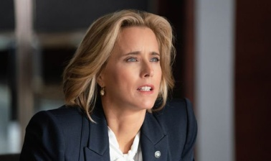
7.6 2014 - Tea Leone
The L Word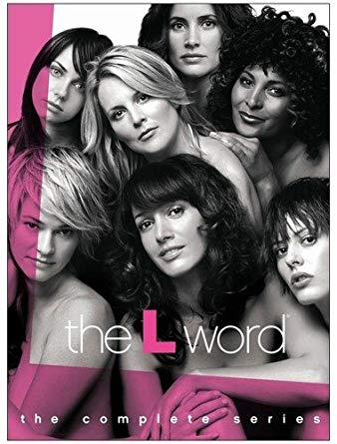
7.6 2004 – 2009 Jennifer Beals
Big Love 7.6 2006 – 2011 Bill Paxton
Blindspot 7.5 2015 –
Young & Hungry 7.4 2014 –
Girls 7.3 2012 – 2017 Lena Dunham
Covert Affairs 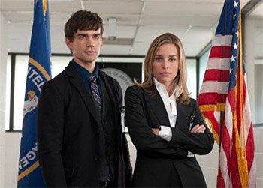
7.3 2010 – 2014 Piper Perabo
Rules Of Engagement 7.3 2007 – 2013 Patrick Warburton, David Spade
Dirty, Sexy, Money 7.3 2007 – 2009 Donald Sutherland, Peter Krause
Mom 7.2 2013 – Alison Janney, Anna Ferris
Hung 7.2 2009 – 2011
Two and A Half Men 7.1 2003 – 2015 Charlie Sheen
Everybody Loves Raymond 7.1 1996 – 2005 Ray Romano
Star 6.7 2017 - Queen Latifa
The Good Doctor 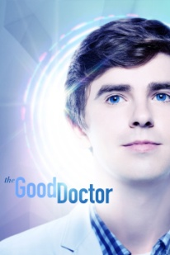
2017 – Freddie Highmore
The Resident
7.2 2017 – Emily Van Camp,
Studio 60
8.3 2006 – 2007 Mathew Perry, Amanda Peet
Royal Pains 7.1 2009 – 2016 Mark Feurstein
About A Boy 7.5 2014 – 2015
Queen Of The South 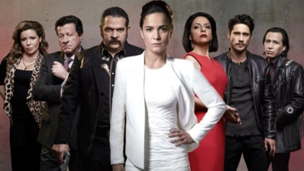
7.8 2016 –
Good Behavior
8.2 2016 –
Mr. Selfridge 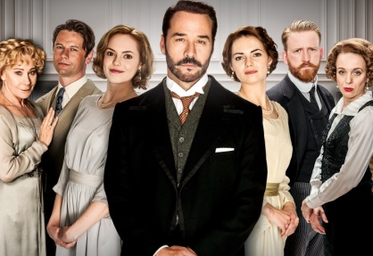
7.7 2013 – 2016 Jeremy Piven
Seinfeld 8.9 1989 – 1998 Jerry Seinfield
Arrested Development 8.9 2003 – Jason Bateman
House 8.8 2004 – 2012 Hugh Lawrie
Pushing Daisies 8.4 2007 – 2009
Ugly Betty 6.6 2006 – 2010 America Ferrara
Life Unexpected 7.6 2010 – 2011
King Of Queens 7.3
Will & Grace 7.2
The Drew Carey Show 6.9
Just Shoot Me 6.7
Quantico 6.7 2015 – 2018
2 Broke Girls 6.7
Private Practice 6.7 Kate Walsh, Taye Diggs
Mad About You 6.6 Paul Rieser, Helen Hunt

Haven’t Seen, Heard They’re Worth Watching
Prison Break 8.4 2005 - 2017
Switched At Birth 7.8
The Sinner 8.0 2017 –
Criminal Minds 8.1 2005 –
Flight Of The Concords 8.6 2007 – 2009
Bob’s Burgers 8.1 2011 -

