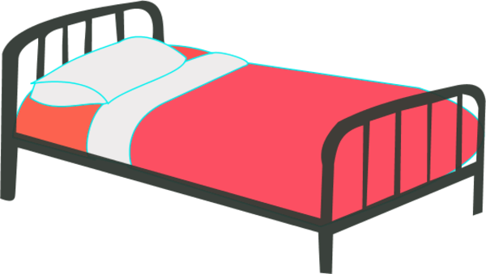
Bedding items
(New or clean and gently used)
Twin or double sheets
Towels
Blankets
Comforter
New pillows
Shower curtain and hooks
Personal-Care Kits

Pack the following new items in a clear zip lock bag:
- Comb and/or hairbrush
- Tooth brush still in original packaging
- Toothpaste (regular size)
- Shampoo (regular size)
- Bar of soap (regular size)
- Deodorant (regular size)
- 10 Disposable razors
- Wash cloth or hand towel
- Body lotion
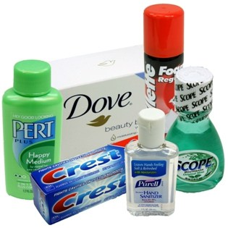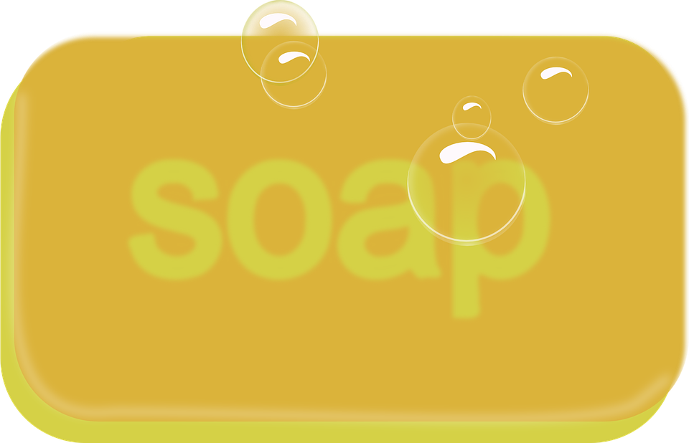

Household-Care Kits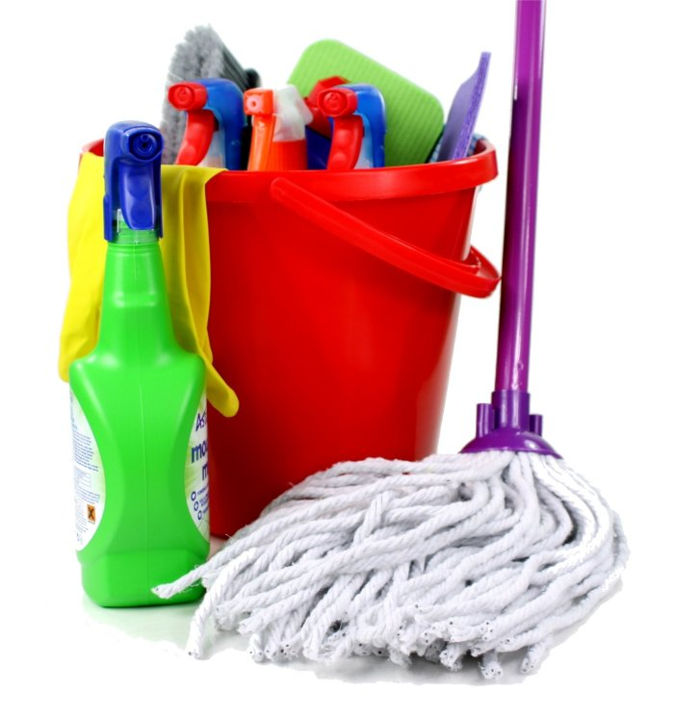

Assemble the following items:
- Two large wastebaskets
- Mop and pail
- 8 rolls of toilet paper
- 1 roll of paper towels
- 3 sponges
- Cleaning product
- Dish detergent
- Laundry detergent
- Box of large trash bags

School Supplies
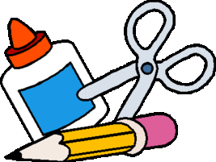
Pencils, pens, crayons, markers
Loose leaf paper
Spiral notebooks
Pencil sharpeners, erasers
Folders
Backpacks
Index cards
Scissors
Rulers

