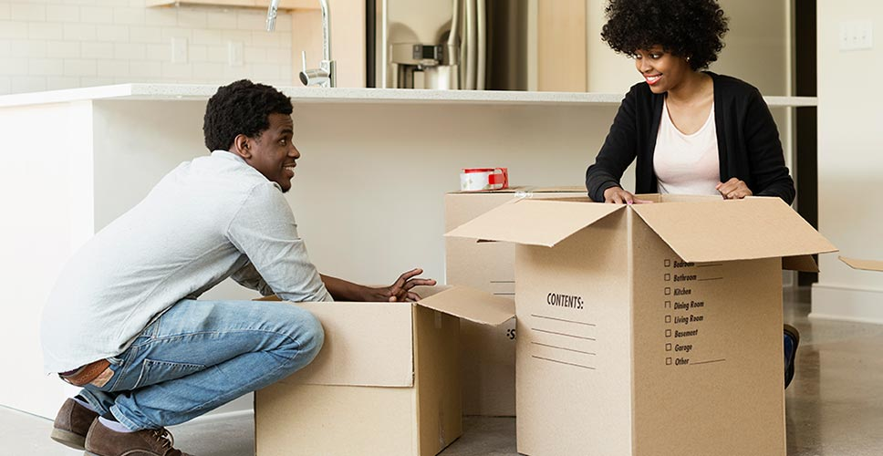

**Introduction**

If you’re doing your own packing, most experts recommend you do it by room (and load moving trucks that way as well). MYMOVE agrees, reminding packing DIYers that all boxes should be marked with the name of the room they’re going into and at least an overview of the contents.

**First things first: Supplies**

Let’s discuss packing supplies. You’ll need the following:

* **Boxes.** You can purchase boxes from a moving company, of course. But in many cases, you can get them for free. A good place to start – Alcoholic Beverage Control stores, grocery stores, and other retailers. All routinely have leftover boxes.
* **Padding.** This includes bubble wrap and similar items to cushion fragile items. Here, consider using socks, towels, and T-shirts if you want to save some money.
* **Blankets.** You’ll want to protect table and other furniture edges from scratches and the like. Again, simple house blankets – which you’ll want to transport anyway – can save you from spending for rentals.
* **Tape.** There’s really no substitute for good old duct tape.

Now, some general advice. Pack like items together. Start packing each box with a layer of padding – it can be newspapers. Then put the heaviest items in. We cannot say this enough: Label each box by room and by contents. Finally, pack one or two first day boxes of stuff that is essential – screwdrivers, hammers, snacks, drinks, toothbrushes, a change of clothes, paper plates, plastic utensils and cups, a first-aid kit, medications, etc.

That settled, let’s move from room to room with packing checklists and tips.

**The kitchen**

* **The refrigerator.** Start using up your food a couple of weeks before the scheduled move. You’ll want to defrost the refrigerator at least 48 hours before moving day.
* **Dishes.** Pack plates and bowls together in boxes. If you have fine china, wrap pieces individually with paper or bubble wrap. Do this for other breakable plates as well. Plastic plates and studier bowls don’t require as much protection, and nest whenever possible.
* **Glasses.** If you have a sectioned box, great. Again, wrap each piece individually before putting into boxes. If you don’t have sectioned boxes, avoid stacking glasses on top of one another unless you have sturdy separators for protection. Cushion glasses with padding.
* **Silverware.** If you have silver, use the packaging it came in whenever possible. If that’s not available, pack in sets and cover with paper or plastic. For regular silverware, use plastic storage boxes, sorting by function. Sharp knives, even if covered, should be stored in separate boxes.
* **Small appliances.** First remove any sharp blades and store in labeled plastic storage boxes. Wrap cords around appliances and secure with duct tape, then cover with paper. Pack in boxes and cushion with paper, towels or other padding.
* **Food.** Unopened dry and canned foods can go in boxes. Fill any coolers you plan to take with you as well.

**The dining room**

* **Table.** If possible, remove legs and leaves. Wrap table, legs, and leaves in blankets.
* **Chairs.** Wrap in blanks.
* **Rugs.** Roll up and wrap in plastic or paper.

**The living room and den**

* **Couches and chairs.** It will reinforce your desire that these be handled with care.
* **Electronics.** Put TVs, computers, etc., back in original packaging if you have them. Secure with duct tape. If don’t have original packaging, wrap components in towels and blankets, and brace in boxes. Fill in open spaces with padding, including towels, socks, blankets, etc.
* **TV stands and shelves.** Remove any glass and wrap in blankets.
* **Artwork and mirrors.** Wrap in blankets.
* **Tables.** Be ready to cover once loaded.
* **Lamps.** Remove bulbs and lampshades. Store in boxes, and cushion carefully.
* **Books, CDs, DVDs.** Don’t make boxes of these too heavy.
* **Rugs.** Again, roll up and wrap in plastic or paper.
* **Home office.** Put important files – medical records, financial records, insurance policies, etc. – in a separate box and store separately.

**The bedroom**

* **Spare bedrooms.** Break down beds and put any clothing in labeled boxes or bags. Place bed hardware in plastic storage bags and attach to headboard with duct tape. Pillows can go in dresser drawers. Remove mirrors from dressers and cover with blankets. Do the same for the master and other bedrooms on moving day morning.
* **Hanging clothes.** Here’s where it may make sense to splurge for boxes. With wardrobe cartons, you can store hanging clothes and easily unpack them at your destination.
* **Other clothing.** Regular boxes work just fine. Label by person and contents.
* **Jewelry.** Place any high-end jewelry in a container you’ll keep with you during the move. Otherwise, follow directions for clothing.

**The bathroom**

* **Be prepared.** Make a box – one you’ll keep handy – with makeup, toiletries, TP, bathroom towels, etc. You’ll likely want to set up a bathroom as soon as possible at the new place.

**The laundry room**

* **Washer and dryer.** Unplug both. Disconnect washer hoses, drain, and store inside machine. Do the same with your dryer vent. Tape cords to the back of each appliance.
* **Detergents, bleach, and fabric softener.** Discard, as these can be dangerous to transport. Plus, they’ll make a mess if they spill.
* **Laundry baskets.** Use to store and transport items. You can do the same for hampers.

**The garage/storage shed**

* **Lawn mower, lawn equipment, gas grill.** Drain gas and oil from mower and lawn equipment. Remove gas tank from grill and turn in.
* **Lawn and patio furniture.** Remove cushions and store in garbage bags.
* **Tools.** Use your tool box for smaller items. Wrap saws, axes, hoes, etc. in old towels.
* **Paint, fertilizer, weed killer.** Dispose of these items.