Fire Fighter Webbing Uses

By: Donald P. Cialone Jr.
Training Officer

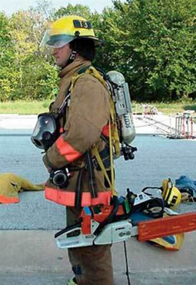
Tool Carry

Girth hitch your tools and throw the loop over your shoulder for hands free carrying.

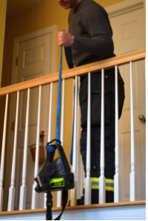
Tool Hoist

Use the same girth hitch to create a hoist with your webbing to lift tools.

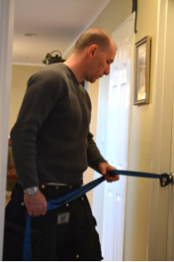
Door Control During Forcible Entry

If you’re forcing a door with unknown fire conditions behind it use the webbing to control the door as it’s being forced.

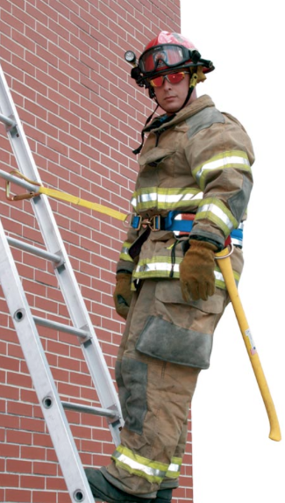
Ladder Safety Belt

Hook your carabiner to a rung for safety while working off a ground ladder.
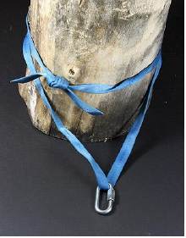
Anchor Strap

Wrap your webbing around a tree or other stable object to create an anchor strap for rappelling or bail out.
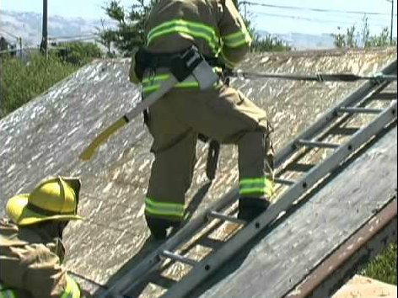
Roof Ladder Safety

Hook your carabiner onto a rung while ventilating a roof for safety and stabilization.
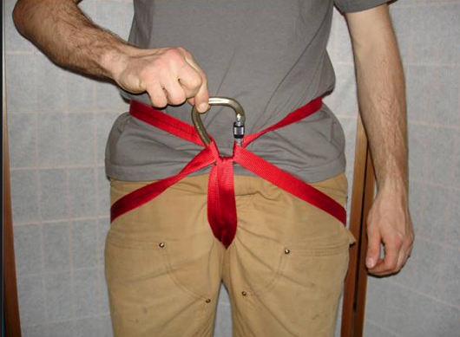
Hasty Harness

Use your webbing to make a hasty harness for emergency rappelling or bail out.
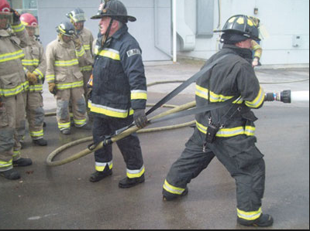
Hose Strap

Tie a girth hitch around your hose then throw the loop over your shoulder to make maneuvering hose easier.

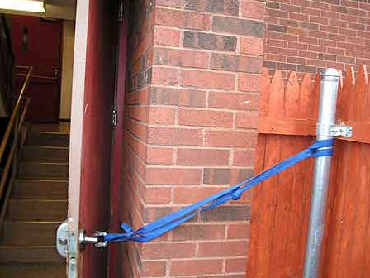
Door Prop

Use your webbing to prop open doors inside or outside the fire building.

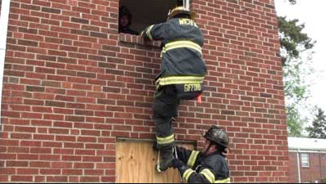
Step Loop

Use the loop in your webbing as a step to help you escape a basement window or to bail out of a window.

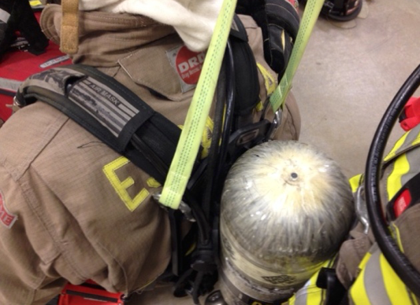
SCBA Harness Drag

Loop your webbing through a down fire fighters SCBA straps and use it to drag them to safety.

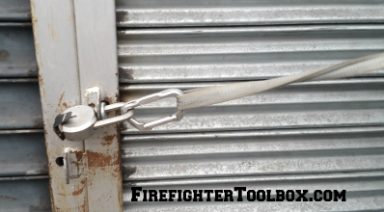
Lock Cutting

Clip your carabiner to a padlock that you’re cutting so you can safely remove it and avoid the heat.

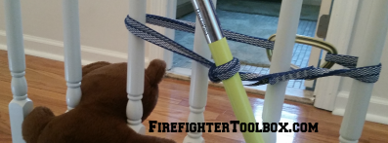
Tourniquet Rescue

Use your webbing when you have a child’s head stuck between two objects to create a tourniquet twisting a halogen bar in order to create room to remove the child.

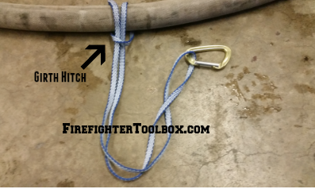
Girth Hitch

Simply wrap your webbing around a hose line, tool, or other object then pull the webbing back through the loop locking the webbing on the object.

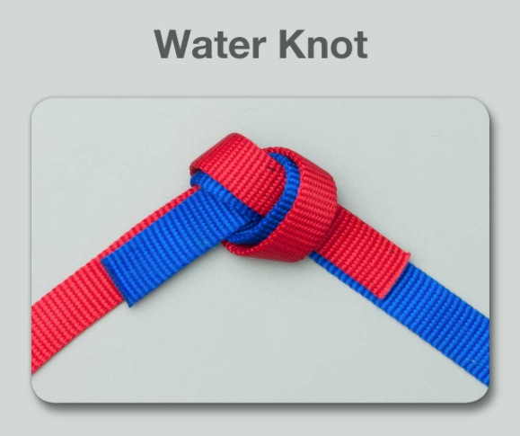
Water Knot

A water knot is tied by simply tying a loose overhand knot at one end of the webbing then following it back through the other side. Then simply tighten the knot!

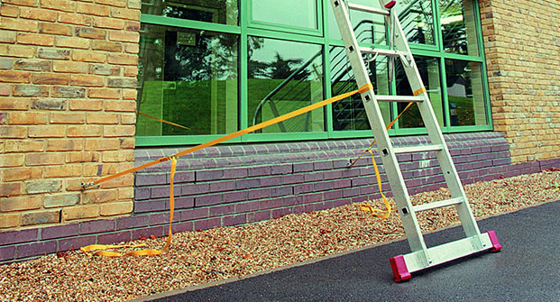
Ladder Tie Off

Girth hitch or lock your carabiner onto the rungs then attach the other side to something secure to stabilize a ladder at either ground or roof level.

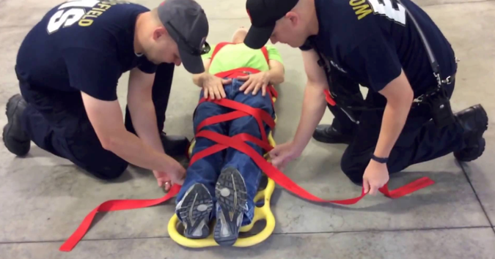
Lashing a Backboard

Use your webbing to lash a person onto a backboard.

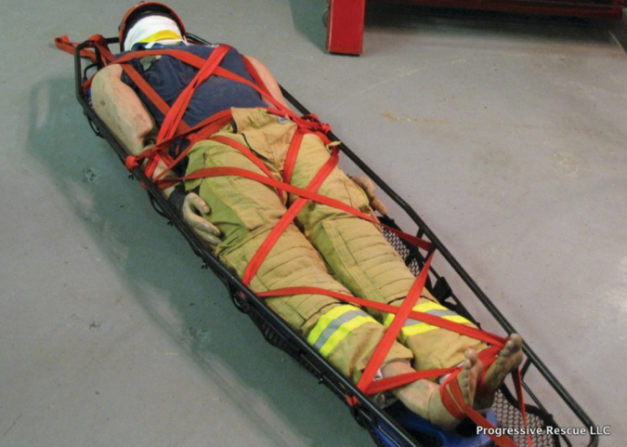
Lashing a Stokes Basket

Use your webbing to lash a person onto a stokes basket.

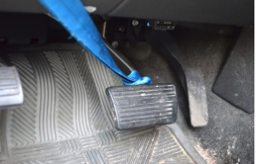
Extrication

Use your webbing to raise a brake pedal from a victims foot or to capture or stabilize doors during auto extrication.

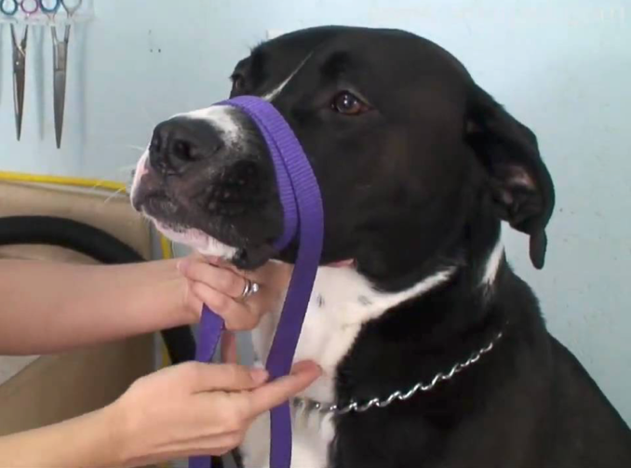
Emergency Dog Muzzle or Leash

Wrap your webbing around a vicious dogs snout to help control it or wrap it around a dogs next to gain control or lead a dog.

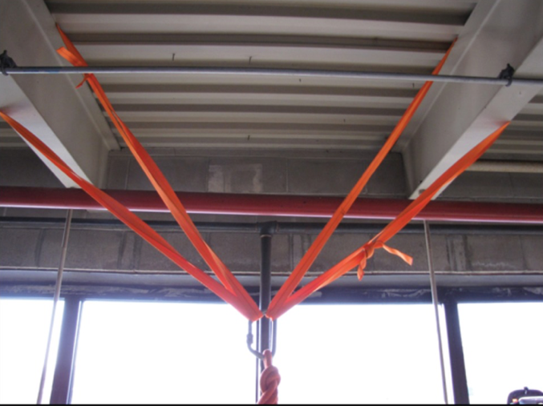
“I” Beam Anchor

Wrap your webbing around a steel “I” beam to use as an anchor point.

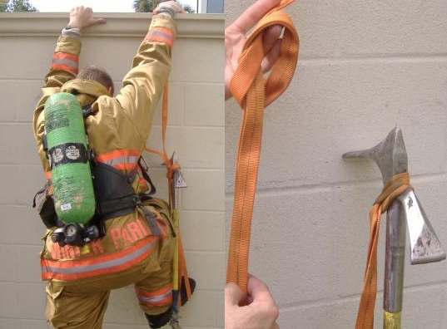
Webbing Step

Use your webbing to concert with a halligan or other tool to create a step you can use to extricate yourself or to get over walls.

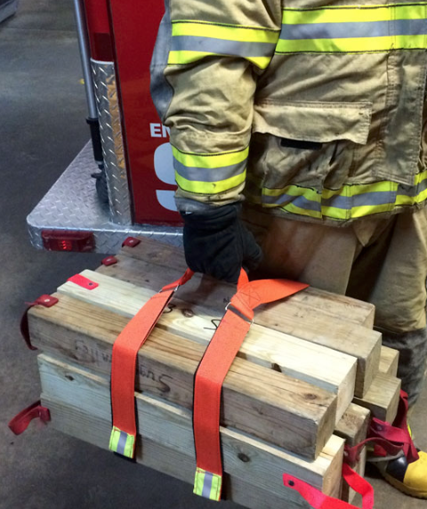
Cribbing Carry

Wrap your webbing around cribbing or anything bulky for ease of carry.

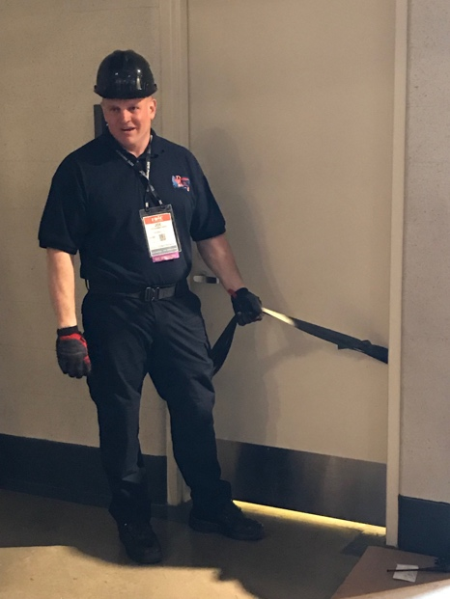
Steel Door Anchor

Wrap your webbing around a steel door several times above the lowest hinge and close the door for a secure indoor anchor point.

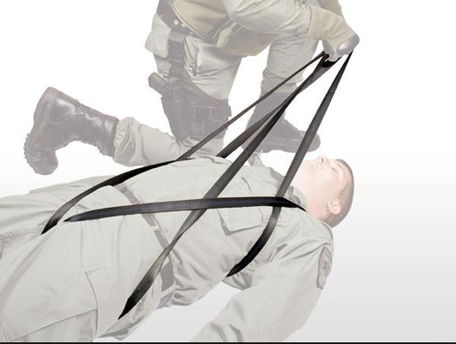
Fire Fighter Drag

Maneuver a large section of webbing into a harness to drag a downed fire fighter to safety.
Tool Belt

Wrap your webbing around your waist and slip your axe handle or halogen bar through the carabiner to hold your tool for you.

Radio Holster

Loop your webbing over your shoulder and clip your radio onto your webbing for a make shift radio holster.

Full Body Hasty Harness

Maneuver a large section of webbing into a full body hasty harness for emergency lowering or safety around high risk fall areas.

Swift Water Rescue Curtain

When conducting a swift water rescue first throwing a length of rope across the body of water then slide various lengths of webbing loops across the rope at different intervals with a carabiner so a victim floating down the water can grab or loop their body through the webbing to stop their flow down stream.

