Know Your District: Pre-Planning 101
By: Donald P. Cialone Jr.
Training Officer - Doyle Hose Company No. 2

Pre-planning is a task a lot of chief officers avoid like the plague thinking it’s unnecessary, outdated, or simply a lot of work. Pre-plans can be a lot of work, but they don’t have to be. In this article I’ll pass on some tips I’ve learned over the years about how you can establish quick and easy pre-plans and build on your foundation over time.

I’ve highlighted four areas of pre-incident planning that you can implement. They are:

- Developing a pre-incident plan form
- Gathering the necessary information for the pre-plan
- Conducting building walk throughs
- Working in concert with I Am Responding

Developing a Pre-Incident Plan Form

Unless you have enough committed personnel to fully implement a proper pre-incident plan program I suggest you start small. You can design a quick form on Word or Excel, print out a bunch of copies and leave them on your rigs. Dig them out when you have free time at a routine EMS call or a false alarm and fill out as much as you can. Once they have been filled out you can organize them into a binder or folder, add hydrant maps, building floor plans, or your Tier Two hazmat forms then find a spot for them back on your rig.

When implementing a pre-incident plan start with the basics: The building name, address, nearest cross street, closest hydrant location, building status, and the presence of any know hazardous materials. Down the road you can add to it as time allows. If motivated you can further investigate the facility with a visit or walk through in the future.

In the pre-incident plans I have established for my district I have them organized into six categories with distinct colored sections. They are: Grey: General Information, Yellow: Occupancy, Blue: Water Supply/Fire Protection Systems, Green: Building Information: Purple: Utility Information, and Orange: Hazardous Materials. Keep in mind this information isn’t just for major fires. You can also use this information for virtually any incident, such as a flooded basement, smoking outlet, a natural gas leak, fire alarm activation, MCI or God forbid an Active Shooter.

Here’s how the information breaks down in each category on my district pre-plans:

General Information: Building Name, Address, Closest Cross Street, Side of the Street, Owner’s Name, Emergency Phone Number, Knox Box Location, Code for Entry Pad, Other Entry Information, Alarm Panel Location, Alarm Company, and Alarm Company Phone.

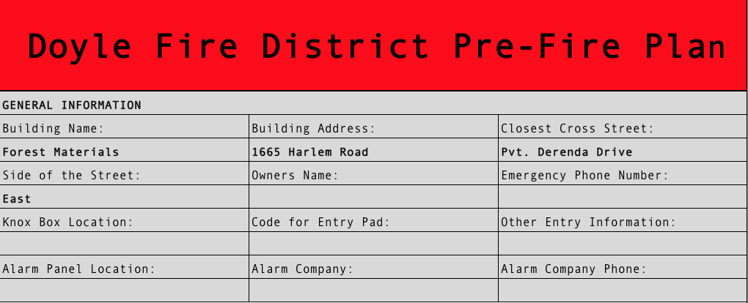

Occupancy: Vacancy, Number of Adults, Number of Children, Number and Name of Dogs, Number and Name of Cats, Other Pets, Public Assembly Permit, Occupancy Rate, Permit Expiration.

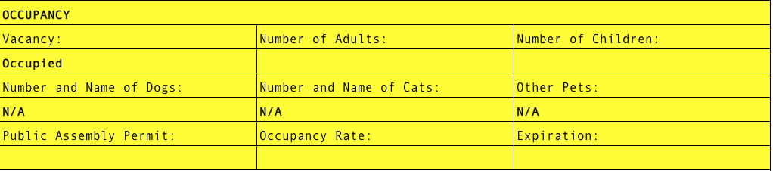

Water Supply/Fire Protection Systems: Closest Hydrant, Secondary Hydrant, Nearest Large Main, Fire Department Connections, Sprinkler System in Use, Valve Locations, Yard Hydrants in Use, Yard Hydrant Locations (x@2), Standpipes in Use, Dry Chemical Systems in Use, Halon Systems in Use.

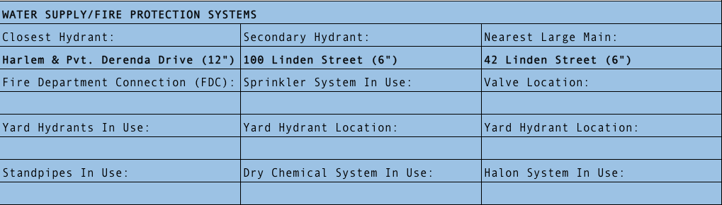

Building Information: Occupancy Type, Construction Type, Combustibility of Contents, Fire Walls, Fire Doors, Number of Exits, Roof Type, Roof Access, Basement Present, Attic or Void Spaces, Parapet, Interior Stairs, Exposure Issues, Exposure Location (x2).

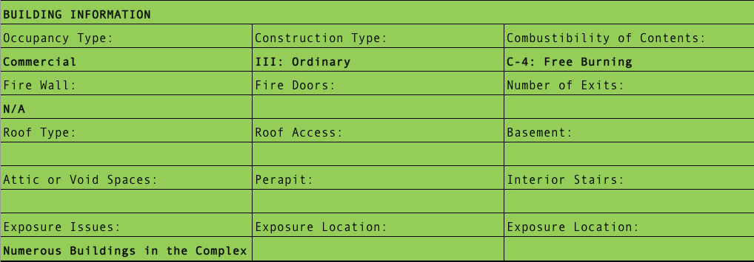

Utility Information: Interior Gas Shutoff, Exterior Gas Shutoff, Propane in Use, Interior Water Shutoff, Exterior Shut Off, Breaker Box Location, HVAC Type, HVAC Location, Emergency Generator in Use, Solar Panels in Use, Other Utility Information.

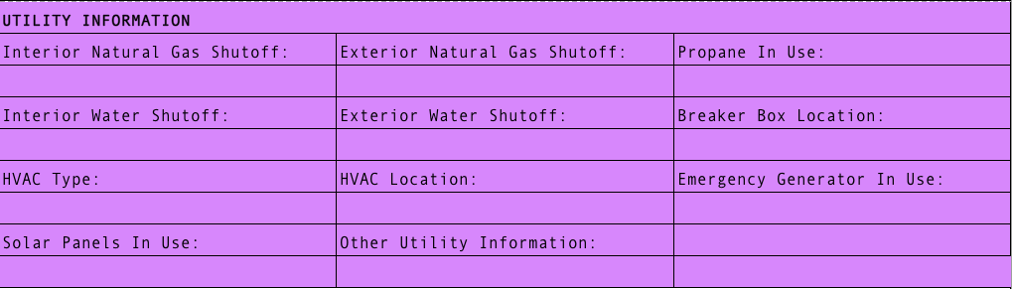

Hazardous Materials: Name of Material, Amount, Exact Location. I have also added DOT Emergency Response Guidebook numbers, so you can easily find the pages you need in a hurry. Also, where possible I have scanned the ERG and NIOSH guidebook pages and put them in I Am Responding for ease of access. Although not necessary in my pre-plans have a list of hazardous materials on site along with their CAS number for ease of reference.

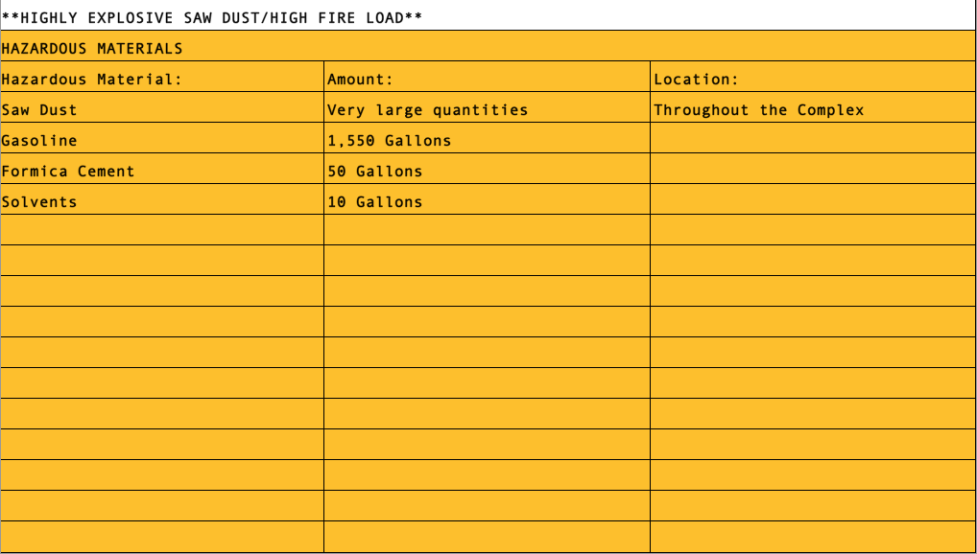

I have also added notes into some sections with special considerations or warnings such as:

**HIGHLY EXPLOSIVE SAW DUST/HIGH FIRE LOAD** or **VACANT STRUCTURE WITH HOLES IN THE FLOOR**

Keep in mind these are the fields I have chosen you can change them to better suite your needs.

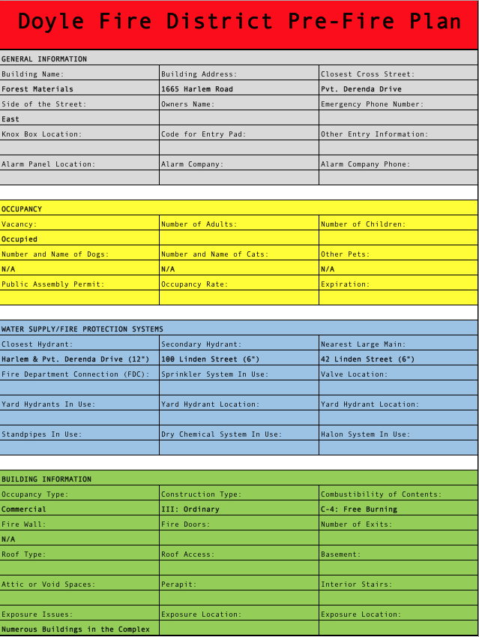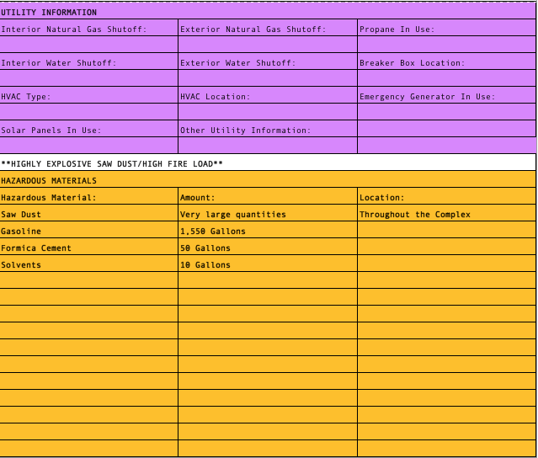
(front and back)

Gathering the Necessary Information

General Information: Your best bet here is to either physically visit the location or do a google search of the business, either way you should be able to verify a lot of the information in this category. Another way to get information on the building is through your Tier Two reports. These reports typically list a lot of the building and personnel information. They should have the facility name, physical address, number of occupants, emergency contacts with phone numbers and emails, and a chemical inventory with amounts and exact locations of hazardous materials.

If you decide you want to do a walkthrough of a facility I would contact your Building/Fire Inspectors Office first, usually they have a rapport with the owner or manager already and can arrange something. Your other option is to phone the owner or manager yourself and request a walkthrough. Be sure to tell them you’re doing a pre-incident plan and you’re not looking to cite them for fire code violations. Most facilities will welcome you and escort you through their facility with a safety rep or manager.

Occupancy: The only item in this section that may be obvious is the building status, most vacant structures are well know to everyone in your first due districts. The rest of the information can be obtained from your Building or Fire Inspection Offices. By law, buildings with public assembly areas must have Public Assembly Permits renewed yearly. An occupancy rate establishes the amount of people safely allowed into the public assembly areas at a time.

Water Supply/Fire Protection Systems: This is the easy part, at least for hydrant locations. Contact your city or county water department and request an updated list of hydrant locations. These are typically in a Microsoft Excel format which can easily be downloaded onto I Am Responding. In suburban Erie County contact the Erie County Water Authority at 716-849-4444. In the City of Buffalo contact the Buffalo Water Authority at 716-847-1065. Be sure and add the main sizes for at least the two closest hydrants and add the nearest large main in case your incident is a fire that requires a larger water supply. For private standpipes and hydrants, you have two options, contact the buildings owner or manager and request the information or contact your local Building or Fire Inspectors Office for the building plans. If the building is new you might be able to get digital floor plans and system maps.

Building Information: In most cases you can collect this information with a simple drive around the building. If you’re looking for more accurate information you’re going to have to request a walk through of the building or explore it while on a call. I personally always take mental notes at every residence, commercial, or industrial facility we respond to in case we’re there in the future for a larger incident.

Utility Information: General speaking utility providers are the same throughout your first due district except in rare cases. In our area NYSEG, National Grid, and National Fuel rule the roost. You’ll have to visit the site to establish utility locations and types. Although you may be able to see large propane tanks or solar panels from the road.

Emergency shutoffs usually are universal. For natural gas there is usually a shut off at the meter. For water shutoff there is usually a valve in the basement near the front foundation wall or inside a crawl space, if there isn’t, basement shutoffs tend to be located near a water heater or sink but anywhere is possible. Typically, there is also a “street shutoff” that is located underground somewhere between the structure and the street. It oftentimes has a painted blue cover that opens to reveal the shutoff. The water company has a “water key” which is usually a long steel rod that they use to reach the valve and turn off the water typically with a quarter turn.

Hazardous Materials: All this information can be obtained from your Tier Two reports. Most likely if you’re not getting them, your city/town emergency manager or fire inspector is hoarding them. Call their office and request copies be sent to you.

Conducting Building Walk Throughs

Again, try and arrange building walk throughs with the assistance of your city/towns Building, Fire Inspector, or Emergency Managers Office. They will likely have that rapport with many of the larger facilities already especially the ones with hazardous materials. If that doesn’t pan out I suggest calling the facility directly and asking them to conduct a Pre-Incident Plan walk through.

If your going to conduct a walk through some of the more important items you should ask for are: The owners name, an emergency contact number, emergency entry information, number of employees typically on-site (broken down by day, evening and overnight), and how many kids or pets on location if appropriate, and their Alarm Company information.

Items you should ask to see include: The alarm panel (ask for a quick lesson on how it works), Knox Box, sprinkler and valve rooms, fire department connections, yard hydrants, any specialized fire suppression systems, the roof and HVAC units, any attics or void spaces, the basement, utility shutoffs, emergency generator, confined spaces, and hazardous material storage locations.

You should get the location and number of: yard hydrants, fire department connections, fire doors, exit doors, parapet’s, and exposure issues along with their proximity to the fire building.

Working in concert with I Am Responding

Any truly active users of I Am Responding will tell you that it is an invaluable resource. Not only can you add your pre-incident plans but all kinds of markers that will further assist you in making your incident response smooth. First, it’s important to note that whoever is entering the information must be reliable, trustworthy, and must be an Administrator for the IAR system. IAR mapping has a series of markers that you can add that will make your life so much easier. The system allows you access to all of its features from your phone, tablet, or laptop. My suggestion is to use the systems Help section for tips, “play” with the markers, and sign up for the free webinars offered by IAR. (Sign up online to receive their emails)

Probably the single most convenient marker is the pre-plan marker. With this marker not only can you add your pre-plan documents but also your Tier Two reports, building maps, or other useful maps. You can also scan in photos of pretty much anything such as standpipes, utilities or even the building features. In one case I scanned photo’s I took of a large apartment complex map in our district, so we can easily find the apartment location before arrival. This will prove invaluable to all your personnel, from the men and women responding to the scene using their smart phone, the chief or apparatus equipped with a tablet or laptop in route to the scene or at the Command Post.

Some of the other markers that might prove helpful are bridge height and weight restrictions (for your apparatus), road closures and construction, Knox box locations, general warnings, truss construction warnings, fire alarm panel and sprinkler room locations, gas and electric shutoff locations, solar panel information, fire department standpipes and connection locations, and the ability to add building numbers to large apartment complexes and Do Not Enter markers. These markers and the others available will not only help your response to the scene but will also aid your establishment of pre-incident plans.

Another convenient marker is the Building/House Number marker. I have used these to overlay numbers on top of large apartment buildings to help locate the building prior to arrival. Another feature of the marker allows you to add information such as a keypad or security code that will pop up when touched. I have used these markers to add Mile Post Markers to the New York State Thruway. This assists drivers in choosing their direction of travel so they may enter the Thruway at the correct entrance.

Probably the most important marker is the Danger marker. Use this marker to identify dangerous dwellings in your first due district. Great uses for this marker include, vacant structures, hoarder houses, compromised structures, etc. Use the Do Not Enter marker for any structure you feel is compromised enough that you don’t want your personnel making entry.

Summary

In summary, unless you plan on going all out start small with a simple form and build on that as time allows. The important thing is to get something started. Pre-incident plans are not only helpful to Chief Officers but every first responder. They will give your personnel invaluable information on your first due district that may very well save time and lives. Use technology to your advantage whether its IAR or another program or system. And most importantly train everyone on how to use your pre-incident plan forms, be able to understand them, and use them correctly to their advantage. There’s no sense in establishing pre-incident plans when only a few personnel know how to use them or where they are kept. And lastly stayed prepared and safe!

