- TRINITY
Tonight, we are going to look into the Trinity. Now the word Trinity is not in the Bible, but it is a belief Christians have because of what the Bible shows us.
So, what is the meaning of Trinity?
Trinity is the belief of 1 God in 3 Persons. The Father, The Son & The Holy Ghost.
CLICK
“There are more than 60 Bible Passages that mention the three Persons together.”(Have group look up and read Matthew 3:16,17; 28:19; 2 Corinthians 13:14; Ephesians 4:4-6)
- EARLY TRINITY
(Explain Slide) “Early on Christians used this diagram to explain the Trinity. The Trinitarian concept was defended by several early church leaders… reaching back to 96AD with Clement and 90-100AD with the “Didache” to name a few. (The Lord's Teaching Through the Twelve Apostles to the Nations Athanasius (367) and Rufinus (c. 380) list the Didache among apocrypha. )
- CLOVER
“It is believed that St. Patrick used the shamrock to illustrate the Trinity: He asked; “Is this one leaf or three? If one leaf, why are there three lobes of equal size? If three leaves, why is there just one stem? If you cannot explain so simple a mystery as the shamrock, how can you hope to understand one so profound as the Holy Trinity?”
- TRINITY DIAGRAM
There is a story behind this drawing. I was taught this by a brilliant professor named Chris Bounds- but what made it stick was how I learned it.
My first class I took toward ministry, was intro to theology. During the class- professor Bounds asked what the Trinity is. No one would answer- it was quiet for like 30 seconds- which to me is a long time.
So, I mentioned a thought that I heard from a show on a radio bible station: I said it is like a man who is a father, yet is a son, and a brother. I was cut short on my explanation- HERESY!!! he yelled out.
To some that may have hurt them but to me hungry for truth- I wanted to know the reason it was heresy. Bounds then went on to teach us about a heresy called modalism- which is a denial of the Trinity.
It states that God is a single person who, throughout history has revealed Himself in three modes or forms. As a Father in the Old Testament times, as a Son with the incarnation, and as the Holy Spirit after Jesus’ ascension.
These modes are consecutive and never simultaneous. Which means that the Father, Son and Holy Spirit never all exist at the same time. Only one after another.
That is why this little diagram stuck with me and is helpful in explaining the Trinity.
Explain diagram: God is the Father, God is the Son, God is the Holy Spirit. The Father is not the Son, the Son is not the Holy Spirit, and the Holy Spirit is not the Father. The Father begets the Son & the Son submits to the Father. The Father breathes the Holy Spirit and the Holy Spirit glorifies the Father. The Son sends the Holy Spirit, and the Holy Spirit glorifies the Son.
Let’s first look to Holy Spirit – in the Old Testament certain theocratic mediators were anointed with the Holy Spirit. These were people who were given the immediate direction of God to govern the Israelites.
Psalm 51:11 NASB
Do not cast me away from Your presence
And do not take Your Holy Spirit from me.
Holy here is Qodesh (ko'-desh); meaning holiness of God
Spirit is Ruwach (roo'-akh); which at times in scripture means wind, breath, mind, spirit… In this verse Ruwach (roo'-akh); would be in upper case meaning;
  - Spirit of God, the third person of the triune God, the Holy Spirit, coequal, coeternal with the Father and the Son
    - as inspiring ecstatic state of prophecy
    - as impelling prophet to utter instruction or warning
    - imparting warlike energy and executive and administrative power
    - as endowing men with various gifts
    - as energy of life
    - as manifest in the Shekinah glory
    - never referred to as a depersonalised force
Shekinah’s original meaning is the Divine Presence of God, especially in the Temple in Jerusalem. It is closely related to the word: “mish-kan,” the Tabernacle. The heavenly “mish-kan” is mentioned in the New Testament in Revelation 15:5: “After these things I looked, and the temple of the tabernacle of testimony in heaven was opened.”
1 Corinthians 3:16 says:
Don’t you know that you are a temple of God, and that God’s Spirit lives in you?”

Xdq Qodesh (ko'-desh);
Word Origin: Hebrew, Noun Masculine
from (06942)
apartness, holiness, sacredness, separateness
  - apartness, sacredness, holiness
    - of God
    - of places
    - of things
set-apartness, separateness
xwr Ruwach (roo'-akh);
Word Origin: Hebrew, Noun Feminine
from (07306)
- wind, breath, mind, spirit
  - breath
  - wind
    - of heaven
    - quarter (of wind), side
    - breath of air
    - air, gas
    - vain, empty thing
  - spirit (as that which breathes quickly in animation or agitation)
    - spirit, animation, vivacity, vigour
    - courage
    - temper, anger
    - impatience, patience
    - spirit, disposition (as troubled, bitter, discontented)
    - disposition (of various kinds), unaccountable or uncontrollable impulse
    - prophetic spirit
  - spirit (of the living, breathing being in man and animals)
    - as gift, preserved by God, God's spirit, departing at death, disembodied being
  - spirit (as seat of emotion)
    - desire
    - sorrow, trouble
  - spirit
    - as seat or organ of mental acts
    - rarely of the will
    - as seat especially of moral character
  - Spirit of God, the third person of the triune God, the Holy Spirit, coequal, coeternal with the Father and the Son
    - as inspiring ecstatic state of prophecy
    - as impelling prophet to utter instruction or warning
    - imparting warlike energy and executive and administrative power
    - as endowing men with various gifts
    - as energy of life
    - as manifest in the Shekinah glory
never referred to as a depersonalised force

We see in our drawing that the Father Breaths Holy Spirit…
Job 32:8
Elihu the youngest of Job’s so-called friends and the one who spoke with the most sense said:
“But it is a spirit in man,
And the breath of the Almighty gives them understanding.

The spirit in man spoken here is Ruwach (roo'-akh) this is lower case spirit – our seat of emotions, desire, our moral character.
CLICK Breath is N@shamah (nesh-aw-maw'); meaning breath of God… because the next word is Almighty which is Shadday (shad-dah'-ee); meaning almighty, most powerful – Shaddai, the Almighty and if we continue the verse ends with gives them understanding.

hmXn N@shamah (nesh-aw-maw');
Word Origin: Hebrew, Noun Feminine
from (05395)
- breath, spirit
  - breath (of God)
  - breath (of man)
  - every breathing thing
  - spirit (of man)
yddX Shadday (shad-dah'-ee);
Word Origin: Hebrew, Noun Masculine
from (07703)
- almighty, most powerful
  - Shaddai, the Almighty (of God)

John 14:26
²⁶ But the Helper, the Holy Spirit, whom the Father will send in My name, He will teach you all things, and bring to your remembrance all that I said to you.

John 15:26-27
²⁶ “When the ^{[h]}Helper comes, whom I will send to you from the Father, that is the Spirit of truth who proceeds from the Father, He will testify about Me, ^{27 [i]}and you will testify also, because you have been with Me from the beginning.

CLICK Send here is Pempo (pem'-po); meaning…

pevmpw Pempo (pem'-po);
Word Origin: Greek, Verb
apparently a root word
- to send
  - to bid a thing to be carried to one
  - to send (thrust or insert) a thing into another

The Holy Spirit Glorifies both the Father and the Son.

John 16:13-15
¹³ But when He, the Spirit of truth, comes, He will guide you into all the truth; for He will not speak on His own initiative, but whatever He hears, He will speak; and He will disclose to you what is to come. ¹⁴ He will glorify Me, for He will take of Mine and will disclose it to you. ¹⁵ All things that the Father has are Mine; therefore I said that He takes of Mine and will disclose it to you.
CLICK Glorify is Doxazo (dox-ad'-zo);
doxavzw Doxazo (dox-ad'-zo);
Word Origin: Greek, Verb
from (1391)
- to think, suppose, be of opinion
- to praise, extol, magnify, celebrate
- to honour, do honour to, hold in honour
- to make glorious, adorn with lustre, clothe with splendour
  - to impart glory to something, render it excellent
  - to make renowned, render illustrious
    - to cause the dignity and worth of some person or thing to become manifest and acknowledged

The Father Begets the Son.

John 1:14
¹⁴ And the Word became flesh, and ^{[k]}dwelt among us, and we saw His glory, glory as of ^{[l]}the only begotten from the Father, full of grace and truth.

CLICK Begets or only-begotten is many times misunderstood and even translated incorrectly – it does not mean to generate or produce from procreation… the Greek term does not mean beget – it is more like the idea of “only beloved one” the meaning of this word denotes singular uniqueness – being beloved like no other. It is not to show origin but rather it shows unique prominence. This same word was used to show the prominence of Isaac, Abrahams second son (Hebrews 11:17)
Monogenes (mon-og-en-ace'); means single of its kind, used of Christ, denotes the only begotten Son of God

monogenhvß Monogenes (mon-og-en-ace');
Word Origin: Greek, Adjective
from (3441) and (1096)
- single of its kind, only
  - used of only sons or daughters (viewed in relation to their parents)
used of Christ, denotes the only begotten son of God

Jesus submits to the Father

Philippians 2:5-8
⁵ Have this attitude ^{[e]}in yourselves which was also in Christ Jesus, ⁶ who, although He existed in the form of God, did not regard equality with God a thing to be ^{[f]}grasped, ⁷ but ^{[g]}emptied Himself, taking the form of a bond-servant, and being made in the likeness of men. ⁸ Being found in appearance as a man, He humbled Himself by becoming obedient to the point of death, even death ^{[h]}on a cross.

Form of a bond-servant is Doulos (doo'-los); meaning

dou'loß Doulos (doo'-los);
Word Origin: Greek, Noun
from (1210)
- a slave, bondman, man of servile condition
  - a slave
  - metaph., one who gives himself up to another's will those whose service is used by Christ in extending and advancing his cause among men
  - devoted to another to the disregard of one's own interests
- a servant, attendant

Another verse that helps us understand this type of submission to God is:
James 4:6-8
⁶ But He gives a greater grace. Therefore it says, “God is opposed to the proud, but gives grace to the humble.” ⁷ Submit therefore to God. Resist the devil and he will flee from you. ⁸ Draw near to God and He will draw near to you.

We are to have the same attitude as Christ did when He made Himself lower than angels and submitted to the will of the Father.

CLICK Submit in this scripture is Hupotasso (hoop-ot-as'-so);

uJpotavssw Hupotasso (hoop-ot-as'-so);
Word Origin: Greek, Verb
from (5259) and (5021)
- to arrange under, to subordinate
- to subject, put in subjection
- to subject one's self, obey
- to submit to one's control
- to yield to one's admonition or advice
- to obey, be subject
A Greek military term meaning "to arrange [troop divisions] in a military fashion under the command of a leader". In non-military use, it was "a voluntary attitude of giving in, cooperating, assuming responsibility, and carrying a burden".

- TRINITY DIAGRAM 2
“God is ETERNAL” (Have group look up scripture) Rom 16:26,27; Rev 1:17; Hebrews 9:14
- TRINITY DIAGRAM 3
“God is OMNIPRESENT- capable of being all places at once” (Have group look up scripture) Jer 23:24; Eph 1:23; Ps 139:7
- TRINITY DIAGRAM 4
“God is OMNISCIENT- God knows all things” (Have group look up scripture) 1 Jn 3:20; John 21:17; 1 Cor 2:10

SONG DOXOLOGY

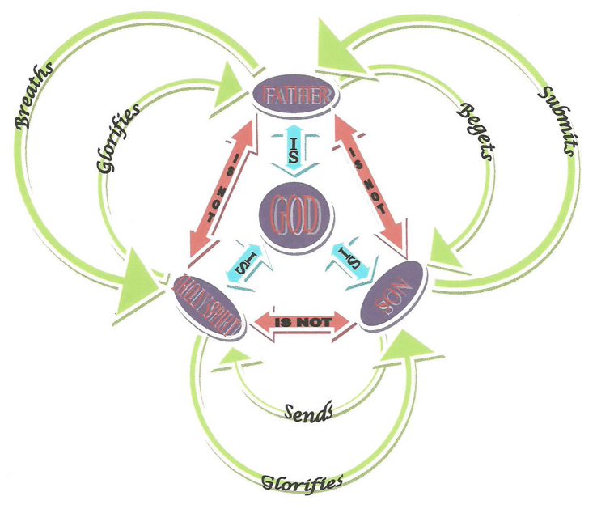
GOD
SON
HOLY SPIRIT
FATHER

