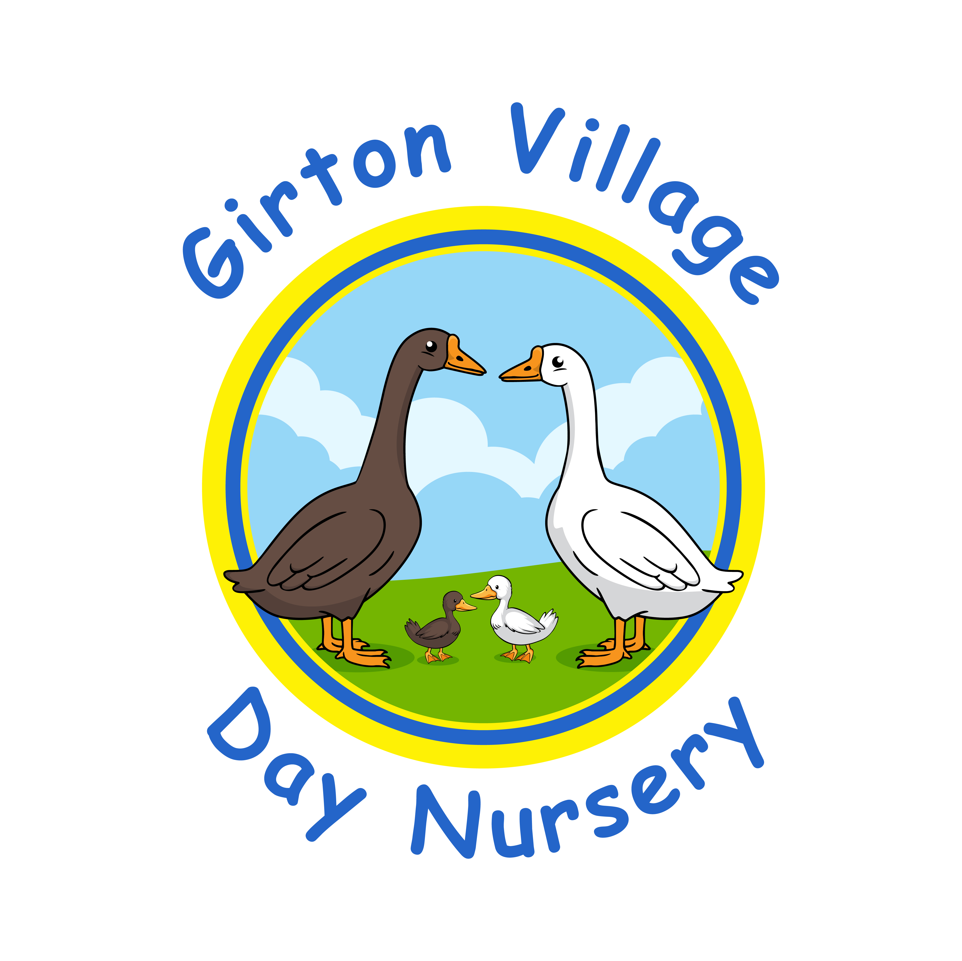
Admissions and Transition Policy

Girton Village Day Nursery welcomes all children and their families. We are open for 51 weeks of the year and accept both 15 and 30 hours of government funding, which is stretched throughout the year. Our minimum booking is two short days per week. However, there are up to three fully funded places available to children in receipt of two-year old funding (code starting with EWB), deprivation funding and/or Early Years Pupil Premium (EYPP). They are accepted on a first come, first served basis as soon as the days families want are available.

A fee of £2.50 will be charged for food for children over age three. We cannot allow packed lunches due to the high number of children with allergies, but you can take your child home for lunch between 12.00 and 1.00 and this hour will not be charged or be taken from your funded hours. Please speak to Charlotte if you would like to consider this option.

A deposit of £50.00 will secure a place at the nursery until your start date, and for six months afterwards in case your dates change. This is refunded on your first invoice. Your deposit will be fully refunded if you provide us with more than two-months notice that you no longer need a place. No deposit is required for children in receipt of two-year old funding (code starting with EWB), deprivation funding and/or Early Years Pupil Premium (EYPP).

Our staff are experienced in supporting children with additional needs and/or medical conditions, such as allergies. Prior to admission, we may meet with parents/carers, and relevant professionals if necessary, to plan how we can best support the child. Where specific training or funding is required prior to the child’s start date, this will be sought from relevant agencies.

If a group is at capacity, a waiting list will be used. Places will be offered based on the hours and days that become available, and in keeping with the order of the list where possible. Priority for days and times is given to families who are currently using the setting in order to meet their requirements. For example, siblings will be prioritised on the waiting list.

Settling Sessions

Settling sessions are an important part of our introduction to nursery and our staff are very experienced in supporting children during this period. Prior to the first session, we will ask you about your child’s likes and dislikes so the activities are specifically planned to interest them.

We try to book settling sessions at times when the nursery is quiet so children have the most one-to-one time with their keyperson in order for bonds to establish. Sessions are planned in advance but sometimes we need to be flexible in order to meet the needs of the individual. For example, if a child is struggling to settle we may ask you to bring them in for a short period every day. Please help us by avoiding holidays in the month before you return to work.

Transition Visits

Before children move to our preschool room, you will be introduced to their new keyperson, offered a tour of the room and be given a booklet providing information about the staff and routines. We support children with this transition by planning opportunities for them to spend time with their new key person in their current room, have visits to the preschool room with a familiar practitioner and enjoy garden time with their new peers.

The nursery also supports transition to school. We welcome teachers, and other professionals, to visit the setting in order to introduce themselves to the children and learn more about them. Where possible, we also facilitate visits to nearby schools, such as the weekly preschool transition visits to Girton Glebe School in May and June.

Transitions can be particularly difficult for children with additional needs and a different, individualised approach may be needed. It may also be necessary for meetings to be arranged with the reception teacher, school SENCo and family members to share information which can give the child a better start at school.

Absence Monitoring

Regular and timely attendance has huge benefits to a child’s sense of belonging, learning and breadth of nursery experiences. Staff carefully plan every day to meet the needs and interests of each child, often building on their experiences over subsequent sessions.

Attendance and late collection is monitored in line with safeguarding guidance, and our attendance and absence policy. Please ensure that you notify us of holidays and medical appointments to ensure they are documented correctly. We are required to notify Cambridgeshire County Council if a funded child is frequently missing sessions.

This policy was adopted in September 2025 and will be reviewed annually, or beforehand if amendments to current requirements are necessary.

