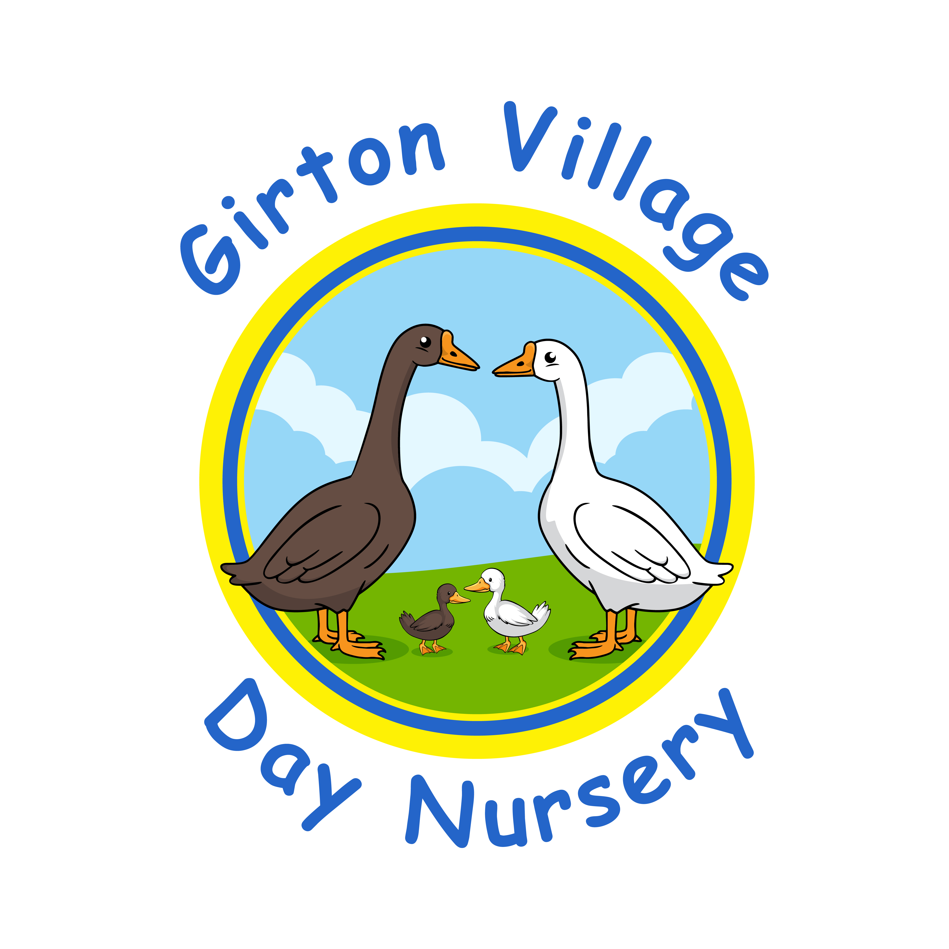
Use of Images Policy

Introduction

This policy is designed to balance safeguarding the children in our care with ensuring families can celebrate in their children’s achievements through the use of technology.

The use of images can be divided into three categories:
- Images taken by the setting i.e., observations
- Images taken by parents at setting events
- Images taken by third parties

Staff and students must not use personal technological devices (including mobile phones and cameras) to take images of children that attend the setting. Personal technological devices must not be operated or stored in rooms used by the children, and should be surrendered on arrival to the designated storage facility in the office.

The General Data Protection Regulation (GDPR) and the Data Protection Act 2018 affect the use of photography. An image of a child is personal data and therefore, during registration we ask for signed consent from the parent/carer of a child for any images made, such as those used for setting websites, observations, outings and events or other purposes. We also take into account the wishes of the child, remembering that some children do not wish to have their photograph taken.
Consent is reviewed annually to ensure that parents and young people, who have previously given consent, can choose to opt out if they no longer wish to be included.
Where parents/carers have refused permission for their child/young person to be photographed or have not returned a completed and signed consent form, the child’s image will not be recorded.

Where a parent/carer has given consent, but a child or young person declines to have an image taken, it will be treated as consent not having been given and other arrangements will be made to ensure that the child is not photographed/filmed. The setting will never exclude a child from an activity if consent is not given.

Care is taken in relation to particularly vulnerable children such as Children in Care, recently adopted or those who have fled domestic abuse.

We will avoid using names during publication of images, and using only first names if we do need to identify them. We will never publish personal information or disguising information about the child.
All images used will be of children wearing appropriate clothing and avoiding full face or body shots of any children taking part in activities such as swimming where there is heightened risk of them being misused.
We will promote the positives of activities in our images.

Examples:
A photograph of a child is taken as part of their Learning and Development record and consent has been gained from parents/carers. The images are likely to be securely stored electronically with other personal data and the terms of the GDPR and Data Protection Act will apply.

A small group of children are photographed during an outing and the photo is to be used in the setting newsletter. This will be personal data but will not breach the GDPR and Data Protection Act 2018 if the children and/or their parents/carers have given their consent and the context in which the photo will be used.

Parents wishing to take images at setting events

The GDPR and Data Protection Act 2018 do not prevent parents/carers from taking images at setting events, but these must be for their own personal use. Any other use would require the consent of the parents of other children in the image – see Appendix B

Examples:
A parent takes a photograph of their child and some friends taking part in a sponsored fun walk to be put in the family photo album. These images are for personal use and the GDPR and Data Protection Act 2018 do not apply.
Grandparents are invited to the setting nativity play and wish to video it. These images are for personal use and the GDPR and Data Protection Act 2018 do not apply. However, if they intend to use the video on a social networking site e.g. Instagram, Twitter, they must receive permission from the parents/carers of all the other children involved.
The setting manager will decide when it is appropriate for parents to be permitted to take images and this information will be provided. Wherever possible, the setting will take their own ‘official’ photos or videos, to retain control over the images produced. We will use any event opportunities to remind visitors such as parents and grandparents of the safe use of images and consent for images being taken.

Third parties

Staff should challenge anyone who is using a camera, mobile phone or video recorder at the setting whom they do not recognise.

Images taken by the press

If a child is photographed by a newspaper, the photo becomes the property of the newspaper who has the final say as to how it is used. (N.B. images can be placed by editors on the newspaper’s website). Generally, newspaper photos of groups of 12 or more children do not have the names of the children attached. Photos of smaller groups might include the full name of the child in the accompanying caption; however, the setting/parents are not obliged to provide children’s names and it is recommended that they do not do so. The setting will collect the name and details of the person taking photographs onsite as a visitor and they will be escorted at all times.

Example:
A photograph is taken by a local newspaper of a setting event. As long as the setting has agreed to this, and the children and/or their guardians are aware that photographs of those attending the event may appear in the newspaper and given permission, this will not breach the GDPR and Data Protection Act 2018.

Images taken by an external photographer/videographer
If an event is being photographed by a hired professional photographer or an external person who has been asked to formally take image, the setting will ensure the photographer is provided with a clear brief about appropriate content, and the photographer is escorted at all times, whilst being correctly signed into the provision as a visitor. Parents, carers and children will be informed of the photographer’s presence and all and any concerns will be reported as necessary.

Storage of images

The setting has a duty of care to safeguard images so that they cannot be used inappropriately, or outside the agreed terms under which consent has been obtained. Images will be stored on the nursery computer or in printed form for displays and development folders.

Images must be maintained securely for authorised setting use only, and disposed of either by return to the child, parents, or by shredding. The images taken will be stored for the length of time required and no longer than the child remains in attendance at the provision.

Consideration will be given to the use of doorbell recording devices, Alexa and other technological device that may hold images or voices of children if purchased. Doorbell footage will only be accessed by staff whilst on the property and not from an outside source without prior consent from management. These devices will be included in the DSL’s filtering and monitoring processes that are in place. Further advice can be sought from the devices own Safeguarding policy.

Transfer of images

There is a risk, however small, that images may be lost while in the process of being transferred by either traditional or electronic methods. Therefore, there is the risk that an individual who would use them inappropriately may obtain the images. This risk will be explained to parents and carers if the need to transfer images of their child arises.

Publishing or displaying photographs or other images of children

The Department for Education advises that if the photograph is used, avoid naming the child. Whatever the purpose of displaying or publishing images of children care should always be taken to avoid the possibility that people outside the setting could identify and then attempt to contact children directly.

- Where possible, general shots of group activities rather than close up pictures of individual children should be used
- Children should be in suitable dress
- An article could be illustrated by including the children’s work as an alternative to using an image of the child

Useful sources of information
The Information Commissioner Office website |  | https://ico.org.uk/
Guidance to the General Data Protection Regulation (GDPR) https://www.gov.uk/government/publications/guide-to-the-general-data-protection-regulation

Child Exploitation and Online Protection | w www.ceop.gov.uk
This policy was adopted in September 2025. It will be reviewed annually, or beforehand if amendments to current requirements are necessary.
Use of Images Consent Form

This form should be completed by an adult who has parental responsibility for the child.

We value the use of photographs in the setting for documenting your child’s achievements, progress and participation in activities. They may be used on displays, in development folders or during planning meetings to improve provision.

During your child’s time at Girton Village Day Nursery images may be taken of your child for our use, to record observations or special events. There may also be occasions (such as a special event), where a third party, e.g. other parents/carers or the media, may take images of your child. Images could be a photograph, video/DVD or website image.

It is a requirement of the General Data Protection Regulation (GDPR) Data Protection Act 2018 that we have your consent for this. Your permission is sought in advance to take, display and on occasion, publish photographs and video recordings involving your son or daughter. It is intended that your consent will cover the duration of the time your child attends the setting. However, we will inform you of all instances where images will be taken and published outside of the setting and you have the right to withdraw consent at any point.
The setting has adopted certain safeguards in order to minimise any risk to your child
- We will avoid the publication of your child’s full name with any image used by the setting
- Images will be kept securely and destroyed after their required time
- Staff, students and parents will not use personal equipment such as mobile phones or cameras to take images of children who attend the setting.
Please note that the setting does not have control of how images taken by the media are published. However, the setting will not provide children’s names to the media without parental permission.
Child’s name:

Name of Parent/Carer: ___________________________________________

I do / do not* give my consent for digital images of my child to be taken and used
by the setting Yes/No
by third parties Yes/No (*please delete as appropriate)

Signature of Parent/Carer
Date:

Request for parents/carers wishing to
take their own photos/videos

In accordance with the General Data Protection Regulation (GDPR) Data Protection Act 2018, I agree to ensure that all images I take will only be for my personal use and will be kept securely and used appropriately. *

Name of setting: | Girton Village Day Nursery

Child’s name:

Name of parent/carer/relative:

Relationship to child:

Signed: |  |  |  | Date:
Print name:

*Thank you for your co-operation. The safety of children in the setting is paramount. For further information please refer to the setting’s policy for the use of images.

