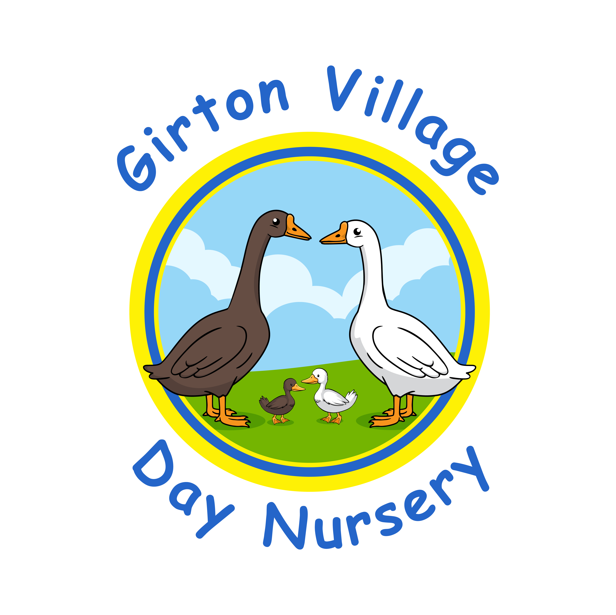
Complaint Policy and Procedure For Parents/Carers

Girton Village Day Nursery is committed to providing a safe, stimulating and caring learning environment for children. We aim to provide a high quality service for everyone, but accept that sometimes things don’t always go according to plan. In such circumstances, we will always try to put it right and address the issue. If at any time parent/carers are not happy with the service we provide, there is a clear procedure to follow:

Stage 1
If a parent/carer has a complaint or cause for concern, we would encourage them to speak directly to the member of staff or senior staff member in the first instance. You may also choose to have an informal discussion with the manager. In the event of a significant allegation against a member of staff we follow the Cambridgeshire County Council procedure for ‘Allegations against a person who works or volunteers with children…. What to do’ (Jan 2021). If a satisfactory solution cannot be found at this stage, then stage 2 of the procedure should be followed.

Stage 2
If the complainant feels their complaint has not been resolved through discussion, they should then put their complaint in writing to the manager, including names, dates, evidence & any other important information related to the nature of the complaint. If the manager has good reason to believe that a criminal offence has been committed, they will contact the police. The setting will acknowledge receipt of the written complaint as soon as possible & will investigate the matter raised. The complainant will be notified of the outcome of the investigation within 28 days of having received the complaint. They will be sent a full & formal response, which will be copied to all relevant members of staff if appropriate. The response will include any action or change to our policies & procedures, emerging from the investigation.

Stage 3
If the complainant is not satisfied with the written outcome response, they may request a meeting with the manager, who will judge if it is best for all parties to meet together or separately where applicable.

Stage 4
If the complainant is still not satisfied, they should contact Ofsted using the contact details below:
OFSTED Complaints Department
Piccadilly Gate
Store Street
Manchester M1 2WD
Tel 0300 123 1231

This policy was adopted on 25th January 2022 and will be reviewed annually, or beforehand if amendments to current requirements are necessary.

