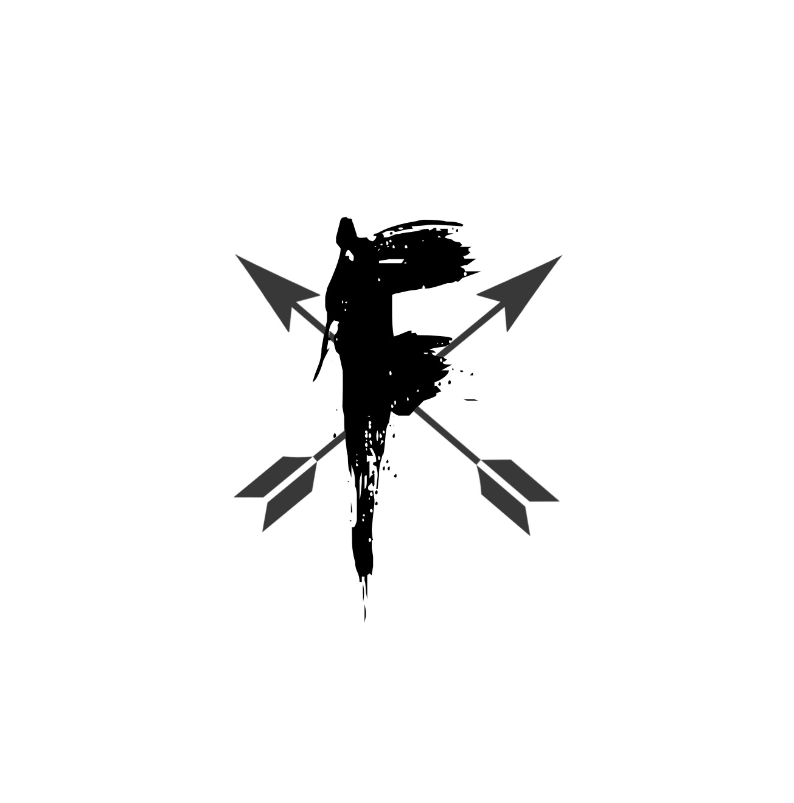

FORD HOLSTER COMPANY, LLC

FORD HOLSTER COMPANY, LLC

FORD HOLSTER COMPANY, LLC

FORD HOLSTER COMPANY, LLC

FORD HOLSTER COMPANY, LLC

FORD HOLSTER COMPANY, LLC

