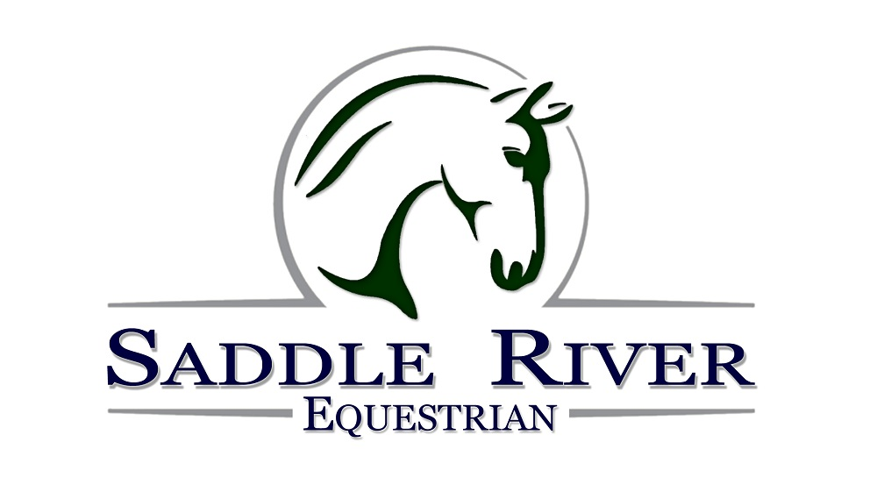

Rider Information Sheet

Name:
Phone Number(s):
Email:
Tell us your interests and we’ll keep you updated:  Address: | [ ] General News  [ ] Services (Boarding, Sales, Leases and Training)  [ ] Horse Shows  [ ] Lessons  [ ] IEA Team  [ ] Summer Camp  [ ] After-school Program
(Circle)
  Adult | Child | Male | Female
  Height: | Weight: | D.O.B.
Experience:
How did you hear about us?

PROPER ATTIRE REQUIRED, APPROVED RIDING HELMET WITH CHIN STRAP, HARD SOLED SHOES WITH A HEEL (NO SNEAKERS), LONG PANTS, FORM-FITTED CLOTHING, ALL HAIR SHOULD BE PULLED BACK IN A TIE OR TUCKED UNDER HELMET.
RELEASE OF LIABILITY

WITNESS THIS AGREEMENT this ______ day of _________________, 20____, by and between Saddle River Equestrian, hereinafter referred to as MANAGER and ________________

________________________, hereinafter referred to as RIDER. For consideration received, and in return for the use, today and on all future dates of the property, facilities and services of Manager, Rider, Rider's heirs, assigns, and representatives, hereby agree as follows:
1. Inherent Risks and Assumption of Risk. The undersigned acknowledges there are inherent risks associated with equine activities such as described below, and hereby expressly assumes all risks associated with participating in such activities. The inherent risks include, but are not limited to the propensity of equines to behave in ways such as, running, bucking, biting, kicking, shying, stumbling, rearing, falling or stepping on, that may result in an injury, harm or death to persons on or around them; the unpredictability of equine’s reaction to such things as sounds, sudden movement and unfamiliar objects, persons or other animals; certain hazards such as surface and subsurface conditions; collisions with other animals; the limited availability of emergency medical care; and the potential of a participant to act in a negligent manner that may contribute to injury to the participant or others, such as failing to maintain control over the animal or not acting within such participant’s ability.
Rider acknowledges that horses, by their very nature are unpredictable and subject to animal whim. Rider assumes all risks in connection therewith, and expressly waives any claims for any injury or loss arising there from. Rider agrees to abide by and follow Manager's rules and regulations which, shall be posted and/or available from time to time. Rider further acknowledges that the behavior of any animal is contingent to some extent upon the ability of Rider. Rider assumes all risks and warrants a full and fair disclosure of Rider's abilities has been made to Manager.
Rider expressly releases Manager from any and all claims for personal injury or property damage, even if caused by negligence (if allowed by the laws of this State) by Manager or its representatives, agents or employees.
WARNING

You are advised that there are inherent risks, including the risk of serious injury or death, while engaging in equine activities. By engaging in equine activities and in accordance with the terms of this agreement you hereby assume all risks of injury or death.
- Rider agrees to hold harmless, indemnify and defend Manager against, and hold harmless from, any and all claims, demands, causes of action, damages, judgments, orders, costs or expenses, including attorney's fees, whether actually incurred or not, which may in any way arise from or be in any way connected with Rider's use of or presence upon the property of Manager and the facilities located thereon.
- In the event Rider is using Rider's own horse, or a horse(s) not owned by Manager, Rider warrants said horse(s) shall be free from infection, contagious or transmittable diseases. Manager reserves the right to refuse access or use of any horse upon the premises that does not appear to Manager to be in good health, or is deemed dangerous or undesirable.
- Any action brought under this agreement shall be brought within one (1) year of the incident or accident giving rise to said claim. Rider agrees that damages shall be limited to $250 for property damage, actual expenses incurred, and a maximum of $10,000 for damages such as pain and suffering.
- Rider agrees to waive the protection of any applicable statutes in this jurisdiction whose purpose, substance and/or effect is to provide that a general release shall not extend to claims, material or otherwise, which the person giving the release does not know or suspect to exist at the time of executing said release.

Manager |  | Rider
 |  | (Guardian if under 18 years of age)

