About the Company…
Twist Catering prides itself on being one of the most reasonable, and unique catering companies in the Upper Peninsula. It is our mission to cook food that inspires us, and to make the food at your event as memorable as you are! We offer free consultations, and food tastings. We are able to cater Weddings, Rehearsal dinners, corporate events, graduation parties and more! No event is too large or too small!
Feel free to look through our menu below. ALSO, if there is something that you want, that we don’t currently offer, PLEASE let us know! We’re kind of into that whole customization thing..

Thanks for your Interest in TWIST!

Cally Dittrich, Catering Coordinator

- All Pricing is subject to date availability, and guest count, and service type. Prices Valid for 2021-2022 Only.

Twist Catering Appetizer Bar $5
For during cocktail hour, or after dinner to keep your guests dancing all night!
Choose Four Items
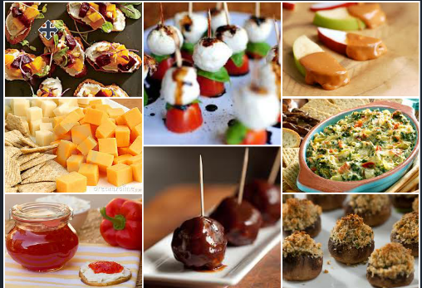
-BBQ Meatballs -Cranberry Squash Crostini -Caramel Apple Wedges
-Mini Pasties -Assorted Cheese and Cracker Tray - Warm Spinach Dip
-Stuffed Mushrooms -Caprese Bruschetta Bites -Smoked Salmon on crackers
-BLT Bites -Taco Dip - Cheeseburger Meatballs
-Jalapeno Popper Dip -Chicken Salad on Apples -Vegetable Cups
-Twisted Devilled Eggs -Fruit Kabobs -Avocado blackened Shrimp
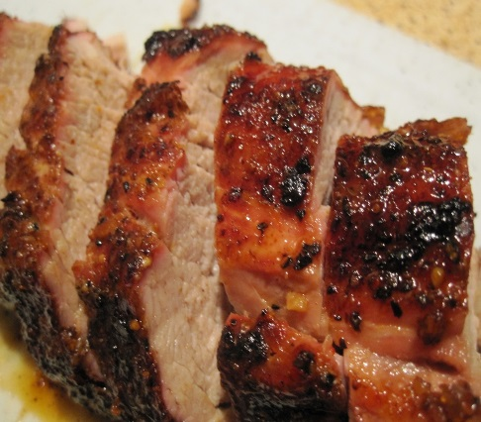 | 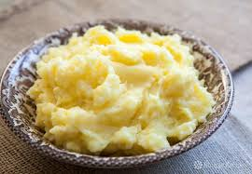
Twist Catering and Events 2021-2022 Menu Options
Entrees
Apple Glazed Pork Loin- Tender, slow roasted pork served with apples or BBQ Style.
Baked Chicken- Assorted white and dark meat chicken. A traditional option!
Ham- Buffet Style Ham, glazed with pineapple, brown sugar and a golden honey BBQ Sauce
Beef Brisket- Grilled beef brisket, charred on the grill, slow roasted for hours, and sliced before service. (add $1)
Swedish Meatballs- hand rolled meatballs, in a traditional Swedish sauce. An oldie, but goodie!
Lasagna- Layers of Italian cheeses and meat, in our basil marinara.
Chicken Alfredo- home-made alfredo, grilled chicken, and pasta. Available as stuffed shells as well!
Baked Cod- Wild caught cod seasoned in old bay, and smothered with butter and lemon.
Stuffed Chicken- Hawaiian BBQ, Cheddar and Broccoli, or Spinach and artichoke a non-traditional, yet wonderful.
Grilled and Marinated Tri-tip beef - Seasoned to perfection and carved to order. (add $1.50 per guest).
Beef Stroganoff- Tender beef, with egg noodles in a red-wine sour cream jus.
Side Items
Bacon Creamed Corn Browned Butter Stuffing Mashed Sweet Potatoes Baked Potato Bar Wild Rice Pilaf Roasted Red Potatoes Cheesy potatoes Mashed Red potatoes Corn on the Cob Steamed vegetables Green Bean Casserole Campfire Baked Beans Brown Sugar Green Beans Bourbon Glazed Carrots Baked Seven Cheese Mac
Cold Salads
Coleslaw Potato Salad Mediterranean Orzo Salad BLT Salad Rotini Salad Spaghetti Salad Tuna Salad Sesame Salad Broccoli Salad with Noodles Garden Salad Chophouse Salad Caesar Salad
Dill Pickle Salad Radiatore Salad Parmesan Ranch Salad

